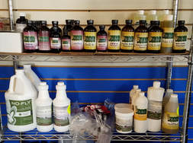
Pictured is one of our retail shelves that is now stocked with Dr. Paul’s products. We also carry Smidley waterer parts on hand, and offer Crystal Creek and Fertrell products.

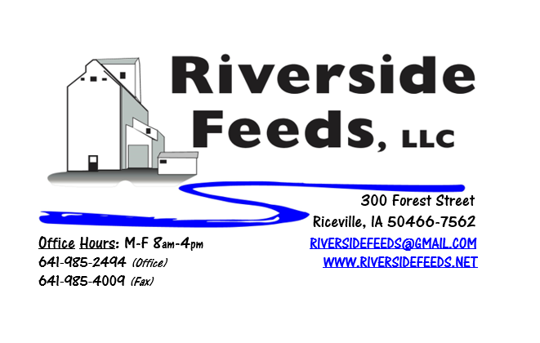
January 2018 Newsletter
Hi everyone! We hope that everyone had a successful year and are making great plans for 2018! Even though we are dealing with extreme cold temperatures while I write this newsletter, we are VERY excited here at Riverside Feeds for a new year with new products being offered! We recently decided to become a dealer for Dr. Paul’s Lab. If you are not familiar with Dr. Paul Dettloff, please read more below, visit our website, or give us a call! You may see some additional information included with this newsletter regarding species specific practices for your operation.
What’s Happening:
As mentioned above, we have recently become a dealer for Dr. Paul’s Lab. Dr. Paul Dettloff is a well-known organic veterinarian, and is an on-staff vet for Organic Valley beyond running his own lab. None of his products are vaccines or drugs, so we do not have to have a FDA License for such. His products are natural ingredients and remedies that would include (but not limited to) kelp, garlic, apple cider vinegar, molasses, humates, herbs, essential oils, etc. All of Dr. Paul’s items are allowed for organic use. Most of Dr. Paul’s products are for ruminant animals, but a lot of his items work for all species. He recently developed a couple products specifically for swine, which really impressed me. We now have swine products that is allowed to be used organically that we never had available in the industry before. I have more information about swine products written below. We have also included in this newsletter a listing of all of Dr. Paul’s products. We don’t carry everything on hand, but we do have a very nice inventory. We can order any products in, and can also direct ship in the event of an emergency. Please call and ask for a sales associate (either Amanda or James will be available to answer questions about this product line) for more information, availability, and pricing.
We are waiting for our updated organic certificate to come. As soon as we have this, we will send a copy out in the newsletter to all of our customers, and post on the website.
Organic Grain Prices:
Organic grain prices should remain fairly steady this winter as harvest reports came in very high. I have not heard any reports of grain prices going up or down at this time.
Beans are trading between $18.00 - $20.00 a bushel here in the upper Midwest (Feed – Food, respectively), and corn is trading between $7.50 - $8.50 a bushel. Barley is around $8.00, and Wheat is around $8.50. Soybean Meal is trading around $800 per ton.
Services We Offer:
Please contact us if you or anyone who you know may be looking for custom pelleting options. Our services now include: Warehousing (including loading dock), Hammer mill, Mixer, Pellet Mill, Crumbler, and load out in either bulk, tote bags, or feed sacks. We also have a fleet of trucks and trailers. We have been receiving many phone calls from large feed and food grade operations looking for custom organic pelleting, and are glad to be available to help fill this demand! Unfortunately, we have decided that it would be in our best financial interest to sell our Clipper Fanning Mill. We don’t have room, large enough demand, or labor force available to set this cleaner up in a new system and run it every day of the week. This was a hard decision to come to, but I feel that it is critical that we focus on what our expertise is – alternative feed products and processing, and grain cleaning won’t be a reality in our current operation.
Events Coming Up:
If there are field days or events that you would like to share with our customer base, please feel free to provide us the information and we will include it in next month’s newsletter!
- Minnesota Organic Conference, St. Cloud, MN. January 11th & 12th. We will have our booth display at this conference – Hope to see you there! Amanda and I will be attending this conference. Please let us know if we can bring any items with us! (can fit a few sacks or Dr. Paul’s items in the truck).
- Practical Farmers of Iowa Annual Conference, Ames, IA. January 18th – 20th. We will be exhibiting at this conference as well! Our very own part time feed mill operator, Bob Owen, will be speaking at this conference on swine genetics! We are very excited to hear from Bob! Amanda, myself, Paige, and Bob will be attending this conference. Please let us know if we can bring any orders with us to this conference!
- MOSES Organic Farming Conference, La Crosse, WI. February 22nd – 24th. We are on the “waiting list” to exhibit at this conference, so please share with conference staff that you want to see Riverside Feeds exhibiting at this conference! Amanda and I will both be attending this conference.
Products We Offer:
We just recently got some more organic soy proteins in, however, supplies are still fairly tight. Sales have been very good recently, and we have a large demand for many products. We are focusing on selling our custom services (grinding, mixing, pelleting) now. We do have more Non-GMO Oat Screenings pellets (Not organic) available for sale yet. We do carry organic and conventional Apple Cider Vinegar, either in 4 gallon pails or 55 gallon drums. As always, we have a full line of vitamins and minerals. I do carry Organic Liquid Molasses in 50# pails. We also carry Crystal Creek “No-Fly” on hand. Otherwise, orders can be placed through us for any Crystal Creek or Smidley Equipment products. We have Smidley water fountain parts on hand at all times. Dr. Paul’s products are on hand and available to be ordered.
Poultry Feeds:
Our poultry feeds are all in crumbled form. We offer Broiler Starter (spring seasonal item), Broiler Grower, Poultry Layer, and Suncoast Pine Shavings (OMRI Approved). We are still looking for a perfect mixture of grains to bag off and sell as “scratch grains”, but haven’t had much luck yet. This is a priority for us since winter is approaching and scratch grains are a great treat for birds!
Swine Feeds:
Pre-wean 22 pig feed pellets make a GREAT starter creep feed pellet for young pigs and should be offered especially during colder winter farrowing months. We carry a few bags on hand, but larger orders must be requested and given a few days in order to work into our schedule to make. Dr. Paul has two swine products – PigAde and SwineX. SwineX is a swine wormer, and I have heard that it works very well (and allowed for organic use). All hogs have worms, and this should be considered in organic production where products are very limited to the industry.
PigAde is an orally administered product for boosting immunity and health for young pigs, especially when they are ill with pneumonia or scours. I HIGHLY recommend that this would be on hand at ALL times for organic producers who farrow, since there are no other products that I know of that is allowed for organic use.
Used Smidley Equipment Available:
We are looking for good, used Smidley hog scales and waterers. We can also order any brand new Smidley equipment, but they are way behind on manufacturing, so it may take a couple months to get a new feeder or piece of equipment. Please call for pricing on the used drinkers.

THANK YOU FOR YOUR BUSINESS!!!
“Revitalizing Industry Byproducts into Livestock Feed by
Recycling Organic and Non-GMO Grain Materials for Family Farmers”

