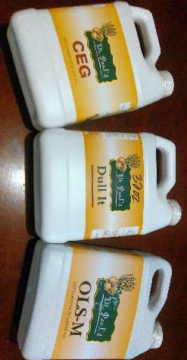

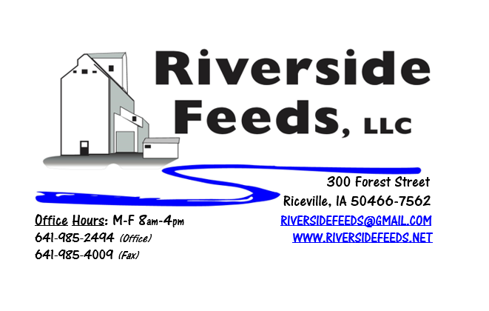
January 2019 Newsletter
Our top three selling Dr. Paul’s Tinctures are pictured: CEG (natural antibiotic), Dull-It (pain relief), and OLS-M (respiratory treatment). We stock these tinctures in both 8 and 32 ounce sizes, as well as numerous other tinctures and herd health products. These tinctures are approved for organic use.
What’s Happening:
THANK YOU all for your cooperation during the busy holiday season! We were able to complete all orders as needed and take time off to spend with our families – I greatly appreciate everyone’s help with the chaos!
As we are analyzing our year end numbers for 2018, we are pleased to report a record shattering year that ended up far beyond our budget! All together, we processed nearly 19,000 tons of feed products last year! Our success is attributed by our customer support, so THANK YOU for your demand towards our business! We are busy making production plans for 2019, and are projecting for a very busy year. In order to help with this increased production, we will be putting more storage bins in this spring. These bins will provide us the flexibility to run three shifts and increase our handling efficiencies.
We are preparing for a very busy winter conference season! Please keep us notified if you will be attending any farming conferences, so we can meet up with you. We may even be able to bring a small amount of product with us if you preorder!

Organic Grain Prices:
Organic corn is now trading in the $10.50 - $11.00 range. Barley is holding steady around $8.50.
Beans have fallen due to the low cost imported meal. Organic soybeans are trading between $17.00 - $19.00 a bushel here in the upper Midwest, and Wheat is around $8.50 - $9.00. Domestic organic Soybean Meal is trading around $775-$850 per ton. BE CATIOUS OF TOXINS!!! If you have any questions about toxins and molds, send a sample to the lab and consult with an expert. We have heard many reports of disastrous toxin levels in soybeans, especially in central Iowa. Toxins are produced from wet weather and conditions during the growing season. If you have questions about toxins in your feed products, please give me a call.
Events Coming Up:
If there are field days or events that you would like to share with our customer base, please feel free to provide us the information and we will include it in next month’s newsletter!
- Minnesota Organic Conference, St. Cloud, MN. January 10 & 11, 2019.
- Practical Farmers of Iowa Conference, Ames, IA. January 18 & 19, 2019.
- Missouri Organic Farming Conference, Independence, MO. January 23, 24, & 25, 2019.
- Organic Farming Conference, LaCrosse, WI. February 21 – 23, 2019.
We will have an exhibit booth at each of these conferences (I’ll be busy traveling this month!). Stop by and say hello! Our exhibit booths will have plenty of information available to hand out including price lists, newsletters, brochures, and possibly extra goodies! As mentioned, you may place small orders prior to these events and we can bring these orders with us.
Products We Offer:
We are long on Non-GMO soy proteins (Not organic) available for sale yet, and can ship that out in bags, totes, or bulk quantities. We have both Soy Pro 40 and Soy Pro 50 available to sell now.
Poultry Feeds:
Poultry may need additional sources of protein during the winter months. Providing high quality alfalfa may be a generous offer to those birds now since they don’t have access to green pastures. We also have Soy Pro 40 protein available that can be supplemented in their feeders. That protein is also high in fat, which may be beneficial during these colder temps.
Swine Feeds:
We have a good supply of Organic Prewean 22 on hand and ready to send out. Young piglets really need a high quality diet to get started on, especially during these colder months. This creep feed ration is loaded with a diverse amount of high quality ingredients to enhance the early start for pigs.
Bovine Feeds:
Keep in mind the benefits of Aloe Pellets and high energy sources like Molasses when feeding calves and any bovine during colder and varying temperatures. Aloe Pellets can help with fevers, pneumonia, and stress. Fall calves tend to struggle a little harder this time of the year due to the changing weather conditions. Keep a close watch over their health and performance.
Horse Feeds:
We have a good supply of our complete Non-GMO Horse Pellets on hand, which have been working great for work horses. This product includes minerals and molasses, among a list of ingredients. We also have oat screening pellets available in bags, totes, or bulk. This has been working very well to replace expensive hay at this time.
Dr. Paul’s Products:
We carry a diversified line of his products and can order any special items at any time. Remember to stock early for your needs this coming fall and winter. Wound spray works for any cuts, abrasions, or other general wounds on all species. It is also allowed to be sprayed directly in the eyes of animals, and could be used to help prevent pink eye. Wound spray comes in a 22 ounce spray bottle or a 64 ounce refill jug.
Used Smidley Livestock Equipment Available:
We do have some 4 drink hog bars on hand. We can order any brand new Smidley livestock equipment. Smidley makes mineral feeders, steer stuffers, multiple sizes hog feeders (both stainless steel and wood), hog scales, hog huts, and livestock water fountains. We stock a full selection of Smidley livestock water fountain parts!

THANK YOU FOR YOUR BUSINESS!!!
“Revitalizing Industry Byproducts into Livestock Feed by
Recycling Organic and Non-GMO Grain Materials for Family Farmers”

