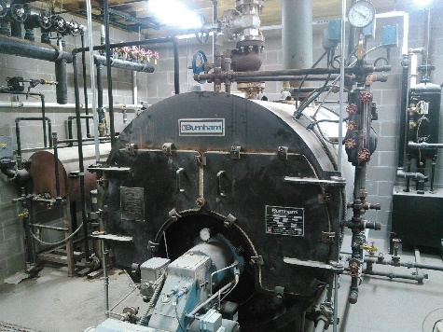
Many HOT pipes exist in our Boiler Room! Pictured is the boiler, which produces steam for the pellet mill, which turns mash into pellets.

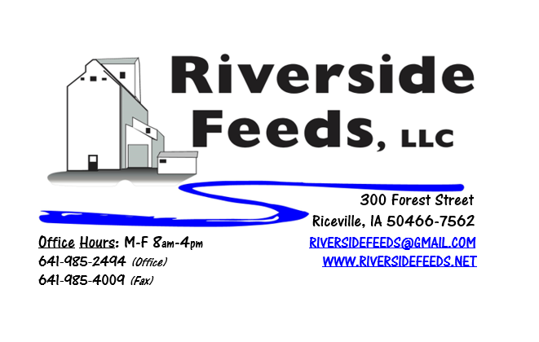
October 2017 Newsletter
Hi everyone! Hoping for a safe and successful fall harvest as the season is quickly approaching! Please share with us some of your yields so we can have a good understanding of what the national yield average will look like, and be able to build some confidence in our new crop grain supply and pricing!
What’s Happening:
As noted last month, we are still in the process of advertising for second shift help. We are very busy with multiple products and many orders, and available time slots in our feed milling or pelleting schedule quickly fill up. *PLEASE place your feed orders in a timely manner, as it may take us a couple days before we can even get to some of the smaller sized orders.* We have hired a couple new people here since last month’s newsletter. We now have additional first shift help for various tasks, and we also have a part time employee focusing on all product inventories, and keeping our inventory numbers up to date. Relieving some of these duties from my shoulders, will help me coordinate more sales, logistics, and product and business development.
Organic Grain Prices:
Organic grain prices have been very steady, even though conventional prices continue to drop as harvest nears and has begun in some southern areas. As mentioned above, please let me know how your yields turn out as you take crops out of the fields. I think most areas will have bumper crops, but it is always hard to tell prior to the combines running.
Beans are trading between $18.00 - $20.00 a bushel here in the upper Midwest (Feed – Food, respectively), and corn is trading between $8 - $9 a bushel. Barley is around $8.00 - $8.50, and Wheat is around $8.50 - $9.00. Soybean Meal is trading between $800 - $850 per ton. I have heard reports of a lot of old crop grain in bins (both organic and conventional), and this may impact harvest and prices by a fair margin.
Services We Offer:
Please contact us if you or anyone who you know may be looking for custom pelleting options. Our services now include: Warehousing (including loading dock), Hammer mill, Mixer, Pellet Mill, Crumbler, and load out in either bulk, tote bags, or feed sacks. We also have a fleet of trucks and trailers. After we finish up some projects around here, we will also have grain cleaning capabilities with a Clipper fanning mill, but that will not be until sometime in 2018.
Events Coming Up:
If there are field days or events that you would like to share with our customer base, please feel free to provide us the information and we will include it in next month’s newsletter!
- Iowa Organic Conference, Iowa City, IA. November 19 – 20. We will have our booth display at this conference – Please stop by and check us out!
Products We Offer:
We are currently long on Organic “Opro 40” protein, and now offer that in a crumblized form to keep the texture consistent. Pricing on that is $825 per ton, and available in either tote bags or bulk. I may be able to offer a price break for an entire truck load! We have an endless supply of either organic or Non-GMO Ground Oat Screenings (pelleted). These screenings have very good nutritional tests. We are ramping up our production of both organic and non-gmo soy hulls, so if you need some alternative soy pellets as a feed ingredient, please give me a call today. We do carry organic and conventional Apple Cider Vinegar, either in 4 gallon pails or 55 gallon drums. As always, we have a full line of vitamins and minerals. I do have a source now of organic liquid molasses, and may start carrying some on hand to try for some certain rations. We carry Crystal Creek “No-Fly” on hand. Otherwise, orders can be placed through us for any Crystal Creek or Smidley Equipment products.
Poultry Feeds:
Our poultry feeds are now in crumbled form, and so far, it has been working well! We offer Broiler Starter, Broiler Grower, Poultry Layer, and Suncoast Pine Shavings (OMRI Approved). We ran out of Scratch Grains, and since we ran out, everybody has been asking for more. I’m not sure when I’ll get more organic scratch grains on hand, but hope to see some come in soon. Stay in touch about this, since the demand is so high. We do have a semi load of Organic Layer Feed Pellets. They are in tote bags, and we are selling this for $640 per ton in those totes, or bulk. If you are interested in larger quantities of organic layer feed, please let me know.
Swine Feeds:
Due to GAP Certification requirements, we made a slight change in the Prewean 22 pig feed pellets. We decided to remove fishmeal from the ration since that is not allowed under GAP certification. I would like to replace that fishmeal with soy isolates, but that is very hard to find in the feed grade (and organic), and is very expensive. For now, I increased the steamed rolled oats, dried buttermilk powder, and soybean meal to replace the crude protein level that the fishmeal offered. We are able to grind, mix, and pellet any swine feed rations – either Non-GMO or Organic. It is too hard to keep complete feed fresh, so we do not carry hog feeds on hand in inventory. This is a custom mixed ration for everyone, so timely ordering on swine feeds is important.
Used Smidley Equipment Available:
Single drinker, single sided (1 hole) – We have 6 on hand.
Single drinker, double sided (2 hole) – We have 0 on hand.
Double drinker, double sided (4 hole) – 1 on hand.
Triple drinker, double sided – (6 hole) – 1 on hand
We are looking for good, used Smidley hog scales. We can also order any brand new Smidley equipment, but they are way behind on manufacturing, so it may take a couple months to get a new feeder or piece of equipment. Please call for pricing on the used drinkers.

THANK YOU FOR YOUR BUSINESS!!!
*Please see attached price sheet for current prices on products. Please call the office with any orders or questions.
** If any farmers or other customers would like to offer some industry or production information, please feel free to contact me about including a short article in our monthly newsletter!

