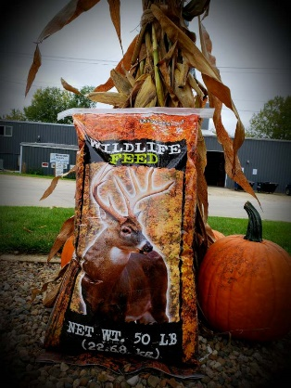
With fall approaching, we decided to try our best at making a new product: Wildlife Feed! Give us a call if you are interested in trying some!

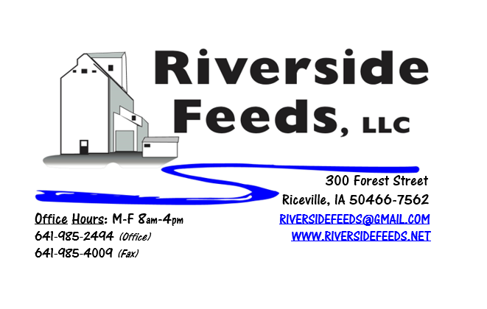
October 2018 Newsletter
Happy October! We hope everyone has a good and safe harvest this fall. Please remember to keep in mind that slowing down and taking your time around machinery will go a lot farther than being involved in any accidents.
What’s Happening:
We have been busy planning this winter’s conference season! Amanda and I will be attending and exhibiting at the following conferences: Iowa Organic Conference, Minnesota Organic Conference, Practical Farmer’s of Iowa Conference, and MOSES Organic Farming Conference. We may even attend a few other meetings and conferences, but these are confirmed at this time for us.
We would also like to remind our local clients that we do offer low cost delivery of product directly to your farm for bagged orders. We do carry and can order many feed ingredients including minerals, limestones, supplements, and additives. If you are not sure if we have something or can order something, please call and check with us. We are a dealer for Fertrell, Crystal Creek, Dr. Paul’s, Smidley, Hall Robert’s Son, and Stutsman. For commonly used items (i.e. calcium carbonate), we may even offer discounts for buying full pallet quantities! Amanda will begin to make more local farm visits and deliveries this fall, so watch for her to be in the local area!
Organic Grain Prices:
Grain prices may bounce up or down a little depending on how harvest takes place nationwide, and early yield reports. Please keep me in touch as you begin to take crops out so we can understand what is out in the country. Corn is now trading in the $10.50 - $11.00 range. Barley is holding steady around $8.50.
Beans are trading between $21.00 - $23.00 a bushel here in the upper Midwest (Feed – Food, respectively, and Wheat is around $8.50 - $9.00. Soybean Meal is up a little, and is trading around $850-$900 per ton.
Events Coming Up:
If there are field days or events that you would like to share with our customer base, please feel free to provide us the information and we will include it in next month’s newsletter! No events are on our schedule for October other than harvest!
Products We Offer:
We are long on organic soy protein (Opro 40), and Non-GMO soy protein (SoyPro 50). Call and check in with me if we can fill any of your needs! I can offer a great deal on the Opro 40 if we can move a full semi load. We are long on Non-GMO Oat Screenings pellets (Not organic) available for sale yet, and can ship that out in bags, totes, or bulk quantities. We have been finding out that these pellets work really well for horses. We can ship any quantity out the door, and usually carry at least a few ton on hand. We also carry organic and conventional Apple Cider Vinegar, either in 4 gallon pails or 55 gallon drums. We do have a supply of organic ACV in 275 gal totes as well. As always, we have a full line of vitamins and minerals and many other ingredients. If you would like to see us carry a certain product on our retail shelf, please let us know and we will certainly consider adding more! We are trying out some “Wildlife Feed” right now for your wildlife needs! This is a pelleted mix offered in 50# bags.
Poultry Feeds:
If anyone needs any chick starter for any late flocks, I do have a few bags left to use up. I’m willing to sell them at a discounted rate, so call soon! Non-GMO Broiler Grower, Non-GMO Poultry Layer, and Suncoast Pine Shavings (OMRI Approved) is on hand at all times. We also have Poultry Grit and Oyster Shells available for retail. Dr. Paul’s Poultry Plus can be used for scours on young birds. We carry this product in half gallon size. We also carry Poultry X as a wormer.
Swine Feeds:
Call today to place your order on any swine feed products. Reminder – we have a minimal production run for our mill, but we could split a few orders up with other customers. Dr. Paul has PigAde (scours) and Swine X (wormer) for your swine health needs! By-O-Reg Plus is made up with a natural oregano essential oil (plus other organic ingredients), and is highly recommended for all stages of swine and poultry. We have started to use this in our Prewean 22 line, and our Non-GMO Poultry Feeds, and seems to be working well. Let us know if you notice any advantages to this.
Bovine Feeds:
I have several bags of Organic Calf Starter 14% Pellets on hand yet. If anyone has some young calves needing a good starter pellet, please let me know and we can get you some bags to try! These pellets are very sturdy and sweet, and I can make this using Non-GMO ingredients as well. (Both organic and Non-GMO calf starter is listed on price sheet) Dr. Paul has MANY items for bovine uses, especially calf start (scours), CGS Remedy (wormer), S&G Pills (wormer for sheep, goats, and calves), and Detox (moldy/toxic feed) for your bovine health needs! If you happen to be treating or processing calves soon, keep us in mind for alternative products to provide. Dull-It should always be used when dehorning calves.
Horse Feeds:
Our new Horse Mix Pellets is on hand in 50# bags, and can be delivered or picked up anytime! This product has been very popular lately with our local accounts. Horse rations can be very complicated, so please consult with me if you have any questions. We can make custom orders. Oat screenings can be a good grain extender and fiber filler for equine. We are long on Non-GMO oat screenings – call today to place your order!
Dr. Paul’s Products:
Our Summer Sales Special for Dr. Paul’s products is now over. We carry a diversified line of his products and can order any special items at any time. Remember to stock early for your needs this coming fall and winter. OLS-M is a great tincture to assist all species with any respiratory issues (pneumonia). Watch for signs of this as the weather begins to change and add stress to all animals.
Used Smidley Livestock Equipment Available:
We are looking for good, used Smidley hog scales and waterers. Current used water fountain supply is VERY limited. We do have a used Sheep Fountain available for sale – First time that I have found one of these used! We can order any brand new Smidley livestock equipment. Smidley makes mineral feeders, steer stuffers, multiple sizes hog feeders (both stainless steel and wood), hog scales, hog huts, and livestock water fountains. We stock a full selection of Smidley livestock water fountain parts!

THANK YOU FOR YOUR BUSINESS!!!
“Revitalizing Industry Byproducts into Livestock Feed by
Recycling Organic and Non-GMO Grain Materials for Family Farmers”

