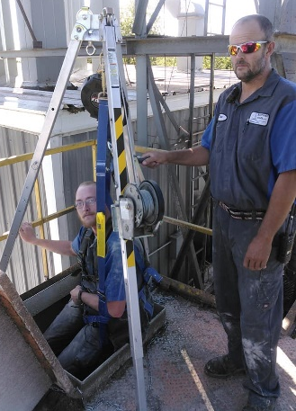
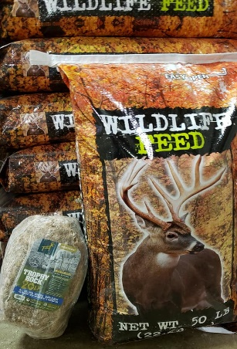

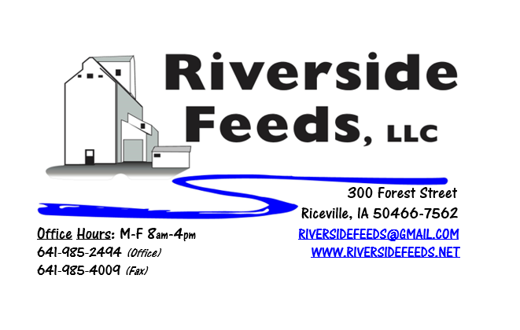
October 2019 Newsletter
Hard to believe it’s fall already! This summer just flew by for us here at Riverside Feeds, but now we are focusing on our fall feed specials. We have a couple stacks of our Wildlife Feed pellets, which is a soy screening, corn, and molasses blended pellet for multiple wildlife species. To accommodate that feed, we also have Redmond’s Trophy Rock available as a retail product. Did you know that all species of animals need salt? Wildlife, including deer, are attracted to this trophy rock for their salt needs. Proper levels of salt will assist with antler growth and development. We sell the Wildlife Feed for $10 per 50# bag, and the Redmond Trophy Rock for $15 (pictured above). Each rock is at least 20# in weight. These rocks have been moving fast, so stop by and stock up before they are all gone!
As the fall harvest nears, we would like to remind all farmers, customers, truck drivers, and public to be safe, take extra time, and remember to slow down. We may get in a hurry with trying to get everything done in a tight schedule but being safe is far better than getting hurt or hurting someone else. Here at Riverside Feeds, we train and practice safety. All operators are trained and certified for forklifts and confined space. Pictured above, a couple of our mill operators practice lowering into one of our overhead bins for confined space training. Using professional equipment including a tripod, cable, fall lifeline cable, body harness, workman’s chair, and 2-way radio communication, we can be lowered down into our overhead bins for cleaning or maintenance purposes. We train and practice this once every year. Some of our bin tanks are over 30’ deep, so this is a job to take seriously.
REMINDER: Saturday Hours are currently by APPOINTMENT ONLY!
Organic Grain Prices:
There seems to be a decent amount of old crop corn still available, and not much is moving right now. Due to this, corn prices have softened a little, but it is hard to say what new crop reports will do to prices this winter. Right now, organic corn is trading in the $8.50 - $9.25 range here in the Midwest.
Beans have fallen due to the low cost imported meal. Organic soybeans are trading between $18.50 - $20.00 a bushel here in the upper Midwest, and Wheat is around $8.50 - $9.75. Domestic organic Soybean Meal is trading around $775-$850 per ton. Barley is around $8.00 - $9.00. Oats are moving in the $4.50 - $6.50 per bushel.
Events Coming Up:
If there are field days or events that you would like to share with our customer base, please feel free to provide us the information and we will include it in next month’s newsletter!
- Please be safe this harvest season! Conference season starts up in November for us.
Products We Offer:
Need soy protein? We have multiple options available right now of Non-GMO Soy Pro 40, Soy Pro 50, and Soy Pro 55! We are willing to negotiate deals on full truck load quantities of these products. If you are running short on roasted beans in your rations this fall, Soy Pro 40 makes a great replacement!
We also have liquid totes of Non-GMO soybean meal and soy oil blend (very wet saturated blend) available at a great price! This is a byproduct from an extruding plant, and we are looking for a home for this. This could be used as a fat source in multiple rations. We also have a couple totes of Non-GMO Soy Oil (no meal blend) available for sale too, and at a great price! This oil can be used as a fat source for multiple species. Call today for more information!
We do have a good supply of Organic Steamed Rolled Oats on hand – Either in 1600# totes, or 50# bags. Call today for your needs – This makes GREAT nursery pig feed.
Poultry Feeds:
Remember that we do offer our Non-GMO Broiler Grower and Layer feeds at Riceville True Value store here in town! We are all cleaned up on Non-GMO Chick Starter and will not make more until spring since that is a seasonal demand. We also have a healthy supply of SunCoast Pine Shavings available for all your bedding needs.
Swine Feeds:
Give us a call for your Organic Prewean 22 feed needs! We stock Non-GMO Starter-Grower and Non-GMO Grower-Finisher pellets on hand in 50# bags! We also carry many swine feed ingredients including organic steamed rolled oats, organic buttermilk powder, organic alfalfa meal, and more!
Bovine Feeds:
We have an organic milk replacer stocked on hand and ready for your use when needed! Redmond has a Beef Mineral mix that we have on hand. We also stock Redmond salt and salt blocks – Check out the price list.
Equine Feeds:
Since we have Non-GMO Soy Oil on hand, consider feeding small amounts of this on top of your horse feed to boost fat levels going into the cold weather. Soy Oil can be poured right on top of any feed, including our oat mill run pellets, which is great fiber source for horses.
Dr. Paul’s Products:
Detox and Detox Plus remedies can help with stomach upsets and grain overload or feed change problems and promotes microbes in rumen and intestine. It is an old Australian recipe including Burdock root, Red Clover Blossoms, Dandelion root, Licorice root, Nettle, Marshmallow root, Ginger, Peppermint, Elder Flower, and Colloidal Carbon.
Used Smidley Livestock Equipment Available:
We do have multiple options available for USED stainless steel hog bars. We have single drinks, 2 drinks, 4 drinks, and a 6 drink available for reasonable prices. These used hog bars are all packed with brand new electrical and plumbing parts.
We can order any brand new Smidley livestock equipment. Smidley makes mineral feeders, steer stuffers, multiple sizes hog feeders (both stainless steel and wood), hog scales, hog huts, and livestock water fountains. We stock a full selection of Smidley livestock water fountain parts! We can also order in any Smidley Feeder parts.
For Sale: Clipper 67D Cleaner with many screens for sale in excellent condition and ready to run. Asking $9,500 OBO. Will clean many different grains and is easy to run. Schlagel Grain Distributor. 8”, double 24 hole swing. $4,000 OBO. Bobcat Backhoe attachment (attaches to Bobcat 2400 Wheel Loader) in very nice condition. $3,000 OBO. Call for more information!

THANK YOU FOR YOUR BUSINESS!!!
“Revitalizing Industry Byproducts into Livestock Feed by
Recycling Organic and Non-GMO Grain Materials for Family Farmers”

