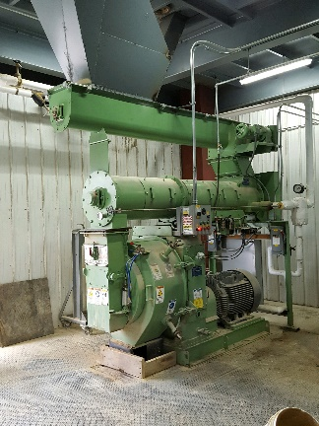
Our CPM 3020-6 Pellet Mill! This machine turns mash feed into round pellets with various die sizes. 150 hp motor spins the 20” diameter by 6” wide die.

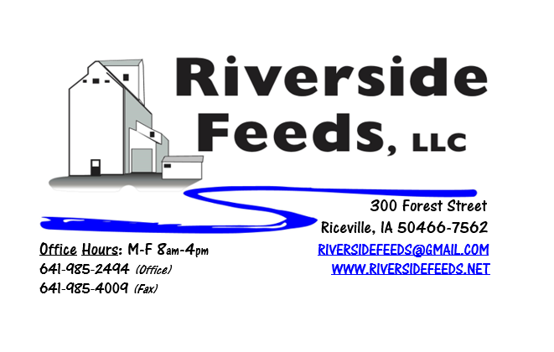
November 2017 Newsletter
Hi everyone! We have been hearing some very good yield reports as harvest has been commencing, however, this season has been going slow due to the wet conditions and tough weather. Please keep me informed on your harvest reports as you take more crops out soon!
What’s Happening:
We have been very busy making feed and feed ingredients around here. We have been taking some time to look over our business performance and goals. In doing so, we have decided due to the high cost of quality labor and increasing overhead costs that we needed to update a few prices of products. Please see the attached Price List carefully as there have been many changes recently. All of these price changes will take place effective November 1, unless if any contracts determines otherwise.
We have also spent some time preparing for this winter’s conference season. I will be traveling to multiple states advertising our business and meeting prospective and active customers. Please read below in the Upcoming Events section to see where you might find me in the coming weeks! While preparing for conferences, we spent some time developing our new business mission statement! You will find this new mission statement at the end of the newsletter!
Organic Grain Prices:
Organic grain prices have been very steady, even though conventional prices continue to drop as harvest nears and has begun in some southern areas. As mentioned above, please let me know how your yields turn out as you take crops out of the fields. I think most areas will have bumper crops, but it is always hard to tell prior to the combines running.
Beans are trading between $18.00 - $20.00 a bushel here in the upper Midwest (Feed – Food, respectively), and corn is trading between $8 - $9 a bushel. Barley is around $8.00, and Wheat is around $8.50 - $9.00. Soybean Meal is trading between $800 - $850 per ton. I have heard reports of a lot of old crop grain in bins (both organic and conventional), and this may impact harvest and prices by a fair margin.
A meeting is being arranged for Wednesday, November 15th, at 7:00 PM at Welsh Family Organic Farm in Lansing, IA, to discuss a new organic grain crop, Hybrid Rye. There will be two production agronomists from Denmark at this meeting explaining the benefits of this crop for soils, crop rotations, and various livestock species. This is a very exciting new product that just hit the United States market this past year! I HIGHLY encourage everyone to make this a priority to attend.
Services We Offer:
Please contact us if you or anyone who you know may be looking for custom pelleting options. Our services now include: Warehousing (including loading dock), Hammer mill, Mixer, Pellet Mill, Crumbler, and load out in either bulk, tote bags, or feed sacks. We also have a fleet of trucks and trailers. After we finish up some projects around here, we will also have grain cleaning capabilities with a Clipper fanning mill, but that will not be until sometime in 2018. We have been receiving many phone calls from large feed and food grade operations looking for custom organic pelleting, and are glad to be available to help fill this demand!
Events Coming Up:
If there are field days or events that you would like to share with our customer base, please feel free to provide us the information and we will include it in next month’s newsletter!
- Organic Farming Conference, Mt. Hope, OH. November 10 – 11. We will have our booth display at this conference, and I will be presenting a workshop on Organic Hogs! Hope to see you there!
- *Hybrid Rye Production and Feeding Meeting at Welsh Family Organic Farm, Lansing, IA. November 15th, 7:00 PM. Please contact Gary Welsh (563) 535-7318 or Tom Frantzen (641) 364-6426 for more information.
- Iowa Organic Conference, Iowa City, IA. November 19 – 20. We will have our booth display at this conference – Please stop by and check us out!
Products We Offer:
We have just recently moved a large amount of protein, and now have a steady supply of Opro 40 and Opro 50 product. We have an endless supply of either organic or Non-GMO Ground Oat Screenings (pelleted). These screenings have very good nutritional tests. We are ramping up our production of both organic and non-gmo soy hulls, so if you need some alternative soy pellets as a feed ingredient, please give me a call today. We do carry organic and conventional Apple Cider Vinegar, either in 4 gallon pails or 55 gallon drums. As always, we have a full line of vitamins and minerals. I do carry Organic Liquid Molasses in 50# pails. We also carry Crystal Creek “No-Fly” on hand. Otherwise, orders can be placed through us for any Crystal Creek or Smidley Equipment products.
Poultry Feeds:
Our poultry feeds are all in crumbled form. We offer Broiler Starter (spring seasonal item), Broiler Grower, Poultry Layer, and Suncoast Pine Shavings (OMRI Approved). We are still looking for a perfect mixture of grains to bag off and sell as “scratch grains”, but haven’t had much luck yet. This is a priority for us since winter is approaching and scratch grains are a great treat for birds!
Swine Feeds:
Pre-wean 22 pig feed pellets make a GREAT starter creep feed pellet for young pigs and should be offered especially during colder winter farrowing months. We carry a few bags on hand, but larger orders must be requested and given a few days in order to work into our schedule to make. We are able to grind, mix, and pellet any swine feed rations – either Non-GMO or Organic. It is too hard to keep complete feed fresh, so we do not carry hog feeds on hand in inventory. This is a custom mixed ration for everyone, so timely ordering on swine feeds is important.
Used Smidley Equipment Available:
Single drinker, single sided (1 hole) – We have 6 on hand.
Single drinker, double sided (2 hole) – We have 0 on hand.
Double drinker, double sided (4 hole) – 1 on hand.
Triple drinker, double sided – (6 hole) – 1 on hand
We are looking for good, used Smidley hog scales. We can also order any brand new Smidley equipment, but they are way behind on manufacturing, so it may take a couple months to get a new feeder or piece of equipment. Please call for pricing on the used drinkers.

THANK YOU FOR YOUR BUSINESS!!!
“Revitalizing Industry Byproducts into Livestock Feed by
Recycling Organic and Non-GMO Grain Materials for Family Farmers”
*Please see attached price sheet for current prices on products. Please call the office with any orders or questions.
** If any farmers or other customers would like to offer some industry or production information, please feel free to contact me about including a short article in our monthly newsletter!

