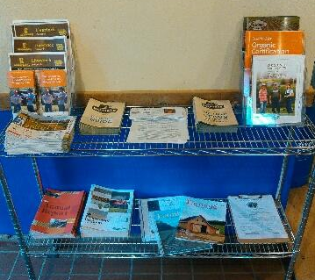
Our front office features PFI research articles, MOSA Organic Certification information, Organic Farming Directories, Redmond Agriculture fliers, among other useful educational information.

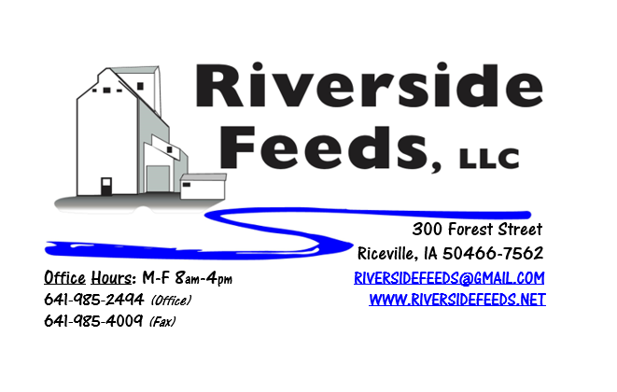
November 2018 Newsletter
Happy fall! As harvest reports have come in across Iowa and the Upper Midwest, we STRONGLY encourage you to test your corn and soybeans for aflatoxins. Due to the excessive wet weather we had during the growing season, we have heard of toxins in both of these grains, especially in central Iowa. If you have any questions about toxins and the dangers they have when feeding to livestock, please give us a call.
What’s Happening:
EARLY REMINDER: Winter is coming, and that means winter driving hazards will slow our trucks down. Please keep winter weather conditions in mind as we are human. We strongly prefer to work around Mother Nature and not be involved in accidents or stressful situations. We also would like to remind you about the holiday seasons that are approaching. Please take note to the attached document stating our Holiday hours. Since the holidays hit the beginning of the work week this year, we will need YOUR HELP to assist us in timely orders and proper scheduling. Our employees have family gatherings and plans, and we will be very short handed during the holidays. Your cooperation will be greatly appreciated! We are simply asking for a very simple rule with this winter reminder: PLEASE ORDER EARLY!!!!
We are preparing for a very busy winter conference season! Please keep us notified if you will be attending any farming conferences, so we can meet up with you. We may even be able to bring a small amount of product with us if you preorder!
We have recently been building up supply and making orders on more bagged ingredient products. If you have any interest in minerals/vitamins/additives, we are a dealer for multiple companies and can provide your needs. We are a dealer for Fertrell, Crystal Creek, Dr. Paul’s, Smidley, Hall Robert’s Son, and Stutsman. For commonly used items (i.e. calcium carbonate), we may even offer discounts for buying full pallet quantities! Amanda will begin to make more local farm visits and deliveries this fall, so watch for her to be in the local area!
Organic Grain Prices:
Grain prices may bounce up or down a little depending on how harvest takes place nationwide, and early yield reports. Please keep me in touch as you begin to take crops out so we can understand what is out in the country. Corn is now trading in the $10.50 - $11.00 range. Barley is holding steady around $8.50.
Beans have fallen due to the low cost imported meal. Organic soybeans are trading between $17.00 - $19.00 a bushel here in the upper Midwest, and Wheat is around $8.50 - $9.00. Domestic organic Soybean Meal is trading around $850-$900 per ton.
Events Coming Up:
If there are field days or events that you would like to share with our customer base, please feel free to provide us the information and we will include it in next month’s newsletter!
- Iowa Organic Conference – Iowa City, IA, November 18th & 19th. Amanda and I will be present with our display booth! This will be at Memorial Union. Contact us for more details!

Products We Offer:
We are long on Non-GMO Oat Screenings pellets (Not organic) available for sale yet, and can ship that out in bags, totes, or bulk quantities. We have been finding out that these pellets work really well for horses. We can ship any quantity out the door, and usually carry at least a few ton on hand. We are trying out some “Wildlife Feed” right now for your wildlife needs! This is a pelleted mix offered in 50# bags.
Poultry Feeds:
If anyone needs any chick starter for any late flocks, I do have a few bags left to use up. I’m willing to sell them at a discounted rate, so call soon! Non-GMO Broiler Grower, Non-GMO Poultry Layer, and Suncoast Pine Shavings (OMRI Approved) is on hand at all times. We also have Poultry Grit and Oyster Shells available for retail. Dr. Paul’s Poultry Plus can be used for scours on young birds. We carry this product in half gallon size. We also carry Poultry X as a wormer.
Swine Feeds:
Call today to place your order on any swine feed products. Reminder – we have a minimal production run for our mill, but we could split a few orders up with other customers. Dr. Paul has PigAde (scours) and Swine X (wormer) for your swine health needs! By-O-Reg Plus is made up with a natural oregano essential oil (plus other organic ingredients), and is highly recommended for all stages of swine and poultry. We have started to use this in our Prewean 22 line, and our Non-GMO Poultry Feeds, and seems to be working well. Let us know if you notice any advantages to this.
Bovine Feeds:
Call for your bovine needs! We have multiple rations and many ingredients available, depending on supply. Dr. Paul has MANY items for bovine uses, especially calf start (scours), CGS Remedy (wormer), S&G Pills (wormer for sheep, goats, and calves), and Detox (moldy/toxic feed) for your bovine health needs! If you happen to be treating or processing calves soon, keep us in mind for alternative products to provide. Dull-It should always be used when dehorning calves. We HIGHLY recommend using the CGS Remedy as a wormer – it worked VERY well on our calves this past spring!
Horse Feeds:
Our new Horse Mix Pellets is on hand in 50# bags, and can be delivered or picked up anytime! This product has been very popular lately with our local accounts. Horse rations can be very complicated, so please consult with me if you have any questions. We can make custom orders. Oat screenings can be a good grain extender and fiber filler for equine. We are long on Non-GMO oat screenings – call today to place your order! We are creating a new brochure for our Equine products for our conference season!
Dr. Paul’s Products:
We carry a diversified line of his products and can order any special items at any time. Remember to stock early for your needs this coming fall and winter. Comfrey is a great bone healing tincture. If you have any animals with a broken leg or any bone, use Comfrey.
Used Smidley Livestock Equipment Available:
We do have a few more hog water bars on hand. We can order any brand new Smidley livestock equipment. Smidley makes mineral feeders, steer stuffers, multiple sizes hog feeders (both stainless steel and wood), hog scales, hog huts, and livestock water fountains. We stock a full selection of Smidley livestock water fountain parts!

THANK YOU FOR YOUR BUSINESS!!!
“Revitalizing Industry Byproducts into Livestock Feed by
Recycling Organic and Non-GMO Grain Materials for Family Farmers”

