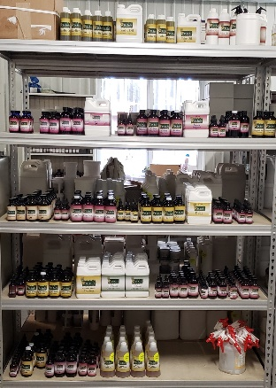
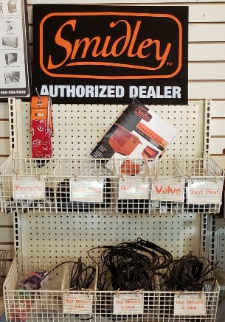

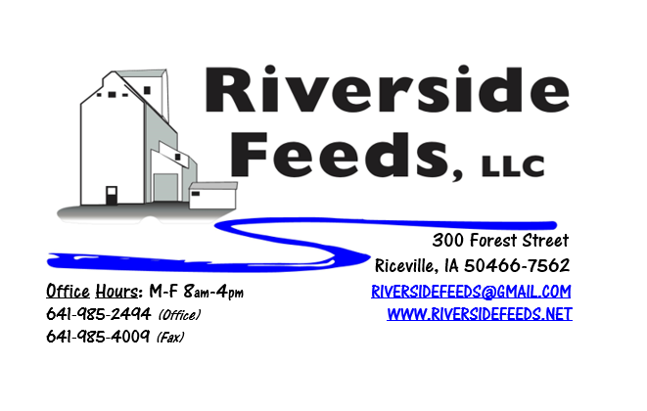
November 2019 Newsletter
Happy Fall! It’s amazing to see how fast these past few months have gone by, and soon we will be celebrating all our accomplishments as we close the books to another successful year! As the warmer months leave us and cold weather sets in, please keep in mind that we are a Smidley livestock equipment dealer. Livestock need clean, fresh water every day, and keeping water thawed out during the winter months can be a chore. Older livestock water fountains may need new electrical heating parts after years of use, and fortunately, Riverside Feeds is very well stocked for all your Smidley fountain parts! As you can see in the picture above, we have a very healthy supply of electrical and plumbing parts to fit any and all Smidley fountains.
Amanda and I had the wonderful opportunity to drive through some beautiful country recently and visited Dr. Paul’s Lab in Mazomanie, WI! We were beyond impressed with our visit, as we toured the new warehouse and manufacturing facility. Dr. Paul’s Lab is heavily stocked with every item available, ready to ship for urgent orders any day of the week. The picture above is one of many shelves of product, this one containing tinctures for animal health.
Enclosed you should find a copy of Dr. Paul’s Fall Newsletter. As mentioned in the newsletter, Dr. Paul’s Lab produced a couple new items! Please read this newsletter to find out about two new great products – CEG Switchel and Garlic Oil. We are pleased to announce that we carry both products on our shelf! We also now stock Dr. Paul’s 1-gallon jug of Organic Apple Cider Vinegar for those who are looking for smaller amounts.
Also enclosed, you should find some of our recent local paper ads. This marketing work is all done in house by Amanda Luna. She is very talented, and we are proud to show these ads off!
Organic Grain Prices:
There seems to be a decent amount of old crop corn still available, and not much is moving right now. Due to this, corn prices have softened a little, but it is hard to say what new crop reports will do to prices this winter. Right now, organic corn is trading in the $8.75 - $9.75 range here in the Midwest. New crop organic corn is coming out late and slow this year. Not much news yet on new crop prices and yields.
Beans have fallen due to the low cost imported meal. Organic soybeans are trading between $18.50 - $20.00 a bushel here in the upper Midwest (feed grade), and Wheat is around $8.50 - $9.75. Domestic organic Soybean Meal is trading around $775-$850 per ton. Barley is around $8.00 - $9.00. Oats are moving in the $4.50 - $6.50 per bushel.
Events Coming Up:
If there are field days or events that you would like to share with our customer base, please feel free to provide us the information and we will include it in next month’s newsletter!
- Iowa Organic Conference, Iowa City, IA. Memorial Union. November 17th & 18th. We will be present with our exhibit booth!
- We have a very busy January coming up for conferences, see next month’s newsletter for where we will be traveling to.
Products We Offer:
Need soy protein? We have multiple options available right now of Non-GMO Soy Pro 40, Soy Pro 50, and Soy Pro 55! We are willing to negotiate deals on full truck load quantities of these products. If you are running short on roasted beans in your rations this fall, Soy Pro 40 makes a great replacement!
We also have liquid totes of Non-GMO soybean meal and soy oil blend (very wet saturated blend) available at a great price! This is a byproduct from an extruding plant, and we are looking for a home for this. This could be used as a fat source in multiple rations. We also have a couple totes of Non-GMO Soy Oil (no meal blend) available for sale too. This oil can be used as a fat source for multiple species. Call today for more information!
Poultry Feeds:
SunCoast Pine Shavings make great bedding packs in nesting boxes for poultry. Consider stocking up on a few extra bags of shavings to keep your birds warm this winter! As always, our Layer and Broiler Grower feeds are always on hand.
Swine Feeds:
Currently in stock: Non-GMO Swine Starter-Grower Pellets, Non-GMO Swine Grower-Finisher Pellets, and Organic Prewean 22 Pellets. We also carry many swine feed ingredients including organic steamed rolled oats, organic buttermilk powder, organic alfalfa meal, and more!
Bovine Feeds:
We have an organic milk replacer stocked on hand and ready for your use when needed! Our organic buttermilk powder can be used as a cheap milk replacer for young animals. Redmond has a Beef Mineral mix that we have on hand. We also stock Redmond salt and salt blocks.
Equine Feeds:
Since we have Non-GMO Soy Oil on hand, consider feeding small amounts of this on top of your horse feed to boost fat levels going into the cold weather. Soy Oil can be poured right on top of any feed, including our oat mill run pellets, which is great fiber source for horses.
Dr. Paul’s Products:
Our exhibit booth this winter at various farming conferences will include the new Dr. Paul’s Lab Catalog! This well illustrated catalog is a must have for those who are looking for alternative treatments. If you would like to receive a free catalog in the mail from us, please give us a call.
Used Smidley Livestock Equipment Available:
We do have multiple options available for USED stainless steel hog bars. We have single drinks, 2 drinks, 4 drinks, and a 6 drink available for reasonable prices. These used hog bars are all packed with brand new electrical and plumbing parts.
We can order any brand new Smidley livestock equipment. Smidley makes mineral feeders, steer stuffers, multiple sizes hog feeders (both stainless steel and wood), hog scales, hog huts, and livestock water fountains. We stock a full selection of Smidley livestock water fountain parts! We can also order in any Smidley Feeder parts.
For Sale: Clipper 67D Cleaner with many screens for sale in excellent condition and ready to run. Asking $9,500 OBO. Will clean many different grains and is easy to run. Schlagel Grain Distributor. 8”, double 24 hole swing. $4,000 OBO. Bobcat Backhoe attachment (attaches to Bobcat 2400 Wheel Loader) in very nice condition. $3,000 OBO. Call for more information!

THANK YOU FOR YOUR BUSINESS!!!
“Revitalizing Industry Byproducts into Livestock Feed by
Recycling Organic and Non-GMO Grain Materials for Family Farmers”

