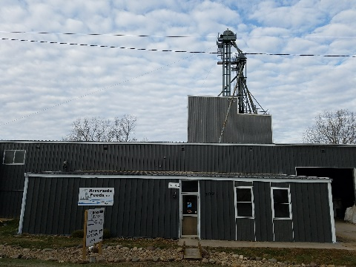
We recently painted the old part of our building (original warehouse that was built in 1975). This is the horizontal part of the building facing towards Forest Street.

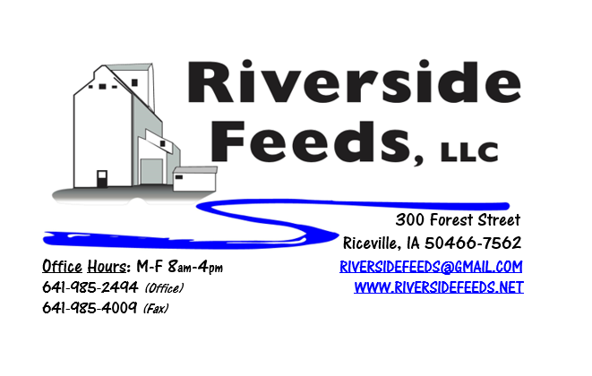
December 2017 Newsletter
Hi everyone! We are pleased to hear great reports on crops throughout the Midwest! I personally feel very strong that the organic crop prices will remain steady going through this winter. We are also enjoying the nice weather that we are experiencing, and getting some last minute jobs done before winter arrives!
What’s Happening:
We have been focusing on creating a customer friendly business in multiple ways. As a long term goal, I always wanted to keep a good curbside appeal, and after years of waiting, we finally painted the front side of the building (facing Forest Street) to match the new construction from last year. This looks a lot better, and our neighbors greatly appreciate this! We are also in the process of updating our website. This takes a lot of time, but we want to make sure that everything listed on our website is up to date, easy to understand, and user friendly. Please check our website out when you have time, at www.riversidefeeds.net. We have also created a Mission Statement last month, and will be marketing this throughout the conference season this year and on our website.
We are waiting for our updated organic certificate to come. As soon as we have this, we will send a copy out in the newsletter to all of our customers, and post on the website.
Organic Grain Prices:
Organic grain prices should remain fairly steady this winter as harvest reports came in very high. I have not heard any reports of grain prices going up or down at this time.
Beans are trading between $18.00 - $20.00 a bushel here in the upper Midwest (Feed – Food, respectively), and corn is trading between $7.50 - $8.50 a bushel. Barley is around $8.00, and Wheat is around $8.50. Soybean Meal is trading between $800 - $825 per ton.
Services We Offer:
Please contact us if you or anyone who you know may be looking for custom pelleting options. Our services now include: Warehousing (including loading dock), Hammer mill, Mixer, Pellet Mill, Crumbler, and load out in either bulk, tote bags, or feed sacks. We also have a fleet of trucks and trailers. After we finish up some projects around here, we will also have grain cleaning capabilities with a Clipper fanning mill, but that will not be until sometime in 2018. We have been receiving many phone calls from large feed and food grade operations looking for custom organic pelleting, and are glad to be available to help fill this demand!
Events Coming Up:
If there are field days or events that you would like to share with our customer base, please feel free to provide us the information and we will include it in next month’s newsletter!
- Nothing scheduled in December – Enjoy the holidays!
- Minnesota Organic Conference, St. Cloud, MN. January 11th & 12th. We will have our booth display at this conference – Hope to see you there!
- Practical Farmers of Iowa Annual Conference, Ames, IA. January 18th – 20th. We will be exhibiting at this conference as well! Our very own part time feed mill operator, Bob Owen, will be speaking at this conference on swine genetics! We are very excited to hear from Bob!
Products We Offer:
We are running short on all inventories. Sales have been very good recently, and we have a large demand for many products. We are focusing on selling our custom services (grinding, mixing, pelleting) now. We do have more Non-GMO Oat Screenings pellets (Not organic) available for sale yet. We do carry organic and conventional Apple Cider Vinegar, either in 4 gallon pails or 55 gallon drums. As always, we have a full line of vitamins and minerals. I do carry Organic Liquid Molasses in 50# pails. We also carry Crystal Creek “No-Fly” on hand. Otherwise, orders can be placed through us for any Crystal Creek or Smidley Equipment products.
Poultry Feeds:
Our poultry feeds are all in crumbled form. We offer Broiler Starter (spring seasonal item), Broiler Grower, Poultry Layer, and Suncoast Pine Shavings (OMRI Approved). We are still looking for a perfect mixture of grains to bag off and sell as “scratch grains”, but haven’t had much luck yet. This is a priority for us since winter is approaching and scratch grains are a great treat for birds!
Swine Feeds:
Pre-wean 22 pig feed pellets make a GREAT starter creep feed pellet for young pigs and should be offered especially during colder winter farrowing months. We carry a few bags on hand, but larger orders must be requested and given a few days in order to work into our schedule to make. We are able to grind, mix, and pellet any swine feed rations – either Non-GMO or Organic. It is too hard to keep complete feed fresh, so we do not carry hog feeds on hand in inventory. This is a custom mixed ration for everyone, so timely ordering on swine feeds is important.

*REMINDER: Please be patient with our busy milling schedule. We GREATLY appreciate orders being placed with at least a 48 hour window of outbound logistics. Orders being placed in less than 48 hour time frame may not be available to fit into our schedule.
Used Smidley Equipment Available:
Single drinker, single sided (1 hole) – We have 2 on hand.
Single drinker, double sided (2 hole) – We have 0 on hand.
Double drinker, double sided (4 hole) – 1 on hand.
Triple drinker, double sided – (6 hole) – 1 on hand
We are looking for good, used Smidley hog scales. We can also order any brand new Smidley equipment, but they are way behind on manufacturing, so it may take a couple months to get a new feeder or piece of equipment. Please call for pricing on the used drinkers.

THANK YOU FOR YOUR BUSINESS!!!
“Revitalizing Industry Byproducts into Livestock Feed by
Recycling Organic and Non-GMO Grain Materials for Family Farmers”
*Please see attached price sheet for current prices on products. Please call the office with any orders or questions.
** If any farmers or other customers would like to offer some industry or production information, please feel free to contact me about including a short article in our monthly newsletter!

