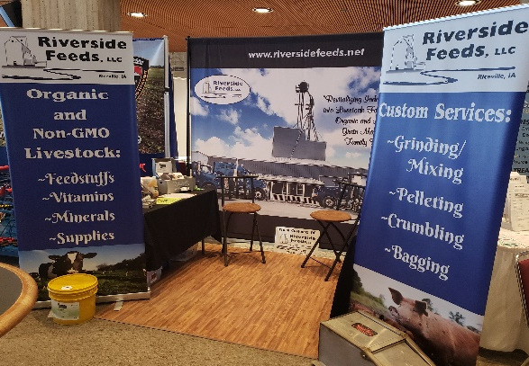

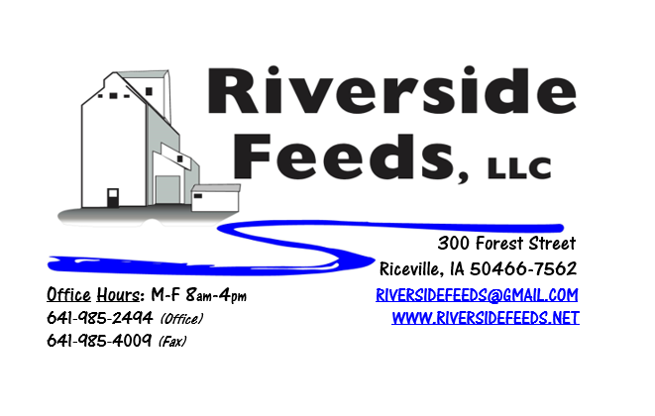
February 2019 Newsletter
We have been very busy traveling last month to a few different farming conferences, including as pictured Practical Farmer’s of Iowa annual meeting in Ames, IA! There, we met with over a thousand people who are looking for sustainable methods of farming.
What’s Happening:
Last week, we experienced some of the coldest wind chill and air temperatures in recorded history here in Northern Iowa. We were forced to shut down for a little over a day. Thank you for allowing us to maneuver some orders around on the schedule. PLEASE keep in mind that when it gets cold, our trucks, equipment, and employees move a lot slower! It can be challenging for us to keep up with orders, and we need some flexibility. We would like to remind everyone about our urgency charge policy for any orders placed and expected to be picked up or delivered less than 48 hours. We need respectable amount of time to get to your orders and turn them out the door. Remember, we only have one mill!
We are making plans right now to add more overhead bins to our pellet mill this spring! We currently have 125 tons worth of finished product storage, and after the new bins are installed, we will have around 400 tons of storage. This is critical for our pellet mill to have enough space to keep running all three shifts. Lately (over the past two months), we have been running non stop Monday through Friday, unless if we are out of bin space, which is our limiting factor. Our efficiencies and ability to meet large orders will be greatly improved after these bins are in place. Please keep this in mind as we will be very busy with construction this spring.
We are also gearing up for a very exciting new conference this spring! Iowa Organic Association will be putting on the first ever “Midwest Organic Pork Conference” in Waterloo, Iowa! This conference needs attendees and exhibitors to get the first year off to a great start! Attached you should find a flier announcing some of the speakers and topics to be discussed! If interested, please register to attend. If you have any questions, please feel free to ask me.

Organic Grain Prices:
Organic corn is now trading in the $9.75 - $10.50 range. Barley is holding steady around $8.50.
Beans have fallen due to the low cost imported meal. Organic soybeans are trading between $17.00 - $19.00 a bushel here in the upper Midwest, and Wheat is around $8.50 - $9.00. Domestic organic Soybean Meal is trading around $775-$850 per ton. BE CATIOUS OF TOXINS!!! If you have any questions about toxins and molds, send a sample to the lab and consult with an expert. We have heard many reports of disastrous toxin levels in soybeans and corn (primarily vomitoxin), especially in central Iowa. Toxins are produced from wet weather and conditions during the growing season. If you have questions about toxins in your feed products, please give me a call.
Events Coming Up:
If there are field days or events that you would like to share with our customer base, please feel free to provide us the information and we will include it in next month’s newsletter!
- Organic Farming Conference, LaCrosse, WI. February 21 – 23, 2019.
- Midwest Organic Pork Conference, Waterloo, IA. March 8 – 9, 2019. (See attachment)
We will have an exhibit booth at both conferences! Stop by and say hello! Our exhibit booths will have plenty of information available to hand out including price lists, newsletters, brochures, and possibly extra goodies! As mentioned, you may place small orders prior to these events and we can bring these orders with us.
Products We Offer:
We are long on Non-GMO soy proteins (Not organic) available for sale yet, and can ship that out in bags, totes, or bulk quantities. We are especially long on Soy Pro 40 at this time, which is a high fat protein (excellent to feed in cold weather). Also remember that we have Redmond salt on hand, as well as many other minerals, vitamins, and micro ingredients.
Poultry Feeds:
Poultry may need additional sources of protein during the winter months. Providing high quality alfalfa may be a generous offer to those birds now since they don’t have access to green pastures. We also have Soy Pro 40 protein available that can be supplemented in their feeders. That protein is also high in fat, which may be beneficial during these colder temps. We will make a fresh batch of Chick Starter when spring gets closer. We will also be updating our poultry rations this spring!
Swine Feeds:
We have a good supply of Organic Prewean 22 on hand and ready to send out. Young piglets really need a high quality diet to get started on, especially during these colder months. This creep feed ration is loaded with a diverse amount of high quality ingredients to enhance the early start for pigs. Stay tuned this spring for new line of Non-GMO swine feeds to be available at all times!
Bovine Feeds:
Keep in mind the benefits of Aloe Pellets and high energy sources like Molasses when feeding calves and any bovine during colder and varying temperatures. Aloe Pellets can help with fevers, pneumonia, and stress. Fall calves tend to struggle a little harder this time of the year due to the changing weather conditions. Keep a close watch over their health and performance, and keep in mind that calf blankets can be very beneficial in this cold weather! We do have some Organic Calf Starter Pellets freshly made up and on hand now.
Horse Feeds:
We have a good supply of our complete Non-GMO Horse Pellets on hand, which have been working great for work horses. This product includes minerals and molasses, among a list of ingredients. We also have oat screening pellets available in bags, totes, or bulk. This has been working very well to replace expensive hay currently.
Dr. Paul’s Products:
We carry a diversified line of his products and can order any special items at any time. Remember to stock early for your needs this coming fall and winter. Calf Ease Bolus is an effective way to treat scours and strengthen immune systems on individual calves. These boluses come in 30 count containers.
Used Smidley Livestock Equipment Available:
We do have some 4 drink hog bars on hand, and a cattle mineral feeder. We can order any brand new Smidley livestock equipment. Smidley makes mineral feeders, steer stuffers, multiple sizes hog feeders (both stainless steel and wood), hog scales, hog huts, and livestock water fountains. We stock a full selection of Smidley livestock water fountain parts!

THANK YOU FOR YOUR BUSINESS!!!
“Revitalizing Industry Byproducts into Livestock Feed by
Recycling Organic and Non-GMO Grain Materials for Family Farmers”

