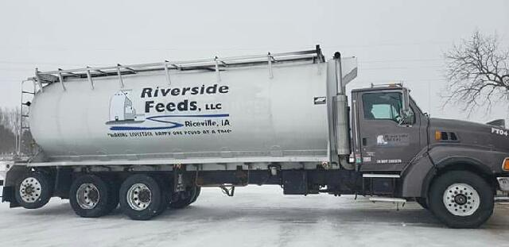

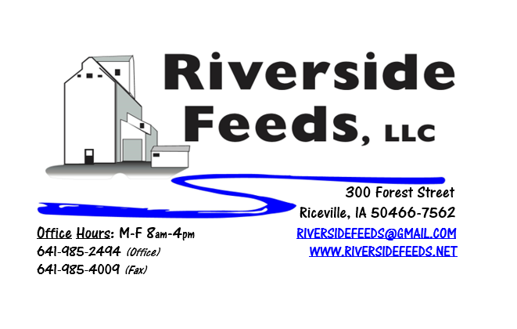
February 2020 Newsletter
Hello everyone! THANK YOU to all our customers, vendors, and dedicated staff for allowing Amanda and myself to take some much-needed time off for our vacation over the holidays! While we enjoyed the warm weather and gorgeous sights in Hawaii, we decided to get married! Amanda and I have been together for several years now, and she has been working directly for Riverside Feeds for some time. You may see her attend some of our winter farming conferences with me. Again, we GREATLY appreciated the time off to relax and refresh ourselves before getting busy in a new year!
In addition to this exciting news, we also made the needed investment in a newer feed truck for our business. This new truck is in far better mechanical condition than our older unit and is slightly larger in size. With this upgrade, we can haul up to 18 tons of product at a time, with 7 separate compartments. You should see this new truck making local deliveries from now on.
Please see the enclosed flier advertising the 2nd Annual Organic Swine Conference coming up in early March. We are very excited for this new farming conference, and we are a major sponsor for this event again. This conference is in its infant stage, and needs sponsors, exhibitors, and attendees. Please consider this conference if you feel it would be beneficial to learn more about organic swine production. If you have any questions about this conference, feel free to call our office and ask myself or Amanda.
Redmond Agriculture will be back in town this March! Redmond would like to put on a production meeting again this coming March 26th right here in Riceville at the community center. We would like to cover multiple topics including some of their new products including “Pest Guard”, animal products, human products, and soil amendment products. This meeting should be very energetic, as it will take place only a week after Amanda and I return from Redmond, Utah, on a dealer’s meeting. We are looking forward to traveling to Utah in mid-March to visit Redmond’s production facilities and tour the 17 miles of underground salt mines! Following this in person meeting, we will have fresh knowledge and excitement about Redmond’s products. We will have a very busy and fun March coming up this year!
Organic Grain Prices:
Reminder: I have heard many reports of large amounts of organic grain available in this country. Organic corn is falling in price, and small grains may drop soon as well. Soybeans are holding steady at $18.50 - $19.50 feed grade, $21-$23 food grade.
Events Coming Up:
If there are field days or events that you would like to share with our customer base, please feel free to provide us the information and we will include it in next month’s newsletter! We will be attending the following conferences with our exhibit booth:
- Organic Farming Conference, February 27th – 29th, La Crosse, WI
- Organic Swine Conference, March 13th – 14th, Dubuque, IA
- Redmond Agriculture production meeting, March 26th, Riceville, IA
Products Available:
Need soy protein? We have multiple options available right now of Non-GMO Soy Pro 40, Soy Pro 50, and Soy Pro 55! We are willing to negotiate deals on full truck load quantities of these products. If you are running short on roasted beans or a good fat source in your rations this winter, Soy Pro 40 makes a great replacement!
We also have liquid totes of Non-GMO soybean meal and soy oil blend (very wet saturated blend) available at a great price. This is a byproduct from an extruding plant, and we are looking for a home for this. This could be used as a fat source in multiple rations. We also have a couple totes of Non-GMO Soy Oil (no meal blend) available for sale too. This oil can be used as a fat source for multiple species. Call today for more information!
We have a steady supply of Non-GMO Soy Hulls available to move. Consider using soy hulls as a replacement for the shorted Oat Mill Run Pellets! Please call us with your needs on Non-GMO Oat Mill Run Pellets, as the list is very limited.
Complete Feeds:
We have multiple feeds on hand and ready for you to pick up anytime. This includes our Non-GMO Poultry and swine feed pellets, Organic Prewean 22 pig feed pellets, and Non-GMO Horse Mix Pellets. We also carry MANY ingredients to make your own feed, including organic steamed rolled oats, organic buttermilk powder, organic alfalfa meal, and many vitamins and minerals.
Retail Products:
Our exhibit booth this winter at various farming conferences will include the new Dr. Paul’s Lab Catalog! This well illustrated catalog is a must have for those who are looking for alternative treatments. If you would like to receive a free catalog in the mail from us, please give us a call.
We have been moving many bags of Dr. Paul’s Aloe Pellets over the past few weeks. Keep Aloe pellets in mind for building immune systems and to reduce stress with changing temperatures and humidity, and transport fevers. We just got a fresh shipment of Aloe Pellets in last week!
We also carry Redmond, Crystal Creek, Dr. Sarah’s Essentials, and Apple Cider Vinegar on hand for other retail options. Stop by and look at our full line of products!
Used Smidley Livestock Equipment Available:
We do have multiple options available for USED stainless steel hog bars. We have single drinks, 2 drinks, 4 drinks, and a 6 drink available for reasonable prices. These used hog bars are all packed with brand new electrical and plumbing parts.
We can order any brand new Smidley livestock equipment. Smidley makes mineral feeders, steer stuffers, multiple sizes hog feeders (both stainless steel and wood), hog scales, hog huts, and livestock water fountains. We stock a full selection of Smidley livestock water fountain parts! We can also order in any Smidley Feeder parts.
For Sale: Clipper 67D Cleaner with many screens for sale in excellent condition and ready to run. Asking $8,500 OBO. Will clean many different grains and is easy to run. Schlagel Grain Distributor. 8”, double 24 hole swing. $2,000 OBO. Call for more information!

THANK YOU FOR YOUR BUSINESS!!!
“Revitalizing Industry Byproducts into Livestock Feed by
Recycling Organic and Non-GMO Grain Materials for Family Farmers”

