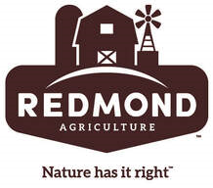

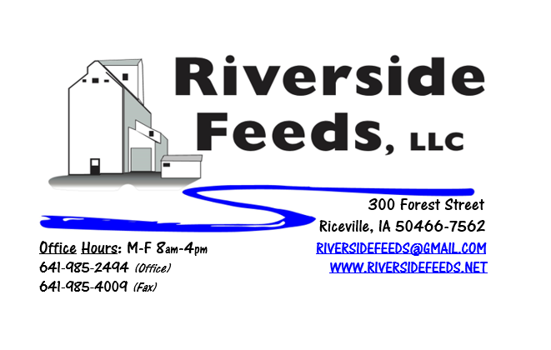
March 2020 Newsletter
Are you ready for Spring? We have been fortunate to have an average winter here in Northern Iowa but are also very eager to see spring come and a new growing season begin! In preparations for a new and better farming year, we would like to extend an invite to our Redmond Agriculture production meeting, which will be held right here in Riceville, Iowa, on Thursday, March 26th! This meeting will take place at the Riceville Community Center from 10:30 AM – 2:30 PM with lunch provided, and is sponsored by Riverside Feeds, Redmond Agriculture, and Hall Robert’s Son. Redmond has many products to offer towards nutritional and health advantages for animals, humans, and soil. Being a Redmond dealer, Amanda and I will be traveling to Utah one week prior to this meeting to tour the salt mines and production facilities! We will have fresh and full knowledge when we return for the local meeting! We will also be highlighting Redmond’s newest products, including “Pest Guard”, which is a garlic flavored salt for ruminant animals. This OMRI Approved product will help reduce flies on livestock, which can also slow down pink eye problems in cattle. Next month’s newsletter will have more information about this product.
Please see the enclosed flier advertising the 2nd Annual Organic Swine Conference coming up in early March. We are very excited for this new farming conference, and we are a major sponsor for this event again. This conference is in its infant stage, and needs sponsors, exhibitors, and attendees. Please consider this conference if you feel it would be beneficial to learn more about organic swine production. If you have any questions about this conference, feel free to call our office and ask myself or Amanda. This year’s agenda looks to be very engaging with a wide array of organic pork topics, including a keynote from the one and only Dr. Paul Dettloff!
Organic Grain Prices:
Reminder: I have heard many reports of large amounts of organic grain available in this country. Organic corn is falling in price and is running in the $7 range now, and small grains may drop soon as well. Soybeans are holding steady at $18.00 - $19.00 feed grade, $20-$22 food grade.
Events Coming Up:
If there are field days or events that you would like to share with our customer base, please feel free to provide us the information and we will include it in next month’s newsletter! We will be attending the following conferences with our exhibit booth:
- Organic Farming Conference, February 27th – 29th, La Crosse, WI
- Organic Swine Conference, March 13th – 14th, Dubuque, IA
- Redmond Agriculture production meeting, March 26th, Riceville, IA
Products Available:
Need soy protein? We have multiple options available right now of Non-GMO Soy Pro 40, Soy Pro 50, and Soy Pro 55! We are willing to negotiate deals on full truck load quantities of these products. If you are running short on roasted beans or a good fat source in your rations this winter, Soy Pro 40 makes a great replacement!
We also have liquid totes of Non-GMO soybean meal and soy oil blend (very wet saturated blend) available at a great price. This is a byproduct from an extruding plant, and we are looking for a home for this. This could be used as a fat source in multiple rations. Call today for more information!
We are running very long on Non-GMO Soy Hulls (Rumapro). We are eager to move more loads of this and have reduced the price slightly on this product line. If you can use soy hull pellets in your cattle rations, consider this as a great way to add in alternative proteins and fiber sources.
Non-GMO Oat Mill Run Pellets are beginning to build back up in supply slowly. If you need product, please let us know in advance and we should be able to work your order in within a short amount of time.
Complete Feeds:
We have multiple feeds on hand and ready for you to pick up anytime. This includes our Non-GMO Poultry and swine feed pellets, Organic Prewean 22 pig feed pellets, and Non-GMO Horse Mix Pellets. We also carry MANY ingredients to make your own feed, including organic steamed rolled oats, organic buttermilk powder, organic alfalfa meal or pellets, Dr. Paul’s Aloe Pellets, and many vitamins and minerals. We have additional supply of organic steamed rolled oats on hand and have reduced the price on this product as well! We can offer steamed rolled oats in 1600# totes or 50# sacks.
Retail Products:
Our exhibit booth this winter at various farming conferences will include the new Dr. Paul’s Lab Catalog! This well illustrated catalog is a must have for those who are looking for alternative treatments. If you would like to receive a free catalog in the mail from us, please give us a call.
Multiple tinctures have been selling off the shelf recently. As the winter fades away and spring comes, weather changes can take a serious toll on young stock health and immune systems. We have a very healthy stock of tinctures in multiple sizes available for all species. If you have specific health issues, consult with our team or Dr. Paul’s Lab, and swing by to stock up on your needed products!
We also carry Redmond, Crystal Creek, Dr. Sarah’s Essentials, Smidley, SunCoast, PyGanic, Fertrell, and Apple Cider Vinegar on hand for other retail options. Stop by and look at our full line of products!
Used Smidley Livestock Equipment Available:
We do have multiple options available for USED stainless steel hog bars. We have single drinks, 2 drinks, 4 drinks, and a 6 drink available for reasonable prices. These used hog bars are all packed with brand new electrical and plumbing parts.
We can order any brand new Smidley livestock equipment. Smidley makes mineral feeders, steer stuffers, multiple sizes hog feeders (both stainless steel and wood), hog scales, hog huts, and livestock water fountains. We stock a full selection of Smidley livestock water fountain parts! We can also order in any Smidley Feeder parts.
For Sale: Clipper 67D Cleaner with many screens for sale in excellent condition and ready to run. Asking $8,500 OBO. Will clean many different grains and is easy to run. Schlagel Grain Distributor. 8”, double 24 hole swing. $2,000 OBO. 1990 International 9400 Feed Truck with 5 compartment, 15 ton CEI Pacer feed body. Complete running condition, $8,500 OBO. Call for more information!

THANK YOU FOR YOUR BUSINESS!!!
“Revitalizing Industry Byproducts into Livestock Feed by
Recycling Organic and Non-GMO Grain Materials for Family Farmers”

