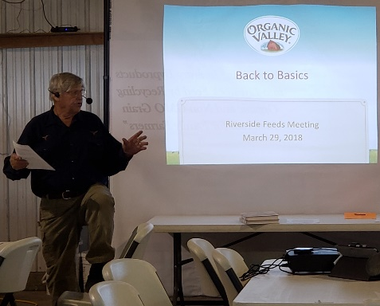
An audience of about 40 listened carefully and enjoyed hearing about alternative and natural treatments of livestock from Dr. Paul Dettloff, held at the Cedar Valley Produce Auction!

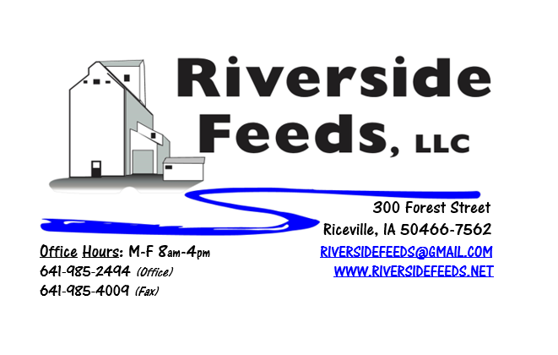
April 2018 Newsletter
We had a great turnout this past week for Dr. Paul Dettloff at the Cedar Valley Produce Auction! As pictured above, Dr. Paul discussed with local livestock producers about alternative and natural treatments for all species. We sold product at a discounted price that day and gave out a lot of information! Thank you to Organic Valley, Stonebridge LTD, and Blue River Hybrids for exhibiting and also providing information for alternative markets and products. We all learned a lot and had a great time!
What’s Happening:
New in our retail store, we now carry some shelf products from Fertrell! Along with Pyganic, we do have a couple OMRI Approved herbicide and insecticide for your gardens or around the home. Nature’s Avenger is a herbicide, and Pure Spray is an insecticide. Check out our price list (back side is all of our retail products, and new items are in red type). We would like to continue to add to our retail store in the coming months. If there is anything that you would like to see us carry, please let us know!
Enclosed, please review and hang onto the green colored sheet announcing our summer specials! Every month this summer, we will have a special summer pricing on select items of Dr. Paul’s. These prices only apply to the products as listed. Full shipping and handling charges apply as usual. Read more about Dr. Paul’s products below.
We have also recently developed species specific brochures to explain in more detail about some of our products! We now have our own brochures for Poultry, Swine, Cattle, and Retail & Equipment Products. If you are interested in receiving any of these brochures to read, please give us a call and we will gladly send to you.
Organic Grain Prices:
Organic grain prices have been slowly but steadily increasing since December. Corn is now trading in the $9.00 - $10.00 range, which has certainly increased since early winter. Barley is holding steady around $8.50.
Beans are trading between $19.00 - $21.00 a bushel here in the upper Midwest (Feed – Food, respectively, and Wheat is around $8.50. Soybean Meal is trading around $800-$825 per ton.
Services We Offer:
Our services include: Limited Warehousing (including loading dock), Hammer mill, Mixer, Pellet Mill, Crumbler, and load out in either bulk, tote bags, or feed sacks. We also have a fleet of trucks and trailers. We do have a nicely displayed and stocked retail shelf in our front office with hard to find farm supply items, focused towards our customers’ needs (OMRI listed, certified organic, or approved for organic use). This includes Dr. Paul’s products, Smidley fountain parts, All-Weather paintsticks, Fertrell products, Apple Cider Vinegar, and more!
Events Coming Up:
If there are field days or events that you would like to share with our customer base, please feel free to provide us the information and we will include it in next month’s newsletter!
- Organic Pig Production Workshop: Thursday, April 12th, 10 am to 2 pm in Rochester, MN. Sponsored by University of Minnesota. I have more details about this event, so if you are interested, please call or email. We will be attending this.
- Waverly Exotic Bird and Animal Swap Meet: Sunday, April 15th, 6:00 AM. Amanda and I have always enjoyed attending this swap meet, and in recent years, we have packed up and sold our Non-GMO poultry feeds and SunCoast Pine Shavings out of our 53’ van trailer! We usually end up hauling feed to the swap meet, and live birds back with us! If you happen to be at this swap meet, stop by and say hi.
Products We Offer:
We are long on organic soy protein (Opro 50), and Non-GMO soy protein (SoyPro 50). Call and check in with me if we can fill any of your needs! We do have more Non-GMO Oat Screenings pellets (Not organic) available for sale yet. We also carry organic and conventional Apple Cider Vinegar, either in 4 gallon pails or 55 gallon drums. As always, we have a full line of vitamins and minerals. I do carry Organic Liquid Molasses in 50# pails, or 275 gal totes. We have Smidley water fountain parts on hand at all times. Dr. Paul’s products are on hand and available to be ordered. We now have Reed Sedge Peat Humates on hand. For those who are interested in other options, I can order in Fertrell “Live Earth” Humates, and Acadian Kelp.
*New product: Calf Starter 14% Pellets – this pelleted product can be made in either sacks, totes, or bulk. We recently created a ration, and have so far seen great success with this product! We have this available both Non-GMO or Organic. Call for more information!
Poultry Feeds:
Our poultry feeds are all in crumbled form. We offer Non-GMO Chick Starter (spring seasonal item), Non-GMO Broiler Grower, Non-GMO Poultry Layer, and Suncoast Pine Shavings (OMRI Approved). We have recently updated our ration to include alfalfa meal and kelp. We DO have a limited amount of Organic Layer Pellets and Organic Chick Starter Pellets, both in 50# sacks. We have about 3 ton of each, and are eager to move this out soon. Please let us know of any interest in this, and the pricing is listed on the price list.
Swine Feeds:
Pre-wean 22 pig feed pellets make a GREAT starter creep feed pellet for young pigs and should be offered especially during colder winter farrowing months. We carry a few bags on hand, but larger orders must be requested and given a few days in order to work into our schedule to make. We do have All-Weather Paintsticks on hand now in our retail store for hog markers. We have multiple colors – Blue, Red, Orange, and Fluorescent Green. We can send a case of markers with your product order at anytime!
Dr. Paul’s Products:
As mentioned above, we are now offering monthly sales special on Dr. Paul’s products. April is “Scours” month, and we will be selling Poultry Plus, PigAde, and Calf Start at 10% off! We only have Poultry Plus in a 5 gallon pail at this time. PigAde comes in 16 ounce bottle with an oral pump. Calf Start comes in multiple sizes: 32 ounce, 64 ounce, and Gallon. Each of these products can be used for either prevention or treatment.
Used Smidley Equipment Available:
We are looking for good, used Smidley hog scales and waterers. We can also order any brand new Smidley livestock equipment. Smidley makes mineral feeders, steer stuffers, multiple sizes hog feeders (both stainless steel and wood), hog scales, hog huts, and livestock water fountains. We have a great selection of Smidley livestock water fountain parts!

THANK YOU FOR YOUR BUSINESS!!!
“Revitalizing Industry Byproducts into Livestock Feed by
Recycling Organic and Non-GMO Grain Materials for Family Farmers”

