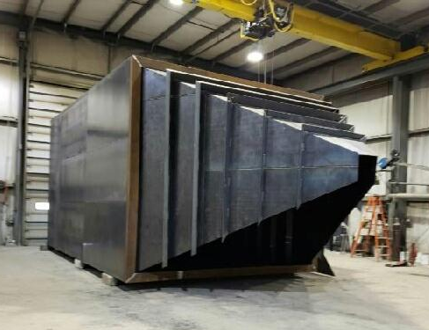

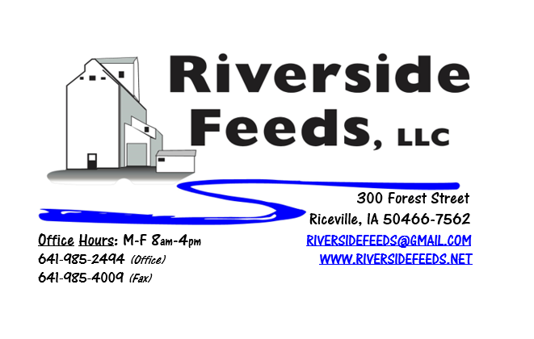
April 2019 Newsletter
As I’m writing this month’s newsletter, truck loads of iron and parts are arriving for our new bins! I guess I have “Construction Fever” setting in now! Pictured above is one of the two very large bins that were built in Kansas this past month! We appreciate everyone’s cooperation while we expand our storage facility, especially from our larger customers who pull multiple loads each week through our plant. We ask for this cooperation so we all can gain in the long run! I’ll apologize in advance to our customers – The first two weeks of April will be extremely busy for me, and communication between all customers and myself may be limited on most days. I fully trust my office staff to take all calls and inquires and report to me when time allows. If there are any dire needs, I’ll try my best to respond as soon as I can. The first week of April will be very busy for everyone here, and we are asking for all customers to try their best to hold off until the following week if needed on feed orders. This past week has been busy as we have been preparing for a few days of no production. We will NOT BE OPEN for business Wednesday afternoon, April 3rd, and all day Thursday, April 4th, as the new bins are set in place. If you happen to stop by, PLEASE respect our construction crews and construction areas – NOBODY will be allowed inside the warehouse while these bins are getting assembled. You MUST check in at the office first!!! Safety of our employees, construction contractors, and customers is always our number one priority. Our bagging line (50# sacks and totes) will not be available April 1st – 10th due to construction. We WILL have our general products on hand that you see listed on the price list in sacks (i.e. Non-GMO poultry and swine feeds, premix, Oat pellets, etc.).
We had a few incidents this past month that grants a policy reminder: We are NOT liable for any feed products being transported on the highway after it leaves our facility, except for when it is hauled on our own trucks. This policy regards to the fact that when you come in and pick up your feed order, PLEASE take care of your own product and secure your own loads! We had a few customers who lost bags and totes on the highway, but that is not our responsibility! Please come prepared with DOT approved ratchet straps.
Organic Grain Prices:
Organic corn is now trading in the $9.75 - $10.50 range. Barley is holding steady around $8.50.
Beans have fallen due to the low cost imported meal. Organic soybeans are trading between $17.50 - $19.50 a bushel here in the upper Midwest, and Wheat is around $8.50 - $9.00. Domestic organic Soybean Meal is trading around $775-$850 per ton.
Events Coming Up:
If there are field days or events that you would like to share with our customer base, please feel free to provide us the information and we will include it in next month’s newsletter!
- Waverly Exotic Animal Swap Meet, April 13th & 14th. Waverly, IA. We are planning on attending with our truck and van trailer and sell pine shavings and feed at this event!
- Practical Farmer’s of Iowa Field Days are coming this summer! We have a few customers who will be having field days this year – Stay tuned!
Products We Offer:
We just got in about 150 tons of Non-GMO Soy Pro 50! This is a lot of product, and we are interested in moving this as soon as possible to help make space in the warehouse. We are willing to negotiate deals on full truckloads of this product. Soy Pro 50 is a fully cooked 50% or higher protein suited for all species of animals. It is low fat (5%). We are also long on Non-GMO Soy Pro 40 at this time, which is a high fat protein (excellent to feed in cold weather). Also remember that we have Redmond salt on hand, as well as many other minerals, vitamins, and micro ingredients.
Poultry Feeds:
We have started to update our poultry rations recently, including adding humates (Reed Sedge Peat) in the ration to prevent scours and boost immunity. You may notice that our poultry feed will now look a little darker in color due to this change. We now have Non-GMO Chick Starter on hand and ready to sell! Stop by today to get your chick products!
Swine Feeds:
We have a good supply of Organic Prewean 22 on hand and ready to send out. We now have Non-GMO Starter-Grower and Non-GMO Grower-Finisher pellets on hand in 50# bags! Check out our updated price lists for these two items. This should help us serve small scale customers with just a few hogs. Reed Sedge Peat (Humates) can be used free-choice to avoid pigs from tail biting.
Bovine Feeds:
We do have some Organic Calf Starter Pellets freshly made up and on hand now. We also now have an organic milk replacer stocked on hand and ready for your use when needed! CGS Remedy is a great herbal product from Dr. Paul for parasite control on calves and cows.
Horse Feeds:
We have a good supply of our complete Non-GMO Horse Pellets on hand, which have been working great for work horses. This product includes minerals and molasses, among a list of ingredients. We also have oat screening pellets available in bags, totes, or bulk. This has been working very well to replace expensive hay currently.
Dr. Paul’s Products:
Knit-Away can treat mites on poultry. Sprinkle this product on the under side of your birds and watch for any improvements. We carry Knit-Away in a 60 ounce container.
Used Smidley Livestock Equipment Available:
We do have some 4 drink hog bars on hand. We can order any brand new Smidley livestock equipment. Smidley makes mineral feeders, steer stuffers, multiple sizes hog feeders (both stainless steel and wood), hog scales, hog huts, and livestock water fountains. We stock a full selection of Smidley livestock water fountain parts!
For Sale: Smidley Cattle Mineral Feeder with attached oiler (fly control) system for sale - $600 OBO. Please see attached flier! We also have a Clipper 67D Cleaner with many screens for sale in excellent condition and ready to run. Asking $10,000 OBO. Motivated to move both items soon!

THANK YOU FOR YOUR BUSINESS!!!
“Revitalizing Industry Byproducts into Livestock Feed by
Recycling Organic and Non-GMO Grain Materials for Family Farmers”

