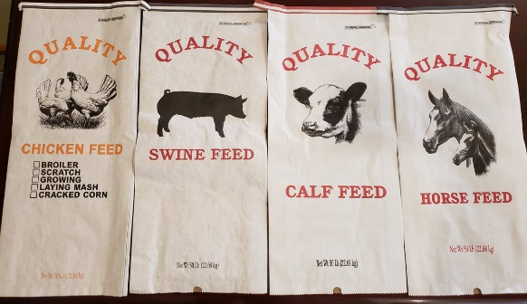
Our colored Quality Feed sacks for complete feed products! Try some out soon!

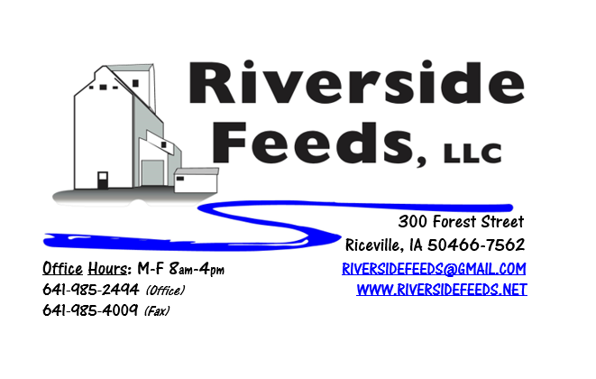
May 2018 Newsletter
Happy Spring everyone! It sure has been a long and crazy winter, and now we finally have some decent weather to get some spring work completed. While we wait for the ground to dry out and weather to warm up, we have been experimenting with some new complete specialty feed rations for some local demand! We have ordered some new feed sacks to match these feed products, as pictured above. Check these products out below!
What’s Happening:
We have added a few more sizes of certain tinctures to our retail shelf from Dr. Paul this month. We now have smaller size bottles of Dull It, Easy Life, FEV-4, Will John, and have also added Pinkeye Drops, and now carry Poultry Plus in half gallon jugs for smaller size flocks. We also just started to carry Poultry Grit (#2 medium) on hand for retail sales. We also stock Shoo-Fly spray and concentrate.
We have also recently developed species specific brochures to explain in more detail about some of our products! We now have our own brochures for Poultry, Swine, Cattle, and Retail & Equipment Products. If you are interested in receiving any of these brochures to read, please give us a call and we will gladly send to you.
Organic Grain Prices:
Organic grain prices have been slowly but steadily increasing since December. Corn is now trading in the $9.00 - $10.00 range, which has certainly increased since early winter. Barley is holding steady around $8.50.
Beans are trading between $19.00 - $21.00 a bushel here in the upper Midwest (Feed – Food, respectively, and Wheat is around $8.50. Soybean Meal is up a little, and is trading around $840-$875 per ton.
Events Coming Up:
If there are field days or events that you would like to share with our customer base, please feel free to provide us the information and we will include it in next month’s newsletter!
Products We Offer:
We are long on organic soy protein (Opro 50), and Non-GMO soy protein (SoyPro 50). Call and check in with me if we can fill any of your needs! We are long on Non-GMO Oat Screenings pellets (Not organic) available for sale yet, and can ship that out in bags, totes, or bulk quantities. We can ship any quantity out the door, and usually carry at least a few ton on hand. We also carry organic and conventional Apple Cider Vinegar, either in 4 gallon pails or 55 gallon drums. As always, we have a full line of vitamins and minerals. I do carry Organic Liquid Molasses in 50# pails, or 275 gal totes. We now have Reed Sedge Peat Humates on hand. For those who are interested in other options, I can order in Fertrell “Live Earth” Humates. Kelp: Ocean Harvest Technology AKA Kelp has been on backorder, and I currently have Acadian on hand for the same price. Ocean Harvest Technology has species specific kelp (poultry, swine, bovine, equine). I do NOT carry the species specific kelp on hand, but can order it in at any time.
*New product: Horse Mix 12% Pellets – This is an experiment, and the ration was based off of Fertrell’s recommendation. This mix includes whole shell corn, oat screenings pellets, soy protein, alfalfa meal, molasses, kelp, and Fertrell horse power mineral. This mix is pelleted (the whole shell corn going through the pellet mill makes a nice large, coarse pellet), and can be sold in either bags, totes, or bulk. We made a small amount up recently and are waiting for feedback on this product! All Non-GMO, and non-medicated. Since we do not handle any medications in my plant, we are sure to have NO DRUG RESIDUE on this product. While supplies last, we are offering one free trial bag if you are interested!
Poultry Feeds:
Our poultry feeds are all in crumbled form, but we are testing to see if pellets work good for our layer feed right now, which may help reduce feed waste and increase efficiency. We offer Non-GMO Chick Starter (spring seasonal item), Non-GMO Broiler Grower, Non-GMO Poultry Layer, and Suncoast Pine Shavings (OMRI Approved). We have recently updated our ration to include alfalfa meal and kelp. We DO have a limited amount of Organic Layer Pellets in 50# sacks at this time. I do have a little Organic Chick Starter-Grower Crumbles left yet. We are eager to move this out soon. Please let us know of any interest in this, and the pricing is listed on the price list. If you are interested in a large quantity of these products, I may be willing to cut a deal! As mentioned, we do now have Poultry Grit available for retail, and also have Oyster Shells. Dr. Paul has Poultry Plus and Poultry X for your poultry health needs!
Swine Feeds:
I carry organic dry buttermilk powder, organic steamed rolled oats, and organic soy isolates on hand right now. This makes GREAT nursery pig diets (pre and post wean stages). These ingredients are expensive, but are well worth the price. We do have All-Weather Paintsticks on hand now in our retail store for hog markers. We have multiple colors – Blue, Red, Orange, and Fluorescent Green. We can send a case of markers with your product order at anytime! Dr. Paul has PigAde and Swine X for your swine health needs!
Bovine Feeds:
We recently made organic Calf Starter 14% Pellets, and this worked VERY well on our organic beef calves this spring. I can make adjustments to the protein percentage for your calf diet needs. These pellets are very sturdy and sweet. Oat screenings can be a good grain extender and fiber filler for all bovine, and also equine. We are long on Non-GMO oat screenings – call today to place your order! Dr. Paul has MANY items for bovine uses, especially calf start, CGS Remedy, S&G Pills (good for sheep, goats, and calves), and Detox for your bovine health needs!
Dr. Paul’s Products:
As mentioned last month, we are now offering monthly sales special on Dr. Paul’s products. May is “Wormers” month, and we will be selling Poultry X, Swine X, CGS Remedy, Knit-Away, Eliminate Bolus, S&G Pills at 10% off! We have Poultry X, Swine X, and CGS Remedy in multiple sizes. Knit-Away comes in a 7.5# container. Eliminate Bolus is available in 25 count, and can be ordered in 80 count. S&G Pills are available on the shelf at 20 count, but can also be ordered in 60 count. Each of these products can be used for either prevention or treatment.
Used Smidley Livestock Equipment Available:
We are looking for good, used Smidley hog scales and waterers. We currently have a few used waterers with new parts on hand but used fountain supply is limited. We can also order any brand new Smidley livestock equipment. Smidley makes mineral feeders, steer stuffers, multiple sizes hog feeders (both stainless steel and wood), hog scales, hog huts, and livestock water fountains. We stock a full selection of Smidley livestock water fountain parts!

THANK YOU FOR YOUR BUSINESS!!!
“Revitalizing Industry Byproducts into Livestock Feed by
Recycling Organic and Non-GMO Grain Materials for Family Farmers”

