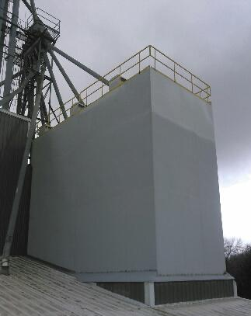

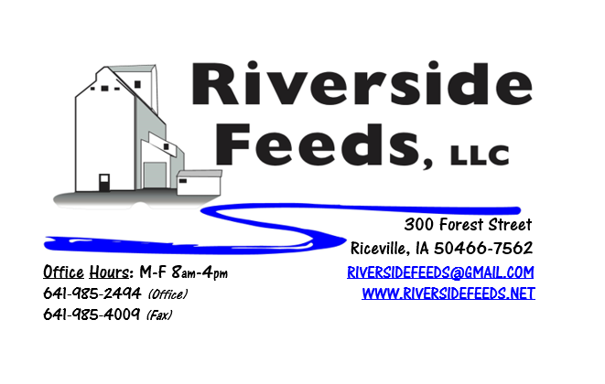
May 2019 Newsletter
Wow! We are beyond blessed to have such a large project go so smoothly and safe! This past month has been extremely busy for us as we installed two brand new bin units for additional outbound storage of finished pellets! This was a HUGE undertaking, and we are very pleased with the professional work done by multiple contractors. Please feel free to stop by for a quick tour of our plant during usual business hours. In only 10 days, we opened the roof of the warehouse above the truck scale, assembled the super structure, lifted and placed in two very large bin tanks with a 300 ton crane, welded the tanks in place, and patched the roof back to the tanks. Then we installed the fill pipes and electrical sensors and finished the load out system inside. While this project took place, our guys have been extremely busy organizing our warehouse flow and improving our bagging operation. We are also in the middle of assembling smaller feed ingredient storage bins to help with our feed mill needs. Thank you for your cooperation in this project since we asked for a little flexibility and time from all our customers as this project took place. We had very little interruptions! Please check out our Facebook page and website for more pictures of the project!
REMINDER: We had a few incidents over past months that grants a policy reminder: We are NOT liable for any feed products being transported on the highway after it leaves our facility, except for when it is hauled on our own trucks. This policy regards to the fact that when you come in and pick up your feed order, PLEASE take care of your own product and secure your own loads! We had a few customers who lost bags and totes on the highway, but that is not our responsibility! Please come prepared with DOT approved ratchet straps. We now sell 2” ratchet straps in our retail store in case if you forget to bring some. Please … PLEASE strap your loads! We don’t want anyone to get hurt in an accident due to lack of proper securement!
Saturday Hours: We experimented with being open Saturday mornings over the past three months. We were impressed with how busy Saturday mornings can be for loading out local customers, however, going into a very busy personal schedule this summer, we have decided to offer Saturday morning load out services by APPOINTMENT ONLY! If you can not make it to Riceville during the week to pick up your feed order, please call no later than 3 pm on Friday for a special load out appointment on Saturday mornings. We would like to restrict this load out time to 8 am – 12 noon. Thank you for your patience and understanding!
Organic Grain Prices:
Organic corn has fallen in recent weeks and is now in the $8.50 - $9.25 range. Barley is holding steady around $8.50.
Beans have fallen due to the low cost imported meal. Organic soybeans are trading between $17.50 - $19.50 a bushel here in the upper Midwest, and Wheat is around $8.50 - $9.00. Domestic organic Soybean Meal is trading around $775-$850 per ton.
Events Coming Up:
If there are field days or events that you would like to share with our customer base, please feel free to provide us the information and we will include it in next month’s newsletter!
- Practical Farmer’s of Iowa Field Days are coming this summer! Stay tuned!
Products We Offer:
We are long by about 125 tons of Non-GMO Soy Pro 50! This is a lot of product, and we are interested in moving this as soon as possible to help make space in the warehouse. We are willing to negotiate deals on full truckloads of this product. Soy Pro 50 is a fully cooked 50% or higher protein suited for all species of animals. It is low fat (5%). We are also long on Non-GMO Soy Pro 40 at this time, which is a high fat protein (excellent to feed in cold weather). Also remember that we have Redmond salt on hand, as well as many other minerals, vitamins, and micro ingredients.
Poultry Feeds:
We have started to update our poultry rations recently, including adding humates (Reed Sedge Peat) in the ration to prevent scours and boost immunity. You may notice that our poultry feed will now look a little darker in color due to this change. We now have Non-GMO Chick Starter on hand and ready to sell! Stop by today to get your chick products, and don’t forget to stock up on SunCoast Pine Shavings as well!
Swine Feeds:
We have a good supply of Organic Prewean 22 on hand and ready to send out. We now have Non-GMO Starter-Grower and Non-GMO Grower-Finisher pellets on hand in 50# bags! Check out our updated price lists for these two items. This should help us serve small scale customers with just a few hogs. Reed Sedge Peat (Humates) can be used free-choice to avoid pigs from tail biting.
Bovine Feeds:
We do have some Organic Calf Starter Pellets freshly made up and on hand now. We also now have an organic milk replacer stocked on hand and ready for your use when needed! CGS Remedy is a great herbal product from Dr. Paul for parasite control on calves and cows. Dr. Paul’s Calf Start or Calf Ease Boluses are great to use for scours. We also have a great supply of Organic Whole Milk Powder which could be used for a low cost milk replacer for all animals. Please call today for more information!
Equine Feeds:
Multiple products available including our very own complete Horse Mix Pellets, Fertrell Horse Power Mineral, Equine Kelp, and Oat Screening Pellets. A lot of Dr. Paul’s products are also great to use for all equine.
Dr. Paul’s Products:
Please see enclosed Dr. Paul’s Lab Spring Newsletter for a great read! A few new products are featured in this newsletter. Our retail store is now stocked with his new book, “Complete Guide to Raising Animals Organically” and we also have S&G Bulk. Stay tuned for a production meeting with Dr. Paul and Redmond Agriculture this July right here in Riceville!
Used Smidley Livestock Equipment Available:
We do have some 4 drink hog bars on hand. We can order any brand new Smidley livestock equipment. Smidley makes mineral feeders, steer stuffers, multiple sizes hog feeders (both stainless steel and wood), hog scales, hog huts, and livestock water fountains. We stock a full selection of Smidley livestock water fountain parts!
For Sale: Clipper 67D Cleaner with many screens for sale in excellent condition and ready to run. Asking $9,500 OBO.
THANK YOU FOR YOUR BUSINESS!!!
“Revitalizing Industry Byproducts into Livestock Feed by
Recycling Organic and Non-GMO Grain Materials for Family Farmers”

