Our parade float for Alta Vista Days this past weekend! Everyone enjoyed the live animals!

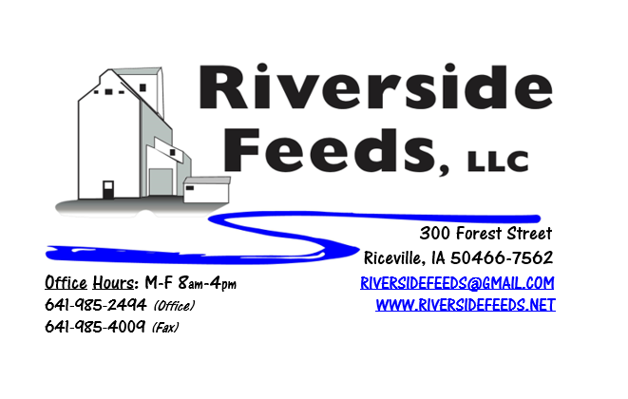
June 2018 Newsletter
Hello everyone! This month marks one year since we started writing this newsletter! After reflecting on a year’s worth of sending out newsletters to you, we decided to ask for a little feedback. Enclosed, you should find a Customer Survey. I am asking for you to spend a few minutes, fill this out as much as you can, and send back to us. Each survey sent back to us will go into a drawing for a gift certificate for Riverside Feeds product! You can send your survey back to us either by mail, fax, or email, and we would like to see them returned in June.
What’s Happening:
We are creating a few new policies to help assist our logistics in a stream lined fashion. We all want to work together as much as possible, and we do work for the customer’s needs, however, we have to be fair to all of our employees and our very busy schedule. Nobody wants to wait in line for their order to be made, and we enjoy being prepared and ready to load out when scheduled to. Effective immediately, we will start to enforce the “Urgency Policy” to all customers. This policy states that if any customers place a custom mix order and demand it to be ready for pickup in less than 48 hours, an urgency charge of $25 per ton will be added to your invoice. This does NOT include retail or bagged products that are normally on hand and available at all times. Please see enclosed “Customer Order Fulfillment Policy” for more details. Most importantly, our employees work very hard, and appreciate an organized work environment with only necessary overtime hours. At this time, we do not work on Saturday mornings. We appreciate your cooperation when placing orders.
We are now a dealer for Redmond Agriculture products! Since we have very limited space, we currently only have Redmond’s Conditioner Coarse and Udder Mud on hand (see price list), however, we are able to order in ANY Redmond products for your needs! Call today for more information!
Organic Grain Prices:
Organic grain prices have been slowly but steadily increasing since December. Corn is now trading in the $9.50 - $10.50 range, which has certainly increased since early winter. Barley is holding steady around $8.50.
Beans are trading between $19.00 - $21.00 a bushel here in the upper Midwest (Feed – Food, respectively, and Wheat is around $8.50 - $9.00. Soybean Meal is up a little, and is trading around $840-$875 per ton.
Events Coming Up:
If there are field days or events that you would like to share with our customer base, please feel free to provide us the information and we will include it in next month’s newsletter!
Products We Offer:
We are long on organic soy protein (Opro 40), and Non-GMO soy protein (SoyPro 50). Call and check in with me if we can fill any of your needs! We are long on Non-GMO Oat Screenings pellets (Not organic) available for sale yet, and can ship that out in bags, totes, or bulk quantities. We can ship any quantity out the door, and usually carry at least a few ton on hand. We also carry organic and conventional Apple Cider Vinegar, either in 4 gallon pails or 55 gallon drums. As always, we have a full line of vitamins and minerals. Our new Horse Mix Pellets are going over very well, and we are excited to make more batches of this up as the demand steadily increases! Kelp: Ocean Harvest Technology AKA Kelp has been on backorder, and I currently have Acadian on hand for the same price. Ocean Harvest Technology has species specific kelp (poultry, swine, bovine, equine). I do NOT carry the species specific kelp on hand, but can order it in at any time.
Poultry Feeds:
We have switched our Broiler Grower and Layer feeds to 1/8” pellets (small size). We feel that this does help reduce feed waste and increase efficiency. The Broiler Starter is still in crumbled form. Starter season is getting close to an end, so let me know if you need any starter feed for late flocks. We offer Non-GMO Chick Starter (spring seasonal item), Non-GMO Broiler Grower, Non-GMO Poultry Layer, and Suncoast Pine Shavings (OMRI Approved). We do have a limited amount of Organic Layer Pellets in 50# sacks at this time. I do have a little Organic Chick Starter-Grower Crumbles left yet. We are eager to move this out soon. Please let us know of any interest in this, and the pricing is listed on the price list. If you are interested in a large quantity of these products, I may be willing to cut a deal! We also have Poultry Grit and Oyster Shells available for retail. Dr. Paul has Poultry Plus and Poultry X for your poultry health needs!
Swine Feeds:
Call today to place your order on any swine feed products. Reminder – we have a minimal production run for our mill, but we could split a few orders up with other customers. We are moving a lot of pig starter right now for small scale producers. We do have All-Weather Paintsticks on hand now in our retail store for hog markers. We have multiple colors – Blue, Red, Orange, and Fluorescent Green. We can send a case of markers with your product order at anytime! Dr. Paul has PigAde and Swine X for your swine health needs!
Bovine Feeds:
We recently made organic Calf Starter 14% Pellets, and this worked VERY well on our organic beef calves this spring. I can make adjustments to the protein percentage for your calf diet needs. These pellets are very sturdy and sweet, and I can make this using Non-GMO ingredients as well. Oat screenings can be a good grain extender and fiber filler for all bovine, and also equine. We are long on Non-GMO oat screenings – call today to place your order! Dr. Paul has MANY items for bovine uses, especially calf start, CGS Remedy, S&G Pills (good for sheep, goats, and calves), and Detox for your bovine health needs!
Dr. Paul’s Products:
We are now offering monthly sales special on Dr. Paul’s products throughout the summer. June is “Flies” month, and we will be selling Shoo-Fly Spray and Concentrate in all sizes available at 10% off! Those nasty flies are really coming in right now, so stock up on your needs for this summer! I tried some Shoo-Fly on a sow who was covered in flies and had EXCELLENT results with this spray! This is allowed for organic use, as well as all of Dr. Paul’s products.
Used Smidley Livestock Equipment Available:
We are looking for good, used Smidley hog scales and waterers. We currently have a few used waterers with new parts on hand but used fountain supply is limited. We can also order any brand new Smidley livestock equipment. Smidley makes mineral feeders, steer stuffers, multiple sizes hog feeders (both stainless steel and wood), hog scales, hog huts, and livestock water fountains. We stock a full selection of Smidley livestock water fountain parts!

THANK YOU FOR YOUR BUSINESS!!!
“Revitalizing Industry Byproducts into Livestock Feed by
Recycling Organic and Non-GMO Grain Materials for Family Farmers”

