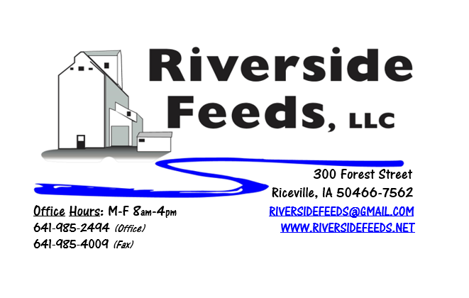
July 2019 Newsletter
Our newly installed bins are in full operation and saving us a lot of time and money! These much-needed bins have reduced excess handling and stress from lack of storage. We are very pleased with the way this entire project turned out! Pictured above is a look down our bulk loading system with the two new bins and extended loadout catwalk! We have noticed a reduction in labor hours and increase in tons produced due to having more space readily available!
We are also very pleased to announce that our entire facility has been updated to LED lights! To assist our electrical demand and motive towards a greener world, we have steadily been changing our older warehouse and outside yard lights from halogen to LED. We now have a much brighter, cheaper, and greener way to see inside and outside! Since we do run 2 shifts (sometimes extending to all night production), our lights generally run around the clock during the week.
Keep in mind that some of our products can be great sources to extend grain and hay supplies. With the wild and very wet weather we have had, grain and hay will be very challenging this year. Call me to discuss any options or needs.
REMINDER: Saturday Hours during Summer months are by APPOINTMENT ONLY!
Organic Grain Prices:
Organic corn has fallen in recent weeks and is now in the $8.50 - $9.25 range. Barley is holding steady around $8.50. I expect for corn prices to increase if we can’t get this year’s planting done in a timely manner.
Beans have fallen due to the low cost imported meal. Organic soybeans are trading between $17.50 - $19.50 a bushel here in the upper Midwest, and Wheat is around $8.50 - $9.00. Domestic organic Soybean Meal is trading around $775-$850 per ton.
Events Coming Up:
If there are field days or events that you would like to share with our customer base, please feel free to provide us the information and we will include it in next month’s newsletter!
- Practical Farmer’s of Iowa Field Days are coming this summer! Stay tuned!
- We will be involved in local parade floats around the Riceville area! Watch for us!
- Dr. Paul’s Lab and Redmond Agriculture meeting – Wednesday, July 24th, at the Community Center in Riceville, IA. Sponsored by Riverside Feeds and Hall Robert’s Son.
Products We Offer:
We are long by about 100 tons of Non-GMO Soy Pro 50! This is a lot of product, and we are interested in moving this as soon as possible to help make space in the warehouse. We are willing to negotiate deals on full truckloads of this product. Soy Pro 50 is a fully cooked 50% or higher protein suited for all species of animals. It is low fat (5%). We are also long on Non-GMO Soy Pro 40 at this time, which is a high fat protein (excellent to feed in cold weather). Also remember that we have Redmond salt on hand, as well as many other minerals, vitamins, and micro ingredients.
Poultry Feeds:
Please call ahead of time to place orders on Chick Starter Crumbles. We don’t want to over produce this seasonal product but are interested in serving your needs as the summer progresses. We currently have a few bags on hand but can make more if needed. We also have a great inventory of SunCoast Pine Shavings for your bedding needs!
Swine Feeds:
We have a good supply of Organic Prewean 22 on hand and ready to send out. We now have Non-GMO Starter-Grower and Non-GMO Grower-Finisher pellets on hand in 50# bags! Check out our updated price lists for these two items. This should help us serve small scale customers with just a few hogs. Reed Sedge Peat (Humates) can be used free-choice to avoid pigs from tail biting. Don’t forget to use Swine-X for intestinal cleanser. Show pig producers: Give us a call or stop by anytime to hear what products we may have for you!
Bovine Feeds:
We do have some Organic Calf Starter Pellets freshly made up and on hand. We also now have an organic milk replacer stocked on hand and ready for your use when needed! S&G Pills or S&G Bulk is a great intestinal cleanser for sheep, goats, and calves. We also have a great supply of Organic Whole Milk Powder which could be used for a low-cost milk replacer for all animals. Please call today for more information!
Equine Feeds:
Multiple products available including our very own complete Horse Mix Pellets, Fertrell Horse Power Mineral, Equine Kelp, and Oat Screening Pellets. A lot of Dr. Paul’s and Dr. Sarah’s Essentials products are also great to use for all equine.
Dr. Paul’s Products:
As noted above, please mark your calendars for an upcoming production meeting, featuring Dr. Paul and Redmond Agriculture! This meeting will be held in the Riceville Community Center on Wednesday, July 24th. Confirming times yet, but this will take place during the day. Lunch provided, sponsored by Riverside Feeds and Hall Robert’s Son.
Dr. Paul’s new book, “Complete Guide to Raising Animals Organically” has recently been published and is on our store shelf now!
Used Smidley Livestock Equipment Available:
We do have some 4 drink hog bars on hand. We can order any brand new Smidley livestock equipment. Smidley makes mineral feeders, steer stuffers, multiple sizes hog feeders (both stainless steel and wood), hog scales, hog huts, and livestock water fountains. We stock a full selection of Smidley livestock water fountain parts!
For Sale: Clipper 67D Cleaner with many screens for sale in excellent condition and ready to run. Asking $9,500 OBO. Schlagel Grain Distributor. 8”, double 24 hole swing. $5,000 OBO.

THANK YOU FOR YOUR BUSINESS!!!
“Revitalizing Industry Byproducts into Livestock Feed by
Recycling Organic and Non-GMO Grain Materials for Family Farmers”

