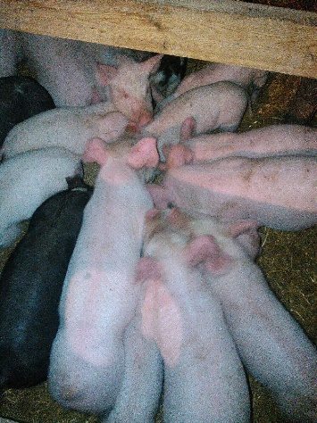
Young pigs in creep feed area munching down on the new “PreWean 22” pig pellets!

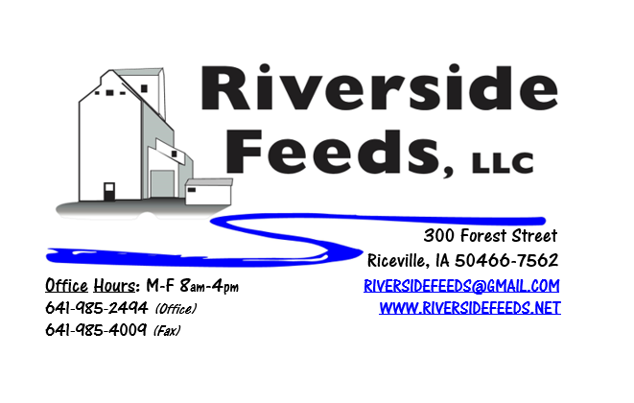
July 2017 Newsletter
Hi everyone! We had such GREAT response from last month’s newsletter that I couldn’t wait to get this month’s edition sent out! Thank you for your feedback and taking a few minutes to read up on what we are doing and have available to offer. We take pride in the work that we do here, and greatly appreciate your support towards this business. As mentioned last month, our monthly newsletter will express what we do here, what we have going on, and some not so usual blends or products that we may be working with. I’ll also include an updated price list for our products. We do have several sources for our materials, so if we don’t have something on hand, please feel free to ask.
What’s Happening:
We have been swamped with working on several small projects around the feed mill and pellet mill. We are making arrangements to store more grains and ingredients for making complete feeds, and this will be a multi-step process over the next several months. We are also making a few changes to increase our handling efficiencies around the feed mill (hammer mill and mixer). On the pellet mill side of the business, we had demand for making poultry crumbles, and decided to invest in a crumbler and installed that in two days – all ourselves! We have some VERY talented employees here who are skilled in welding and fabricating, and I’m beyond impressed and pleased with what we can do without having to hire outside contractors. Starting right now, we are crumbling pellets for poultry feeds on a custom processing basis. We are hoping this will take off well for us!
Organic Grain Prices:
I haven’t heard many changes since last month, but the next 30 – 45 days will be the deciding factor on new crop prices, depending on how Mother Nature treats us!
Services We Offer:
As most of you may know, we do have a hammer mill for grinding any solid state materials, a 4 ton ribbon blender for mixing products, and a pellet mill for pelleting feed products. We currently have two pellet dies – 1/8 inch, and a 3/16 inch. All cattle pellets are going through the 3/16 inch, but I may order another larger die sometime this summer for making mini cubes for sow feed or pasture pellets. We can pellet any products on a custom basis as well – bring it to me, and we will pellet it! We also have bagging operations, so not all products have to go out in the bulk form. We can fill feed sacks or tote bags for a specific fee. We also have a full truck and trailer fleet. We have a few trucks to assist with transportation needs: “Big Blue” and “Lil Blue” are our two semi tractors, and “Straight Blue” is our newest addition, which is a 15 ton feed truck (Yes, all three trucks are blue!). We also have a couple heavy pickup trucks for pallet items. We do have a line of hopper bottom trailers, a van trailer, and a flatbed trailer. For additional transportation needs, we have a list of carriers who we work with on a weekly basis.
Events Coming Up:
*See us in some local town parades this summer! We will be advertising our business with our parade float in the Colwell Day Parade on July 8th, Old Roundhouse Trail Days (Elma) Parade on July 22, and Wapsi Days (Riceville) on August 5th. If you are in the area, please help support these small towns and their annual celebrations! We sponsor a couple of bands for Wapsi Days since we are located right in Riceville. My favorite is “Church of Cash” – a Johnny Cash Tribute band that plays in the late afternoon on August 5th. If you would like to hear some good music, consider coming during Wapsi Days!
*Practical Farmers of Iowa Field Day at Rosmann Family Farm – “Pigs and Water Quality”, Saturday, September 9th 1 – 4:30 pm, Harlan, IA.
If there are other field days or events that you would like to share with our customer base, please feel free to provide us the information and we will include it in next month’s newsletter!
Products We Offer:
As mentioned, we have been working a lot with ground oat screenings, and some customers are experimenting with a new blend of soy hulls and oat screenings, which we call “Cattle Pro”. This new Cattle Pro is working very well, and we have been making up “Cattle Pro 30”, which is 30% oat screenings in the mixture. We do carry organic and conventional Apple Cider Vinegar, either in 4 gallon pails or 55 gallon drums. We also have organic soy oil on hand at all times. As always, we have a full line of vitamins and minerals. We are a dealer of Crystal Creek products as well as Smidley equipment.
Poultry Feeds:
We have a full line of complete Non-GMO Poultry Feeds (not organic at this time). We have Broiler Starter, Broiler Grower, and Layer Feed. We also carry SunCoast Pine Shavings for your bedding needs. The pine shavings are OMRI Approved. With our new crumbler ready to run, we have decided to pellet and crumble all of our poultry feeds to increase the consistency of particle size. Since this is a streamline operation for us, we decided that we will not increase the price of our poultry feeds due to the additional operations. So, our Broiler Grower and Layer feeds will be in crumbled form starting July 1, for $16 per 50# bag, and the Broiler Starter will be crumbled as well, and retailing for $17.50 per 50# bag!
Swine Feeds:
As I mentioned last month, we have developed a new “PreWean 22 pig pellet” feed for creep feeding young pigs prior to weaning. This has been going over very well, but is still in testing stages. I have several hog farmers using this product right now, and we will be looking for some feedback soon from those individuals. As for our own pigs at Frantzen Farm, I have seen a HUGE difference! We have a side-by-side trial going, and the pigs are looking heavier, closer together in size, and most importantly – the sows are in much better condition score with the Prewean 22 pellets being fed as a creep feed compared to the control group. We weighed the pigs going into this trial and will weigh them out very soon, but we didn’t think about weighing the sows, and I think that is the largest difference with using this product. Stay tuned, and please call and chat with me for more information on this. We may very likely develop a “Wean 18” pig pellet to follow this product line with for freshly weaned pigs.
Used Smidley Equipment Available:
Single drinker, single sided (1 hole) – We have 6 on hand. Single drinker, double sided (2 hole) – We have 3 on hand. Double drinker, double sided (4 hole) – 2 on hand. Triple drinker, double sided – (6 hole) – 1 on hand. We are looking for good, used Smidley hog scales. We can also order any brand new Smidley equipment, but they are way behind on manufacturing, so it may take a couple months to get a new feeder or piece of equipment. Please call for pricing on the drinkers.

THANK YOU FOR YOUR BUSINESS!!!
*Please see attached price sheet for current prices on products. Please call the office with any orders or questions.

