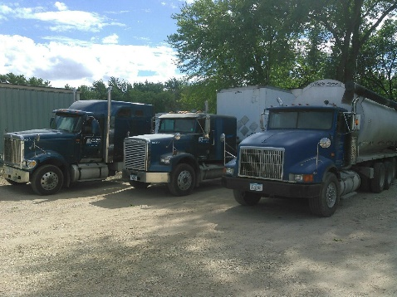
Our fleet of blue! Left to Right:
Big Blue, Lil Blue, and Straight Blue!

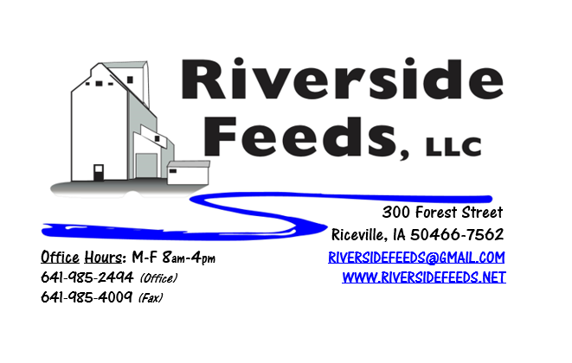
August 2017 Newsletter
Hi everyone! It’s been a crazy and high speed summer – we hope everyone is doing well, despite some severe weather in certain areas. If anyone has any corn crop damage from the weather, PLEASE contact me right away and get some corn booked while the prices are steady. I have a feeling that grain prices may go up this fall. Please read more about organic grains below and some other options to help reduce corn usage in ruminant animals.
What’s Happening:
We have been busy with tackling some finishing touches on our new pellet mill and stream lining our overall processing operations – everything from grinding and mixing through the pelleting and bagging lines. A lot of work has been happening around here, and due to some of this work, we needed to move our Clipper Cleaner. We will NOT have our grain cleaner installed in its new location and ready to run for some time due to the list of projects. This may take the next couple of months to complete yet. We have had some calls recently about cleaning grains, so if you are in need of such operation, please bear with us while we are under construction, and keep in touch with us for a projected completion date.
Organic Grain Prices:
Organic Grain prices have been holding steady, despite some recent federal investigations on fraudulent brokers with imported grains. PLEASE call me if you have any concerns at all about imported grains and I’ll discuss this risky situation with you. As for our products, we have sent an affidavit out to all of our suppliers requesting information about where their products are imported from, and to help assure that our products are not origin from current at-risk countries.
Beans are trading between $17.50 - $20.00 a bushel here in the upper Midwest (Feed – Food, respectively), and corn is trading between $9 - $10 a bushel. Barley is around $8.00 - $8.50, and Wheat is around $8.50 - $9.00. Soybean Meal is trading between $800 - $875 per ton.
Services We Offer:
Please contact us if you or anyone who you know may be looking for custom pelleting options. Our services now include: Warehousing (including loading dock), Hammermill, Mixer, Pellet Mill, Crumbler, and load out in either bulk, tote bags, or feed sacks. We also have a fleet of trucks and trailers. After we finish up some projects around here, we will also have grain cleaning capabilities with a Clipper fanning mill.
Events Coming Up:
*See us in some local town parades this summer! We will be advertising our business with our parade float in one more parade for this year, which will be at Wapsi Days (Riceville) on August 5th. We sponsor a couple of bands for Wapsi Days since we are located right in Riceville. My favorite is “Church of Cash” – a Johnny Cash Tribute band that plays in the late afternoon on August 5th. If you would like to hear some good music, consider coming during Wapsi Days!
*Practical Farmers of Iowa Field Day at JOIA Food Farm – Wendy Johnson & Johnny Rafkin - "Managing Potholes and Matching Conservation Efforts to Farm Goals”, Thursday, August 3rd, 10 AM – 1 PM, Charles City, IA. Please contact PFI to RSVP for this event.
*Practical Farmers of Iowa Field Day at Rosmann Family Farm – “Pigs and Water Quality”, Saturday, September 9th 1 – 4:30 pm, Harlan, IA.
If there are other field days or events that you would like to share with our customer base, please feel free to provide us the information and we will include it in next month’s newsletter!
Products We Offer:
We are currently long on Organic “Opro 40” protein, and now offer that in a crumblized form to keep the texture consistent. Pricing on that is $825 per ton, and available in either tote bags or bulk. We have an endless supply of either organic or Non-GMO Ground Oat Screenings (pelleted). Using these oat screening pellets in your cattle rations (dairy or beef) can help replace corn! We do carry organic and conventional Apple Cider Vinegar, either in 4 gallon pails or 55 gallon drums. We also have organic soy oil on hand at all times. As always, we have a full line of vitamins and minerals. We are a dealer of Crystal Creek products as well as Smidley equipment.
Poultry Feeds:
Our poultry feeds are now in crumbled form, and so far, it has been working well! We offer Broiler Starter, Broiler Grower, Poultry Layer, and Suncoast Pine Shavings (OMRI Approved). We ran out of Scratch Grains, and since we ran out, everybody has been asking for more. I’m not sure when I’ll get more organic scratch grains on hand, but hope to see some come in soon. Stay in touch about this, since the demand is so high.
Swine Feeds:
Prewean 22 pig feed pellet has been moving off the shelf nicely, and I have heard many positive remarks about this, and the pigs are doing great on this product. Please call for more information! We are able to grind, mix, and pellet any swine feed rations – either Non-GMO or Organic. This takes some scheduling work, so if you are interested in this, please contact me in advance.
Used Smidley Equipment Available:
Single drinker, single sided (1 hole) – We have 6 on hand.
Single drinker, double sided (2 hole) – We have 5 on hand.
Double drinker, double sided (4 hole) – 2 on hand.
Triple drinker, double sided – (6 hole) – 1 on hand – SOLD!
We are looking for good, used Smidley hog scales. We can also order any brand new Smidley equipment, but they are way behind on manufacturing, so it may take a couple months to get a new feeder or piece of equipment. Please call for pricing on the used drinkers.

THANK YOU FOR YOUR BUSINESS!!!
*Please see attached price sheet for current prices on products. Please call the office with any orders or questions.

