We sponsored Santa Claus to show a Duroc reindeer at the Celebrity Swine Show for the Chickasaw County 4-H and FFA Achievement Show! Santa has a long history in swine, and won the People’s Choice Award!

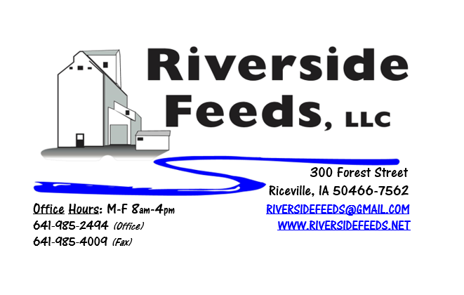
August 2018 Newsletter
Hello everyone! Time sure does fly by – Not only is it August already, but we have also noticed that we have been located in “Forest Street Plant” for five years! This building sure has changed a lot since day one. When I bought this property, it was just an empty warehouse. We constructed and installed EVERY piece of feed mill equipment that exists today. It has been an amazing ride so far, and we are totally ready for a strong future! In celebration for this, we will be offering free organic popcorn (grown by Rosmann Family Farms) and lemonade on Friday, August 3rd during business hours! If you are in the area, feel free to stop by and say hi to our hard working staff!
What’s Happening:
We have been VERY busy the past couple months and have hit record levels of production! We are very pleased with all this business and are excited to continue to grow and sell more. We are focusing on more marketing of our diverse products, which includes a push on our retail store, poultry feeds, calf pellets, horse pellets, etc.
Since we are now a Redmond Agriculture dealer, we now have Real Salt on our retail shelf available for sale. This is a table grade salt, and we carry both the 9 ounce shaker and 26 ounce pouch for your personal use. I have tried this salt on some popcorn, and I will not settle for anything of less quality! Real Salt is just what it is …. REAL salt. No chemicals or preservatives!
Organic Grain Prices:
Organic grain prices have been slowly but steadily increasing since December. Corn is now trading in the $10.00 - $11.00 range, which has certainly increased since this spring. Barley is holding steady around $8.50.
Beans are trading between $20.00 - $22.00 a bushel here in the upper Midwest (Feed – Food, respectively, and Wheat is around $8.50 - $9.00. Soybean Meal is up a little, and is trading around $850-$900 per ton. If you have any organic soybeans to sell, please contact myself or Linda Holthaus at Agra Trading immediately. Beans are becoming a little short, and additional supply now before new crop is in demand.
Events Coming Up:
If there are field days or events that you would like to share with our customer base, please feel free to provide us the information and we will include it in next month’s newsletter!
- Riceville’s Wapsi Days 2018 – August 3 – 5. We will be participating in the parade on Saturday, August 4th at 4:00 pm. Come to town and see us right here in Riceville, IA!
- PFI Field Day: DIY Watering and Corral Systems for Cattle and Pigs, hosted by Jake and Crystal Bigelow - Bigelow Family Farm, LLC. Friday, August 24th, 2-6 pm, Winterset, IA. Check out Practical Farmers of Iowa Field Day Guide or website for more information! This field day is partly sponsored by Riverside Feeds!
Products We Offer:
We are long on organic soy protein (Opro 40), organic soy protein (Opro 50), and Non-GMO soy protein (SoyPro 50). Call and check in with me if we can fill any of your needs! We are long on Non-GMO Oat Screenings pellets (Not organic) available for sale yet, and can ship that out in bags, totes, or bulk quantities. We can ship any quantity out the door, and usually carry at least a few ton on hand. We also carry organic and conventional Apple Cider Vinegar, either in 4 gallon pails or 55 gallon drums. As always, we have a full line of vitamins and minerals and many other ingredients. If you need anything special, let us know and we could look into ordering of products!
Poultry Feeds:
Starter season is getting close to an end, so let me know if you need any starter feed for late flocks. We offer Non-GMO Chick Starter (spring seasonal item), Non-GMO Broiler Grower, Non-GMO Poultry Layer, and Suncoast Pine Shavings (OMRI Approved). We still have a limited amount of Organic Layer Pellets in 50# sacks at this time, and it has been reduced in price to $16 a bag until remaining inventory is gone! We also have Poultry Grit and Oyster Shells available for retail. Dr. Paul has Poultry Plus (scours) and Poultry X (wormer) for your poultry health needs!
Swine Feeds:
Call today to place your order on any swine feed products. Reminder – we have a minimal production run for our mill, but we could split a few orders up with other customers. We have been getting a lot of orders from show pig producers for pine shavings and trying some of Dr. Paul’s products out! Protect Her is a great product for hair coats, and I think it would work great on all show stock to keep the skin moist and hair coats looking good! Dr. Paul has PigAde (scours) and Swine X (wormer) for your swine health needs! By-O-Reg Plus is made up with a natural oregano essential oil (plus other organic ingredients), and is highly recommended for all stages of swine. Call for more information!
Bovine Feeds:
I have several bags of Organic Calf Starter 14% Pellets on hand yet. If anyone has some young calves needing a good starter pellet, please let me know and we can get you some bags to try! These pellets are very sturdy and sweet, and I can make this using Non-GMO ingredients as well. (Both organic and Non-GMO calf starter is listed on price sheet) Oat screenings can be a good grain extender and fiber filler for all bovine, and also equine. We are long on Non-GMO oat screenings – call today to place your order! Dr. Paul has MANY items for bovine uses, especially calf start (scours), CGS Remedy (wormer), S&G Pills (wormer for sheep, goats, and calves), and Detox (moldy/toxic feed) for your bovine health needs!
Horse Feeds:
Our new Horse Mix Pellets is on hand in 50# bags, and can be delivered or picked up anytime! As mentioned above, Protect Her is a great product to use for skin moisturizer and hair coat on horses. Detox can be used on Bovine or Equine to assist the gut health if the animal has been exposed to moldy or toxic feed products.
Dr. Paul’s Products:
This month’s sales special on Dr. Paul’s products is “Tinctures”. ANY 2, 4, or 8 ounce tinctures of Dr. Paul’s will be 10% off through August. (32 ounce tinctures are excluded from this offer). Stock up for your needs!
Used Smidley Livestock Equipment Available:
We are looking for good, used Smidley hog scales and waterers. Current used water fountain supply is VERY limited. We can order any brand new Smidley livestock equipment. Smidley makes mineral feeders, steer stuffers, multiple sizes hog feeders (both stainless steel and wood), hog scales, hog huts, and livestock water fountains. We stock a full selection of Smidley livestock water fountain parts!
THANK YOU FOR YOUR BUSINESS!!!
“Revitalizing Industry Byproducts into Livestock Feed by
Recycling Organic and Non-GMO Grain Materials for Family Farmers”

