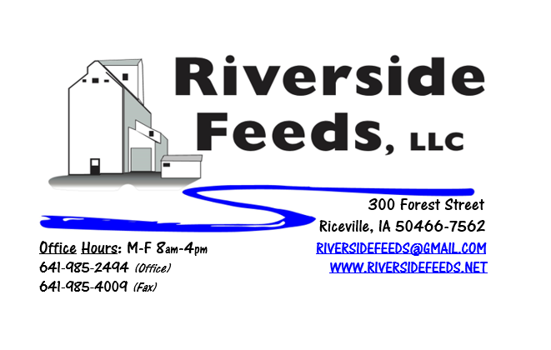
August 2019 Newsletter
We had a great time with Tim Williams and Dr. Paul Dettloff (pictured above) at our meeting on Wednesday, July 24th! The meeting started out with Tim Williams, Redmond Agriculture, discussing how Redmond products can help animals, humans, and the soil. In the afternoon, Dr. Paul presented a keynote address about the Past, Present, and Future Agriculture. Following his keynote, he discussed about his natural remedies and tinctures and how they help with many health issues in livestock. I know the weather was very nice for a change, so the crowd was smaller than expected, however, we had a very effective meeting and many questions were asked! Following the meeting, many customers came down to our office to stock up on these essential supplies. Stay tuned this fall as we continue to promote our retail products!
When harvesting small grains (like oats, wheat, rye, barley, etc.), it is important to consider using Diatomaceous Earth on the grain during storage. Diatomaceous Earth is a very fine sea shell powder. This powder is very abrasive to small insects, and when insects crawl in this, they scratch themselves to death. If you have a lot of insects in your grains, throw in a handful of Diatomaceous Earth every 50 – 100 bushels as you unload or transfer. You can also throw in several handfuls of DE into an aeriation fan, blowing into the bin. After the insects crawl around and die, the grain can easily be cleaned by using a grain vac to blow FM and insects out. We stock and sell Diatomaceous Earth, which is also OMRI approved.
REMINDER: Saturday Hours during Summer months are by APPOINTMENT ONLY!
Organic Grain Prices:
We are expecting for organic corn prices to steadily rise as we near this fall’s harvest. We have heard major shortages of corn acres getting planted in Indiana and Ohio, and this could effect the organic corn market severely. Right now, organic corn is trading in the $9.50 - $11.00 range here in the Midwest.
Beans have fallen due to the low cost imported meal. Organic soybeans are trading between $18.50 - $20.00 a bushel here in the upper Midwest, and Wheat is around $8.50 - $9.75. Domestic organic Soybean Meal is trading around $775-$850 per ton. Barley is around $8.00 - $9.00. Oats are moving in the $5.00 - $7.00 per bushel.
Events Coming Up:
If there are field days or events that you would like to share with our customer base, please feel free to provide us the information and we will include it in next month’s newsletter!
- Practical Farmer’s of Iowa Field Days are taking place! Visit www.practicalfarmers.org
- Rosmann Family Farms field day, August 16th in Harlan, IA, from 1 – 4:30 pm. Check out www.practicalfarmers.org for more info!
Products We Offer:
We are long by about 100 tons of Non-GMO Soy Pro 50! This is a lot of product, and we are interested in moving this as soon as possible to help make space in the warehouse. We are willing to negotiate deals on full truckloads of this product. Soy Pro 50 is a fully cooked 50% or higher protein suited for all species of animals. It is low fat (5%). We are also long on Non-GMO Soy Pro 40 at this time, which is a high fat protein (excellent to feed in cold weather). Soy Pro 40 is a full fat, fully cooked, high bypass soy meal that can replace roasted soybeans. If you use roasted soybeans in your dairy cattle rations and are running low before harvest, this will work as a great replacement! Keep us in mind!
We also have liquid totes of Non-GMO soybean meal and soy oil blend (very wet saturated blend) available at a great price! This is a byproduct from an extruding plant, and we are looking for a home for this. This could be used as a fat source in multiple rations. We also have a couple totes of Non-GMO Soy Oil (no meal blend) available for sale too, and at a great price! Call today for more information!
We do have a good supply of Organic Steamed Rolled Oats on hand – Either in 1600# totes, or 50# bags. Call today for your needs – This makes GREAT nursery pig feed.
Poultry Feeds:
We do have a few bags of chick starter available yet if needed. We have been moving a lot of layer and broiler grower feed recently. We also have a great inventory of SunCoast Pine Shavings for your bedding needs! We will soon start adding Redmond Conditioner in our poultry and swine feeds!
Swine Feeds:
Give us a call for your Organic Prewean 22 feed needs! We also have Non-GMO Starter-Grower and Non-GMO Grower-Finisher pellets on hand in 50# bags! We also carry many swine feed ingredients including organic steamed rolled oats, organic buttermilk powder, organic alfalfa meal, and more! Dr. Paul’s Swine X should be used for internal parasites following weaning.
Bovine Feeds:
We do have some Organic Calf Starter Pellets available. We also now have an organic milk replacer stocked on hand and ready for your use when needed! We do have a great supply of Organic Whole Milk Powder which could be used for a low-cost milk replacer for all animals. Please call today for more information! Consider using Redmond Agriculture products for Bovine needs.
Equine Feeds:
Multiple products available including our very own complete Horse Mix Pellets, Fertrell Horse Power Mineral, Equine Kelp, and Oat Screening Pellets. A lot of Dr. Paul’s and Dr. Sarah’s Essentials products are also great to use for all equine. Oat Screening Pellets have been working great for extending hay and whole oat needs on horses.
Dr. Paul’s Products:
Aloe Pellets can help cure many health issues. Aloe Pellets should be used to reduce stress during and after transport of animals or other stressful times (weaning, birthing, weather changes, etc.). Locally, we have had some ill horses suffering from coughs. I have heard that Dr. Paul’s Aloe Pellets help alleviate congestion and coughs in horses if fed for a week or two.
Used Smidley Livestock Equipment Available:
We do have multiple options available for stainless steel hog bars. We can order any brand new Smidley livestock equipment. Smidley makes mineral feeders, steer stuffers, multiple sizes hog feeders (both stainless steel and wood), hog scales, hog huts, and livestock water fountains. We stock a full selection of Smidley livestock water fountain parts!
For Sale: Clipper 67D Cleaner with many screens for sale in excellent condition and ready to run. Asking $9,500 OBO. Schlagel Grain Distributor. 8”, double 24 hole swing. $5,000 OBO.

THANK YOU FOR YOUR BUSINESS!!!
“Revitalizing Industry Byproducts into Livestock Feed by
Recycling Organic and Non-GMO Grain Materials for Family Farmers”

