. | The Feeder |  |  |  | January 2023

2023: celebrating 10 amazing years!
Can you believe it? I’m still not sure if I can yet or not, but here we are in a whole new year, and a very special year for Riverside Feeds: 2023 – Our 10th anniversary of being in business!  When the calendar rolled into the year 2013, I had no idea that within a couple of weeks I would be starting my own business and steadily take over a part time feed business that my father started roughly ten years prior. All of that changed when a very certain opportunity was offered to my father and I at a Practical Farmer’s of Iowa Conference in Ames in January of 2013. Without going into detail of that conversation with a certain product vendor, we were sitting in our local bank after that very weekend (literally the very next business day), and opened a checking account which would in time turn into Riverside Feeds, LLC. That first year of business for me resulted in purchasing ‘Forest Street Plant’ which is our current mill location in Riceville, IA, along with some startup equipment and inventory. I produced and shipped 1,030 tons of feed at a value of $281,000. Ten years later in 2022, my dedicated team of 10 employees produced and shipped 33,750 tons at a total gross value of $6,180,000! Included in that wild growth, we have invested millions of dollars towards mill improvements, bulk storage, pellet mill, trucks, office, and equipment for our success. |  | 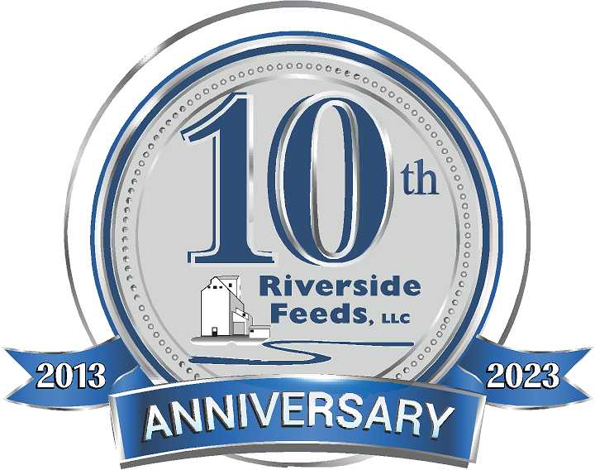  SAVE THE DATE!  Friday, August 4th, 2023  Riverside Feeds 10th Anniversary Open House – Riceville, IA  More details will come throughout the year, but we are already in the planning stages of hosting an open house on August 4th to the general public and our customers! This open house will include food, beverages, music, and tours of our fully revamped facility that we have been building for the past 10 years! We hope you can join in on the fun!  Product supplies have been slowly rebounding. We have started to see some organic soy proteins become available, and the prices have slowly been easing. Certain byproducts like organic soy hulls are very difficult to find, and are very limited. Keep a close eye on our price list to see what products are available or not. Our production schedule is very tight for up to 2 weeks out, so please call us ahead of time to schedule for any feed needs. Also keep in mind that Mother Nature can slow us down, which can greatly effect our schedule. |  | 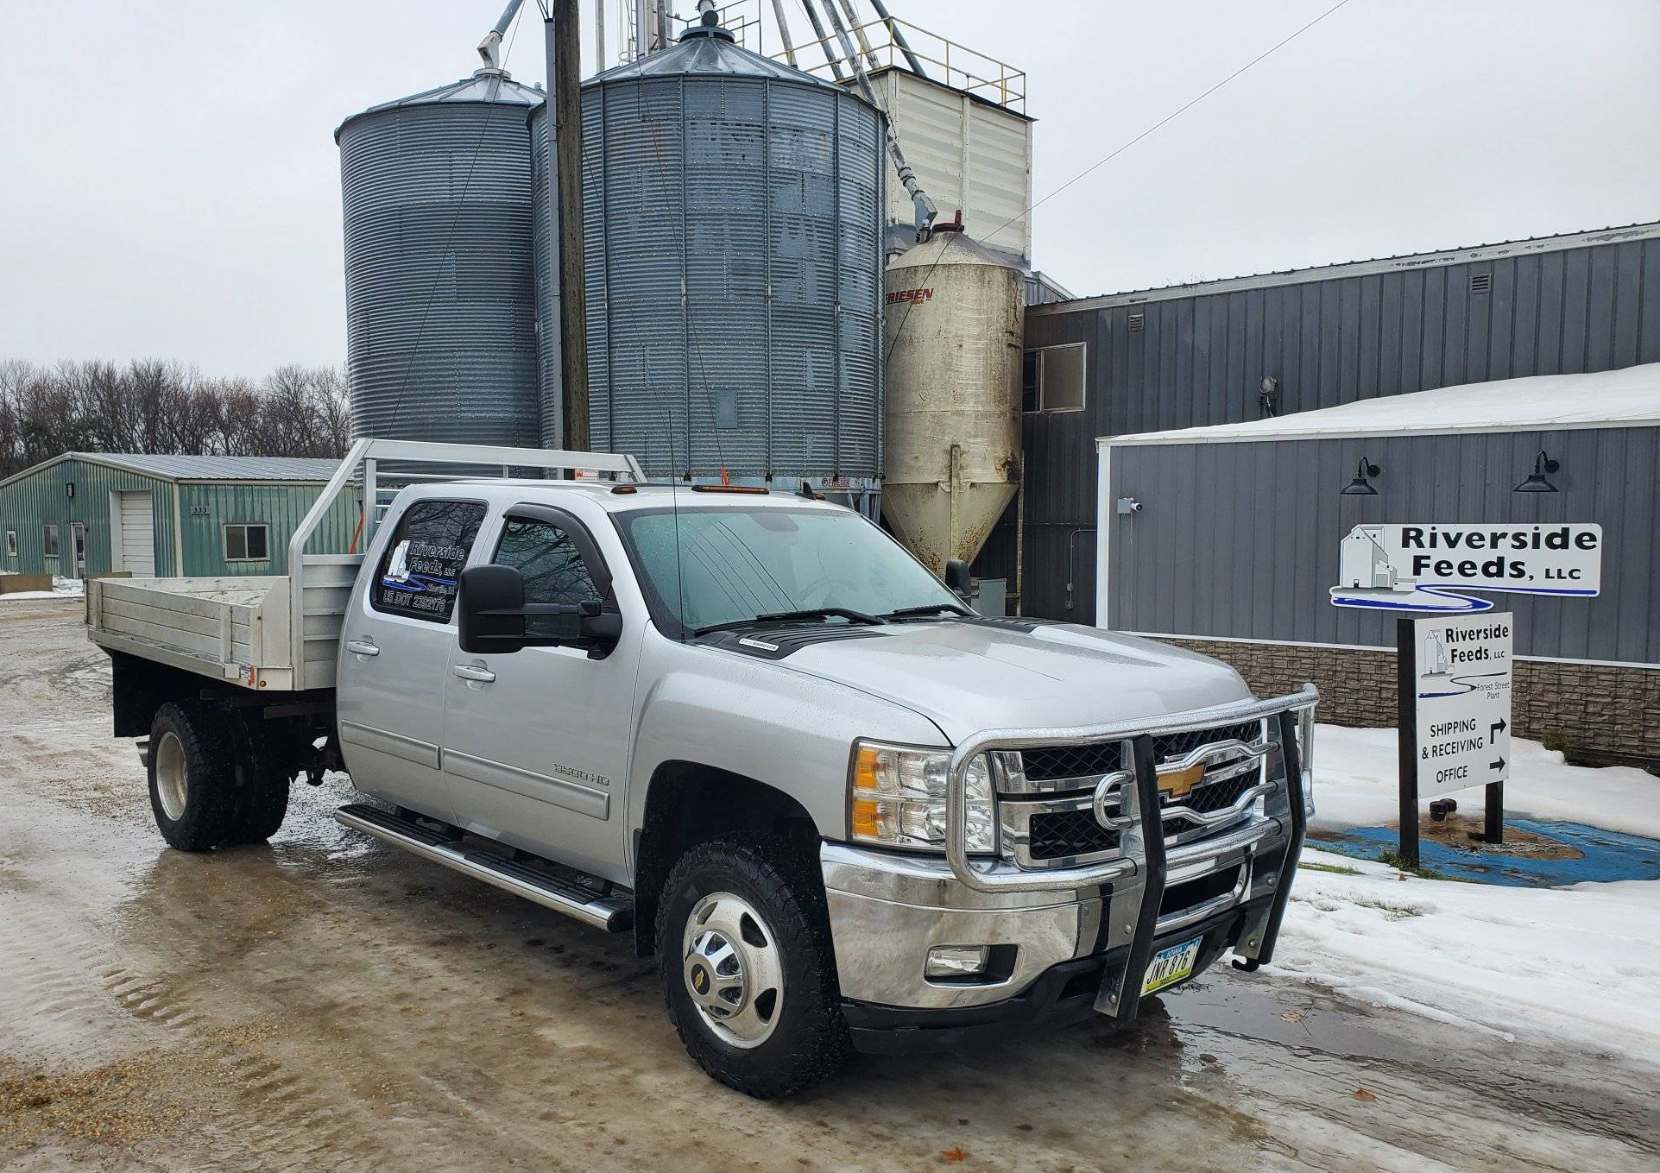 | new flatbed truck  After some serious electrical problems with our old heavy duty one ton pickup truck, we have finally made an upgrade to a far nicer, lower mileage, and more practical heavy hauling one ton truck. This 2014 Chevy 3500HD Duramax features an 8’ x 8.5’ flatbed, which will allow us to haul up to 4 pallets of product at a time before needing to hook onto our heavy gooseneck flatbed trailer. We have a lot of skids of sacks and totes going out for local delivery, and now our fleet of trucks include a very efficient hauling vehicle for palleted items. With diesel fuel finally easing up a bit, we have adjusted our delivery rates for the immediate tri-state area:  One Ton Pickup Truck: $3 / loaded one-way mile  One Ton Truck with Flatbed Trailer: $3.50 / loaded one-way mile  18 Ton Bulk Feed Truck: $4.50 / loaded one-way mile  25 Ton Bulk Semi Truck-Trailer: $4.75 / loaded mile

Warehouse offerings!
CONTACT US!
300 Forest Street
Riceville, IA 50466
641-985-2494 Office
riversidefeeds@gmail.com
www.riversidefeeds.net
Current specials of available supplies. Please refer to enclosed Price List for all products. All items/products are FOB Riceville, IA. Please call to verify availability on all products. Customer pickup or delivery of products can be arranged anytime. |  |  |  |  |  | ORGANIC GRAIN PRICES:  *Upper Midwest References – NOT Riverside Feeds Offers  Corn: $10.00 / Bu  Soybeans: $28.00 + / Bu Feed, $30.00 + / Bu Food  Wheat: $9.00 / Bu  Barley: $8.00 / Bu  Oats: $6.00 / Bu  Soybean Meal: $1370 / Ton +
Smidley Livestock Waterer Equipment: single, double, and triple hog drinking bars and scales available in used, refurbished condition.  Smidley used equipment special: Hog, Sheep, Goat portable head chute! A great condition oldie. Asking $950 OBO. Digital head hog scale - $2800. |  |  | Organic Soybean Oil – Available in 1 ton liquid totes for $0.85 / #. Currently have 1 tote available.  Organic Opro 40 Soy Protein – Available either bulk or 2,000# totes. $1150 / ton. Organic Okara Soy Protein – bulk or totes $1,000 / ton.  Non-GMO & Organic Oat Mill Run Pellets – 50 pound sacks, totes, or bulk. Supply is readily available!  Organic Steamed Rolled Oats – Available in 2,000# totes or bulk. $1000 / ton.  EXPANDED Retail Shelf: Smidley, Crystal Creek, Fertrell, Redmond Agriculture, Redmond human & hunt products, Dr. Paul’s Lab, Dr. Sarah’s Essentials, Pyganic, Apple Cider Vinegar – For humans and animals!
FUTURE EVENTS:
- We will be attending the Minnesota Organic Conference in St. Cloud, MN, this week Thursday & Friday, January 5th & 6th. We will have our exhibit booth in the trade show featuring our products.
- Practical Farmers of Iowa Annual Meeting will be Friday and Saturday, January 20th & 21st in Ames, IA. We will be present with our exhibit booth at this conference as well!
- Marbleseed Organic Conference (formerly MOSES) will be Thursday – Saturday, February 23rd – 25th in LaCrosse, WI. We will be on the trade show floor with our exhibit booth – look for us for info!
- Riverside Feeds 10 Year Open House – Friday, August 4th, 2023, in Riceville, IA. Save the Date!!!
- Keeping COVID-19 concerns in mind, please do NOT enter our premises if you are feeling ill or recently tested positive for COVID-19. Our office doors are OPEN to the public.
- PLEASE NOTE - Office Hours: Monday – Thursday: 8 am – 5 pm. Friday: 8 am – 4 pm.
Seasonal Products:

Non-GMO Swine Feeds – Hog Starter/Grower pellets for $16 / 50# bag, and Hog Grower/Finisher pellets for $13 / 50# bag
Redmond Trophy rock ($15 / 20#) and Bomb Pellets (Cherry or Apple flavor - $14 / 20# bag) for wildlife growth and development. Redmond Apple or Cherry Spray for $14. Riverside’s Wildlife Feed freshly made for $10 / 50# bag.

