. | The Feeder |  |  |  | October 2022

new bagging room ready for action!
This past month we have been focusing on finishing our bagging room (40# & 50# feed sacks), which was a project that resulted from the office renovation. Immediately behind our office, we fully renovated the remaining available space in the warehouse into our new climate controlled bagging room. Our old bagging station was located in a cold warehouse environment, which obviously caused issues during the cold and hot seasons. Now, our new bagging line will be climate controlled and very comfortable for our employees to work. This new room also has a lot better LED lighting and plenty of outlets for our equipment. This room now stores all of our new feed sack supplies, sewing supplies, feed tags/labels, and our shrink wrap machine and supplies. This room actually has two sack filling lines. The primary overhead bin holds approxiamentaly 9 tons of pellets, and is filled direct from the pellet mill or receiving leg. The secondary bagging line is filled directly from above via one ton forklift hoppers or totes for small batches, and direct fed. This new setup will save us a lot of time as everything will be permanently setup and ready to go, provide excellent employee comfort for maximum efficiency, and proper lighting for heavy work. We also built a small dust system to pull dust out of the bagging scales to help keep a clean environment in this room. |  | 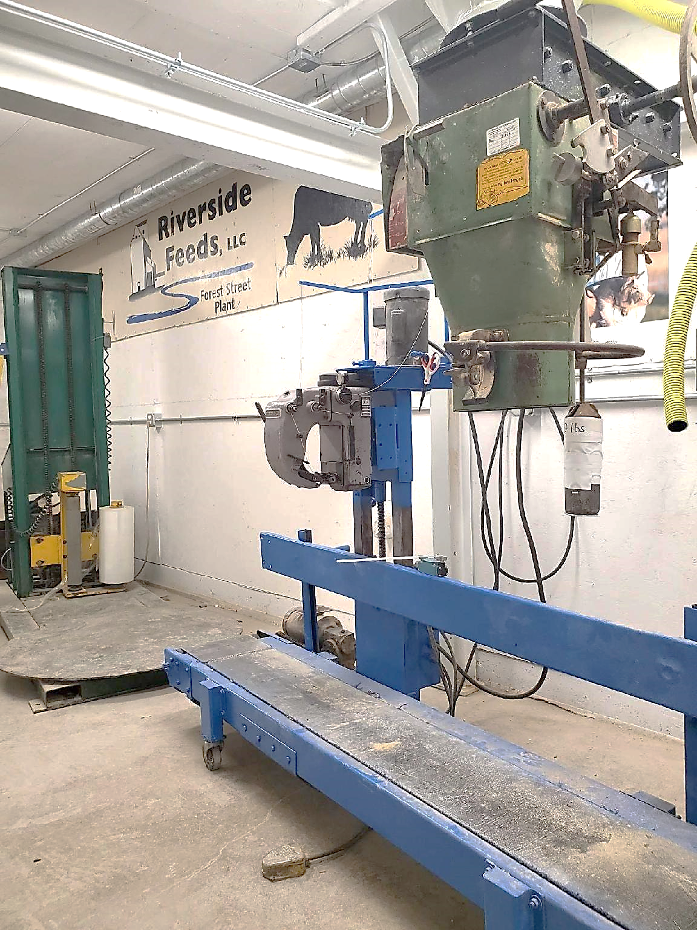  In the above picture, you can see our new primary bagging bin with bagging scale, sewing conveyor, and shrink wrap machine in the backround. The painted sign of our logo and farm animals hanging on the wall was saved from the old office and is on display in the new bagging room. My sister, Jess Frantzen, painted this for our old office many years ago!  You may see on the price list that a lot of products are marked as “Limited” or “OUT”. Please keep in touch with our staff on your upcoming needs. Organic protein prices have started to slightly reduce in price, however, it’ll remain very high priced for some time yet – perhaps another entire year before it drops to a “normal” level. We do have a steady source for Organic Okara, which is a soy byproduct, for an alternative protein option. Call for details! |  |  | cold weather immune support: Aloe pellets  Change of season means change of weather. As we begin to decline in our temperature ranges every day, these weather swings can be very stressful on ALL species of animals. Now is a good time to check all your livestock pens and assure that they have the proper amount of clean bedding. It is also a great time to offer natural remedies to help boost immune systems, and our number one go-to product to do that is Dr. Paul’s Aloe Pellets. Aloe Pellets are made from Aloe Vera, which has proven to be very beneficial to all living beings (animals and humans) in multiple ways, including increasing immunity. Aloe Pellets also greatly improves respiratory systems and reduces coughing. Fall is also a great time to offer intestinal cleansing products such as Dewormers. CGS Remedy is a natural dewormer for any ruminant animal, and equine. Clean Start pellets is a formulated pellet that can be fed to any species as a dewormer as well. SwineX and PoultryX are dewormers for swine and poultry. We proudly stock all these products!  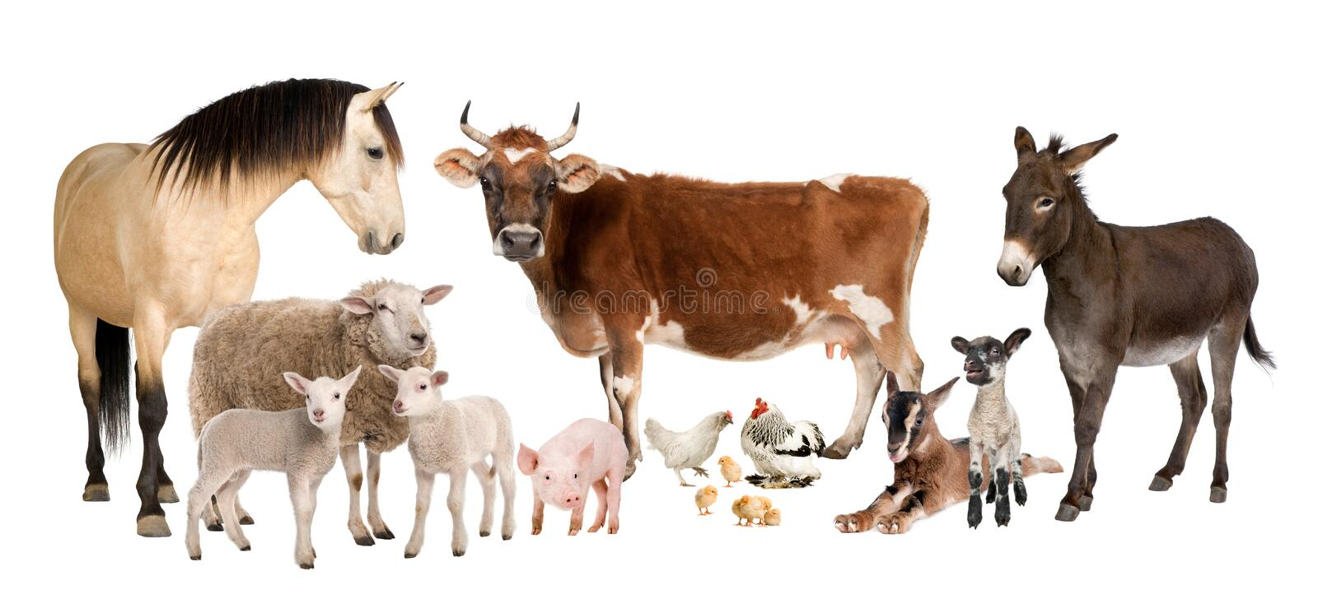

Warehouse offerings!
CONTACT US!
300 Forest Street
Riceville, IA 50466
641-985-2494 Office
riversidefeeds@gmail.com
www.riversidefeeds.net
Current specials of available supplies. Please refer to enclosed Price List for all products. All items/products are FOB Riceville, IA. Please call to verify availability on all products. Customer pickup or delivery of products can be arranged anytime. |  |  |  |  |  | ORGANIC GRAIN PRICES:  *Upper Midwest References – NOT Riverside Feeds Offers  Corn: $10.00 / Bu  Soybeans: $32.00 + / Bu Feed, $34.00 + / Bu Food  Wheat: $11.00 / Bu  Barley: $10.00 / Bu  Oats: $8.00 / Bu  Soybean Meal: $1600 / Ton +
Smidley Livestock Waterer Equipment: single, double, and triple hog drinking bars and scales available in used, refurbished condition.  Smidley used equipment special: Hog, Sheep, Goat portable head chute! A great condition oldie. Asking $950 OBO. Digital head hog scale - $2800. |  |  | Organic Soybean Oil – Available in 1 ton liquid totes for $0.85 / #. Currently have 2 totes available.  Non-GMO & Organic Oat Mill Run Pellets – 50 pound sacks, totes, or bulk. Supply is readily available!  Organic Steamed Rolled Oats – Available in 2,000# totes or bulk. $1000 / ton.  EXPANDED Retail Shelf: Smidley, Crystal Creek, Fertrell, Redmond Agriculture, Redmond human & hunt products, Dr. Paul’s Lab, Dr. Sarah’s Essentials, Pyganic, Apple Cider Vinegar – For humans and animals!  Full Warehouse selection of vitamins, minerals, and ingredients! Ingredient prices have been going up, so stock up now to save money.
FUTURE EVENTS:
- Have a SAFE harvest season! Remember to keep an eye on your feed supplies as our order and delivery schedule is filling up fast for October.
- Feel free to stop by anytime and ask for a tour of our newly renovated office, break room, and bagging room! Our employees greatly appreciate the much-needed upgrade, and we have heard many positive comments from truck drivers, customers, and vendors.
- We are planning on attending several organic farming conferences this winter, including Iowa Organic Conference, Minnesota Organic Conference, Practical Farmers of Iowa Conference, and Marbleseed Organic Farming Conference.
Keeping COVID-19 concerns in mind, please do NOT enter our premises if you are feeling ill or recently tested positive for COVID-19. Our office doors are OPEN to the public.
- PLEASE NOTE - Office Hours: Monday – Thursday: 8 am – 5 pm. Friday: 8 am – 4 pm.
Seasonal Products:

Non-GMO Swine Feeds – Hog Starter/Grower pellets for $16 / 50# bag, and Hog Grower/Finisher pellets for $13 / 50# bag
Redmond Trophy rock ($15 / 20#) and Bomb Pellets (Cherry or Apple flavor - $14 / 20# bag) for wildlife growth and development. Redmond Apple or Cherry Spray for $14. Riverside’s Wildlife Feed freshly made for $10 / 50# bag.

