 | The Feeder |  |  |  | November 2020

Fall visit with dr. paul’s lab!
What a comfortable and colorful fall we had here in Northeast Iowa and Upper Midwest area! A few of us needed a break from the busy office life recently, so in middle of October, Amanda, Douglas, and I (James) traveled to Mazomanie, WI, and visited Dr. Paul’s Lab! We have been a dealer with Dr. Paul’s Lab for a few years now and have seen firsthand how beneficial their natural remedies are to multiple species of livestock. Their new lab location, which is now ran by Dr. Paul’s daughter, Megan, is a hidden gem in a wooded area just Northwest of Madison. We enjoyed our day visit, and as always – learned new things from Dr. Paul, as we were fortunate enough to catch him at the lab! We also learned about some of their new products, which is always exciting! Read more about those in this month’s Product Feature. Also take note that we recently rearranged the retail price list, and organized Dr. Paul’s products into primary categories. Check it out!  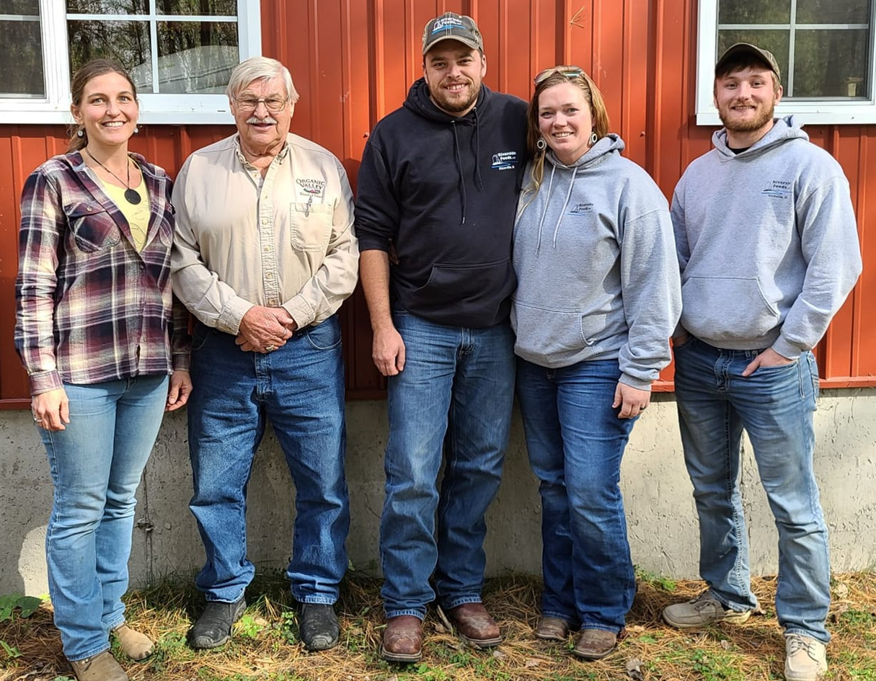Pictured L-R: Megan Dettloff-Meyer, Dr. Paul Dettloff, James, Amanda, and Douglas. |  | Non-GMO Oat Mill Run Pellets Going up in Price, but Available  Effective November 1st, our Non-GMO Oat Mill Run Pellets will be increasing in retail price by $15 per ton. This price increase was brought upon us from our supplier of the oat mill run byproduct (due to increased prices of other byproducts), so we had to follow through to the retail price in order to maintain our margins and cover our operations of pelleting and bagging. The new prices will be as follows: $160 / ton bulk, $190 / ton tote bag, and $220 / ton 50# sacks ($5.50 per bag).  Our supply of Oat Mill Run Pellets (both Non-GMO and Organic) has been holding very steady, and we are able to move any amount needed at this time. With winter months coming soon, I highly encourage for you to stock up on these pellets if needed.  *Please also consider on ALL loads: As winter weather sets in, please allow additional time for all trucks to make deliveries to your farm. We also kindly ask for you to properly move snow and ice to make your driveways and yards as safe and friendly as possible to our dedicated and hard working drivers. They would GREATLY appreciate your help! |  |  | Product feature!  *New dr. paul’s lab products:  Covid-Aid Tincture:  As soon as symptoms develop, take 4 – 6 times a day under the tongue. Available in 2 or 4 ounce bottles.  Ration Boost:  Top dress feed for mature stock twice daily, when immune systems need an extra boost, or possible signs of moldy feed. Comes in 11# container.  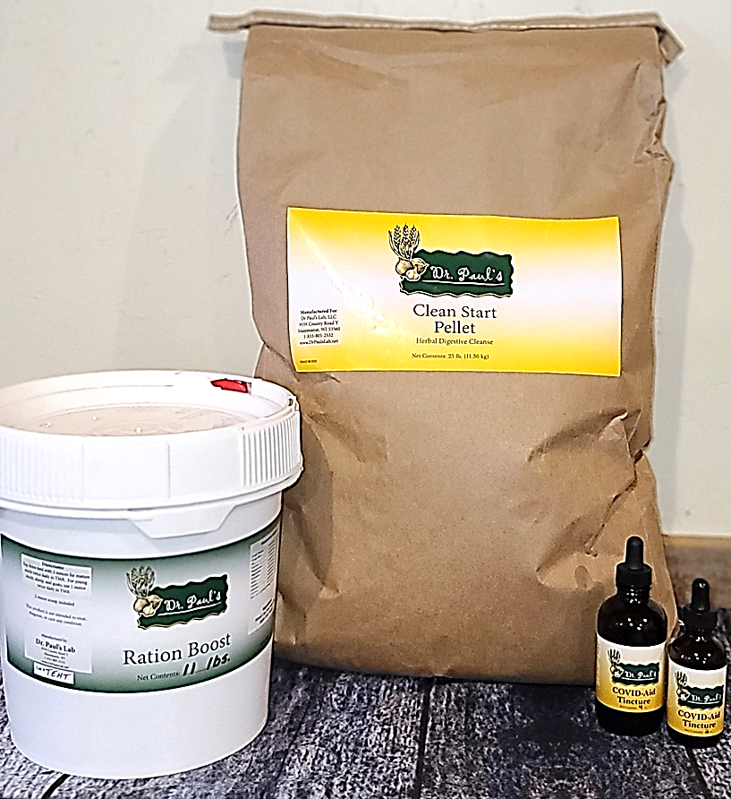  Clean Start Pellets:  One time blast feed as a wormer and for internal parasites for ALL SPECIES of livestock, including horses! Repeat in two weeks for additional internal parasite cleansing. Certified Organic by MOSA. Comes in 5# pails or 25# bags.

Warehouse offerings!
CONTACT US!
300 Forest Street
Riceville, IA 50466
641-985-2494 Office
riversidefeeds@gmail.com
www.riversidefeeds.net
Current specials of available supplies. Please refer to enclosed Price List for all products. All items/products are FOB Riceville, IA. Our most recent Organic Certificate is also enclosed with this month’s newsletter for organic producers. |  |  |  |  |  | ORGANIC GRAIN PRICES:  *Upper Midwest References  Corn: $7.50 / Bu  Soybeans: $18.25 / Bu Feed, $20.50 / Bu Food  Wheat: $8.00 / Bu  Barley: $7.00 / Bu  Oats: $5.50 / Bu  Soybean Meal: $850 / Ton
Smidley Livestock Equipment: single, double, and triple hog drinking bars available in used, refurbished condition.  Seasonal Products:  Redmond’s Trophy Rock – mineral supplement for wildlife, will promote antler growth on deer. Available for $15 / 20# rock.  Wildlife Feed – Special grain screening and molasses blended pellet for any wildlife species. $10 / 50# sack.  Non-GMO Chick Starter Crumbles – Now OUT OF STOCK!  Organic Oat Mill Run Pellets – can be offered in sacks or totes, but currently available in bulk. $185 / ton bulk. |  |  | Organic Steamed Rolled Oats – either 50 pound sacks, or 1600 pound totes, $900 / ton.  Non-GMO Oat Mill Run Pellets – 50 pound sacks, totes, or bulk. Check Price List for recently updated prices. Stock up now before winter sets in!  Non-GMO Pig Starter/Grower, and Non-GMO Hog Grower/Finisher in 50 pound sacks in stock.  Retail: Smidley, Crystal Creek, Fertrell, Redmond, Dr. Paul’s, Dr. Sarah’s, Pyganic, Apple Cider Vinegar – For humans and animals!  Full Warehouse selection of vitamins, minerals, and ingredients! Ingredient prices have been going up, so stock up now to save money.
FUTURE EVENTS:
- Most, if not, all organic farming conferences around the Midwest have announced plans to host virtual conferences this winter instead of in person gatherings due to COVID. This means that we will NOT be attending any exhibit booths this coming winter. We will, however, continue to support all organic farming conferences in the Upper Midwest with advertisements and sponsorships.
- Riverside Feeds will NOT host any farmer production meetings until we feel it is safe to have a public gathering. My guess is that this will not happen until sometime next year at the earliest.
- We highly recommend face masks and social distancing when visiting our facility. If you wish to pick your order up via curbside without coming in contact with our staff, please call our office when you arrive for load out instructions. We will continue to offer customer service at the window in front of our office to avoid traffic inside of the office.
- If any customers would like to see our new feed mill setup, feel free to give us a call or stop by and ask for a personal tour! We encourage social distancing and face masks when visiting our facility.

