 | The Feeder |  |  |  | November 2021

heavy construction near completion!
October surely was a busy month for us! Not only have we started to see our normal spike in feed sales naturally due to this time of the year, but we have been very busy with constructing our new overhead storage bins for both raw inbound products and finished outbound pellets! We appreciate everyone being very cooperative around this construction process as we have had a lot of very large and very heavy steel structures manuvuer around the yard and up into the air with cranes. We are still in middle of this project at this time, however, we believe we will be finishing up by the end of the first week of November.  We traveled to Gridley, Kansas, on October 5th to see our new overhead bins for the pellet mill get assembled. These bins were manufactured by FCS Manufacturing. On Friday, October 15th, we closed all truck traffic and production down so we could set the brand new overhead bin tanks in place for the pellet mill. This was a very large and major project that took a lot of highly skilled workers and two cranes.  These two brand new bin tanks will hold about 75 tons each, or about 3 semi-truck loads of product each. This will greatly improve our finished product storage and increase our flexibility for outgoing bulk pellet orders. |  | We are also constructing some overhead storage bins above our feed mill with a receiving grain leg and tower for handling our inbound raw grain screening supplies. This system is all used structures but will certainly improve our handling efficiency a lot. The tower and receiving leg for this will be the most noticeable new feature when you visit our facility, as it will stand 75 feet tall!  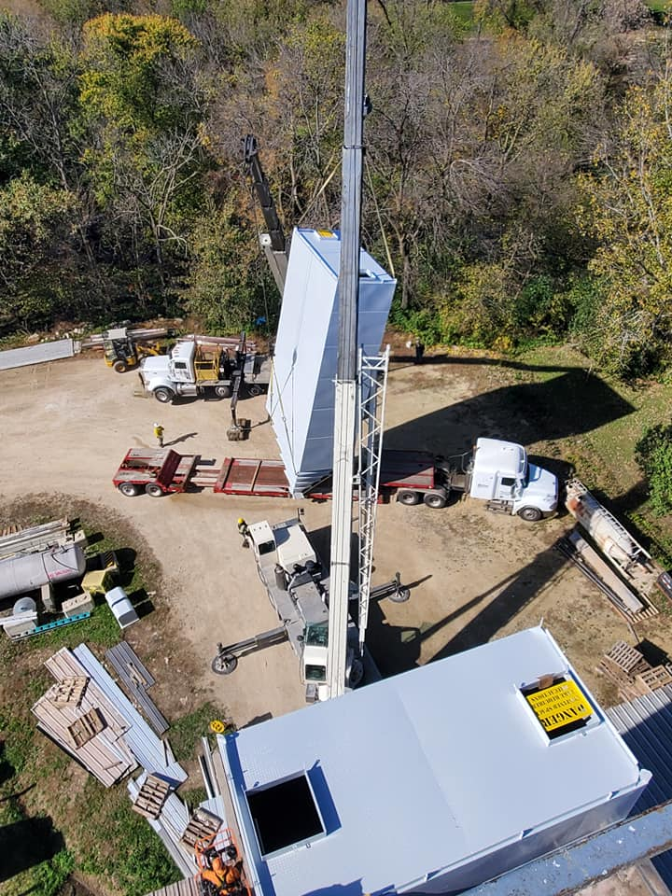  Enclosed you should find a great article about organic pig production by Dr. Paul Dettloff. This article has a lot of very good suggestions and expertise from a very talented organic large animal veterinarian! On the back side of this article is a short suggestion provided by my father, Tom Frantzen, about Smidley water fountain maintenance. We are well stocked with all your Smidley fountain part needs! |  |  | Redmond minerals visit:  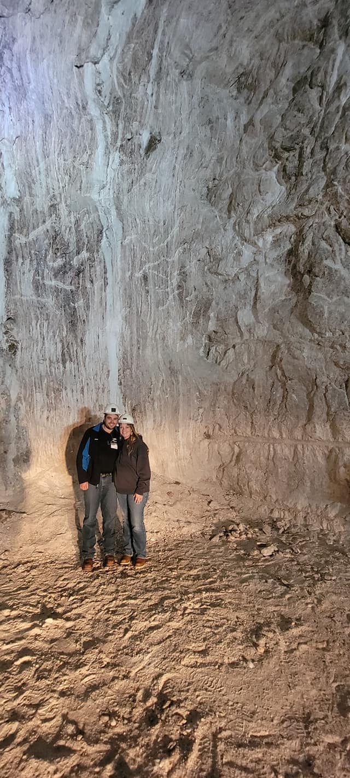  Amanda and I traveled to Redmond, Utah, this past month to visit and tour their facility and salt mine. To say that it was an incredible tour is an understatement, and we learned a lot more about Redmond’s products and how beneficial they are when used properly. We were given a tour of the salt mine, which lead us down a maze of tunnels as deep as 800 feet below surface! Redmond has been mining the highest quality and healthiest ancient sea salt that has been discovered since 1958. This salt includes over 65 trace minerals, providing a near perfect balance for many species including humans. When we were in the salt mine, you could lick salt all around the tunnel! Redmond mines approximately 8,400 tons of salt per week!

Warehouse offerings!
CONTACT US!
300 Forest Street
Riceville, IA 50466
641-985-2494 Office
riversidefeeds@gmail.com
www.riversidefeeds.net
Current specials of available supplies. Please refer to enclosed Price List for all products. All items/products are FOB Riceville, IA. Please call to verify availability on all products. Customer pickup or delivery of products can be arranged anytime. |  |  |  |  |  | ORGANIC GRAIN PRICES:  *Upper Midwest References  Corn: $9.50 / Bu  Soybeans: $32.00 + / Bu Feed, $34.00 + / Bu Food  Wheat: $8.00 / Bu  Barley: $8.00 / Bu  Oats: $5.50 / Bu  Soybean Meal: $1550 / Ton
Smidley Livestock Equipment: single, double, and triple hog drinking bars & hog scales available in used, refurbished condition. |  |  | Organic Steamed Rolled Oats – either 50 pound sacks, or 1600 pound totes, $900 / ton.  Non-GMO Oat Mill Run Pellets – 50 pound sacks, totes, or bulk. Supply is readily available again!  Non-GMO Pig Starter/Grower, and Non-GMO Hog Grower/Finisher in 50 pound sacks in stock.  Retail: Smidley, Crystal Creek, Fertrell, Redmond Agriculture, Redmond human & hunt products, Dr. Paul’s Lab, Dr. Sarah’s Essentials, Pyganic, Apple Cider Vinegar – For humans and animals!  Full Warehouse selection of vitamins, minerals, and ingredients! Ingredient prices have been going up, so stock up now to save money.
FUTURE EVENTS:
- We will be finishing up our heavy construction project through out the first week of November. Again, please take precautions when you visit our facility to stay safe and out of dangerous areas while we finish this large project.
- Iowa Organic Conference – Sunday & Monday, November 21 & 22 in Iowa City, IA. We will be present with our exhibit booth for this conference, eager to get out and start connecting again!
- Office & Production will be CLOSED on Thursday, November 25th, for the Thanksgiving holiday. Don’t forget to stock up on your favorite Redmond Real Salt seasonings for the holidays!
- Keeping COVID-19 concerns in mind, please do NOT enter our premises if you are feeling ill or recently tested positive for COVID-19. Our office doors are OPEN to the public.
- PLEASE NOTE - Office Hours: Monday – Thursday: 8 am – 5 pm. Friday: 8 am – 4 pm.
Seasonal Products:

Wildlife Feed Pellets – Fresh made, Now Available! $10 / 50# bag
Redmond Trophy Rock – Wildlife mineral rock. $15 / 20# rock
Redmond Hunt Cherry or Apple Bomb $14 / 20# bag - $22 / 40# bag Cherry or Apple Bomb Spray $14
SunCoast Pine Shavings – Keep your critters warm and dry! $8 / 25# bag 12 cubic foot
Non-GMO Oat Fiber for bedding use only – Available in 50# bags, totes, or bulk – Call for more info. $125 / ton. LIMITED TIME ONLY!

