. | The Feeder |  |  |  | November 2022

“feed lot” preparing meals for workers
We haven’t shared much information about our new break room for our staff that was part of our office renovation project, so this month I wanted to highlight this area and share with you how we pay back our hard working employees with a little lunch hour appreciation! My wife, Amanda Frantzen, is an outstanding chef, and has stepped up to help support our hard working employees. With Amanda’s request, we included a brand new full kitchen in our break room design, including a full size freezer, fridge, stove/oven, commercial convection oven microwave, air fryer, large farmhouse sink, and dishwasher, plus all new utensils, pots, pans, and dishware. So far, Amanda has blown us away with her talents, preparing lunches a couple times a week, and most recently starting “Appetizer Thursday”, which takes place starting at 3 pm on Thursdays! We treat all of our employees to birthday lunches on their birthday with their personal favorites on the menu. Our lunch menus have ranged from sandwhiches and wraps, to meatloaf and loaded mashed potatoes, to pasta dishes, and even chicken, steaks, with side dishes!  With all this amazing food, naming the new break room “Feed Lot” was an obvious decision! Our employees stay extremely busy keeping up with numerous orders everyday, so having a hot meal available is always appreciated! |  | 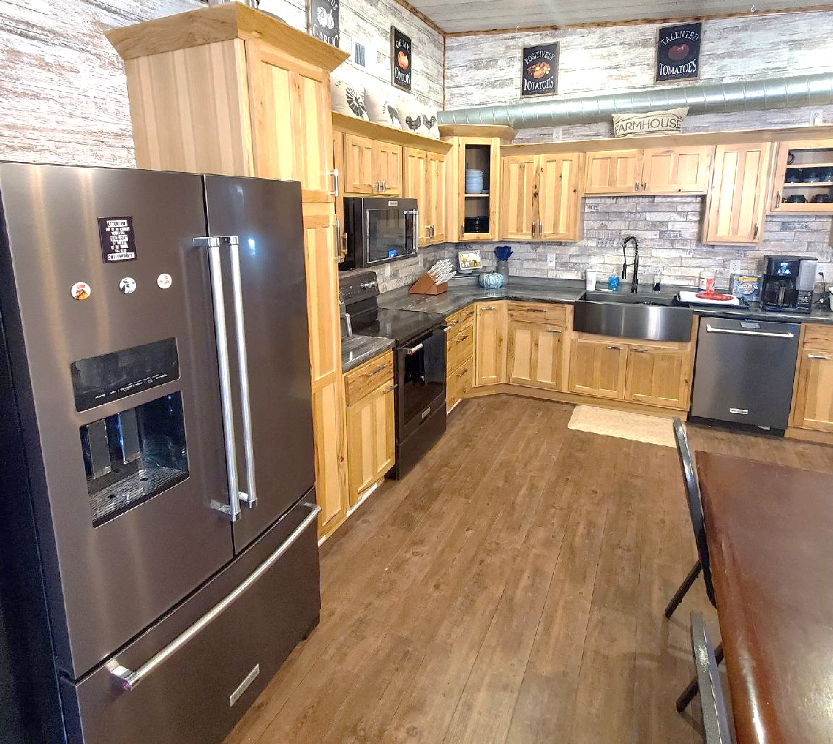  We are grateful to be completely finished with our numerous construction projects as we head into our busiest time of the year. Please keep in mind as the weather begins to turn that our skilled and dedicated delivery drivers need some cooperation with cleared driveways and yards in order to unload into your bins.  You may see on the price list that a lot of products are marked as “Limited” or “OUT”. Please keep in touch with our staff on your upcoming needs. Organic protein prices have started to slightly reduce in price, however, it’ll remain very high priced for some time yet – perhaps another entire year before it drops to a “normal” level. We do have a steady source for Organic Okara, which is a soy byproduct, for an alternative protein option. Organic Opro 40 is also now available again! Call for details!  See enclosed: Dr. Paul’s Lab Fall Newsletter! Learn about Dr. Paul’s parasite management products that we stock on our retail shelf, or can order in. |  |  | cold weather preparations:  Smidley water fountain parts  Yes, it is that time of the year again to prepare all your water fountains for the long cold winter season. We focus our business solely on “hard to find” type of products, which explains why we stock Smidley fountain parts but not any of other competitors that are generally found in any agricultural hardware store in the country. I personally have been a Smidley dealer since I graduated high school. Today, I focus on Smidley’s stainless steel water fountains, but still offer deals on any of their brand new equipment. Since we sell refurbished stainless steel water fountains, we always maintain a well-stocked shelf with all their fountain parts – both plumbing and electrical. If you need any Smidley fountain parts, we have them all available including: rubber flush plugs, thermostats, heating elements for all sizes, floats, valves, and lid rods.  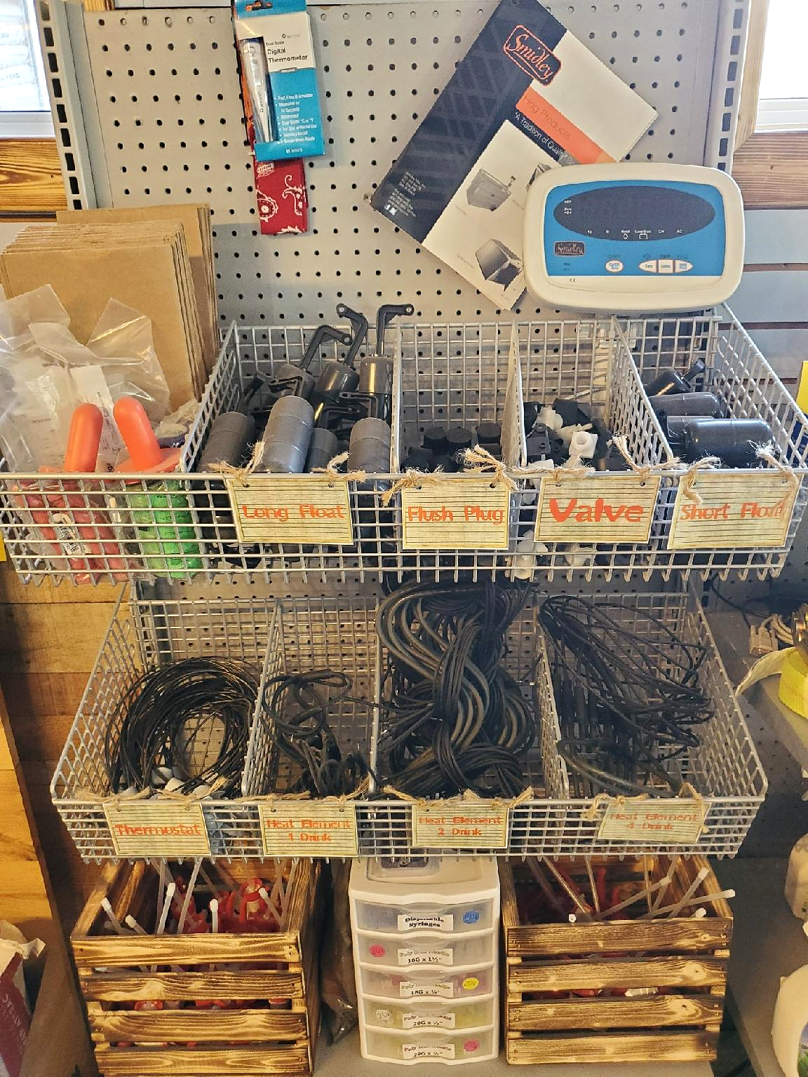

Warehouse offerings!
CONTACT US!
300 Forest Street
Riceville, IA 50466
641-985-2494 Office
riversidefeeds@gmail.com
www.riversidefeeds.net
Current specials of available supplies. Please refer to enclosed Price List for all products. All items/products are FOB Riceville, IA. Please call to verify availability on all products. Customer pickup or delivery of products can be arranged anytime. |  |  |  |  |  | ORGANIC GRAIN PRICES:  *Upper Midwest References – NOT Riverside Feeds Offers  Corn: $10.00 / Bu  Soybeans: $30.00 + / Bu Feed, $32.00 + / Bu Food  Wheat: $11.00 / Bu  Barley: $10.00 / Bu  Oats: $8.00 / Bu  Soybean Meal: $1370 / Ton +
Smidley Livestock Waterer Equipment: single, double, and triple hog drinking bars and scales available in used, refurbished condition.  Smidley used equipment special: Hog, Sheep, Goat portable head chute! A great condition oldie. Asking $950 OBO. Digital head hog scale - $2800. |  |  | Organic Soybean Oil – Available in 1 ton liquid totes for $0.85 / #. Currently have 1 tote available.  Organic Opro 40 Soy Protein – Available either bulk or 2,000# totes. $1150 / ton. Organic Okara Soy Protein – bulk or totes $1,000 / ton.  Non-GMO & Organic Oat Mill Run Pellets – 50 pound sacks, totes, or bulk. Supply is readily available!  Organic Steamed Rolled Oats – Available in 2,000# totes or bulk. $1000 / ton.  EXPANDED Retail Shelf: Smidley, Crystal Creek, Fertrell, Redmond Agriculture, Redmond human & hunt products, Dr. Paul’s Lab, Dr. Sarah’s Essentials, Pyganic, Apple Cider Vinegar – For humans and animals!
FUTURE EVENTS:
- Feel free to stop by anytime and ask for a tour of our newly renovated office, break room, and bagging room! Our employees greatly appreciate the much-needed upgrade, and we have heard many positive comments from truck drivers, customers, and vendors.
- Iowa Organic Conference: November 20 & 21, Iowa Memorial Union, Iowa City, IA. For more information including registration: https://www.regcytes.extension.iastate.edu/iowaorganic/
- We are planning on attending several organic farming conferences this winter, including Iowa Organic Conference, Minnesota Organic Conference, Practical Farmers of Iowa Conference, and Marbleseed Organic Farming Conference.
Keeping COVID-19 concerns in mind, please do NOT enter our premises if you are feeling ill or recently tested positive for COVID-19. Our office doors are OPEN to the public.
- PLEASE NOTE - Office Hours: Monday – Thursday: 8 am – 5 pm. Friday: 8 am – 4 pm.
Seasonal Products:

Non-GMO Swine Feeds – Hog Starter/Grower pellets for $16 / 50# bag, and Hog Grower/Finisher pellets for $13 / 50# bag
Redmond Trophy rock ($15 / 20#) and Bomb Pellets (Cherry or Apple flavor - $14 / 20# bag) for wildlife growth and development. Redmond Apple or Cherry Spray for $14. Riverside’s Wildlife Feed freshly made for $10 / 50# bag.

