 | The Feeder |  |  |  | December 2020

Happy holidays from riverside feeds!
Happy Holidays from all of us at Riverside Feeds! We are so eager to end 2020, not only to move on from this year’s challenges including COVID, but to also close out another record-breaking year in the books for our sales and production! Without you, we would never have been able to operate such a successful business, and we all deeply appreciate your cooperation and loyalty! We have MANY accomplishments to be proud of, however, the most important is that YOU are supporting a small, diverse, and growing business that employs 12 full time employees in Riceville, IA (population of 760)! I am astonished and thankful with what we have achieved, and excited to jump into some new projects for 2021, which we will share with you soon!  Enclosed with this month’s mailing is the Fall 2020 Newsletter from Dr. Paul’s Lab! Read on to learn more about the new Clean Start Pellets and a review of all their new products this year.  *Please consider on ALL loads: As winter weather sets in, please allow additional time for all trucks to make deliveries to your farm. We also kindly ask for you to properly move snow and ice to make your driveways and yards as safe and friendly as possible to our dedicated and hard working drivers. It would be appreciated! |  | SOY PROTEINS NOW TIGHT ON SUPPLY!  Our inbound supply has dried up for a bit on Non-GMO Soy Pro 40 and Organic Opro 50. Other soy proteins (Non-GMO Soy Pro 50 and Organic Opro 40) are on hand and available for right now, however, we are watching those supply chains carefully. We usually see a dip in supply around this time of the year as soy processors clean up old crop supply and switch to new crop, however, our warehouse is getting empty! If you need any kind of soy protein from us, please call ahead and check our supply.  Our source of Oat Mill Run Pellets (both Non-GMO and Organic) has been holding very steady, and we are able to move any amount needed at this time. With winter months coming soon, I highly encourage for you to stock up on these pellets if needed.  We wish you a safe and fun holiday season and look forward to serving you in the new year! Thank you for your loyal support! |  |  | Product feature!  immune boosters:  Aloe Pellets or Liquid:  Aloe pellets or liquid products can be greatly beneficial for multiple health issues, including digestive and immune health, stress relief, and shipping fever. Aloe-C is available in one gallon, Aloe Pellets is available in 3.5#, 25#, and 50# quantities.  Apple Cider Vinegar:  Selling in multiple size quantities (1 gal, 4 gal, 55 gal), ACV has proven to enhance immune systems, prevent illnesses, and increase feed intake in multiple species.  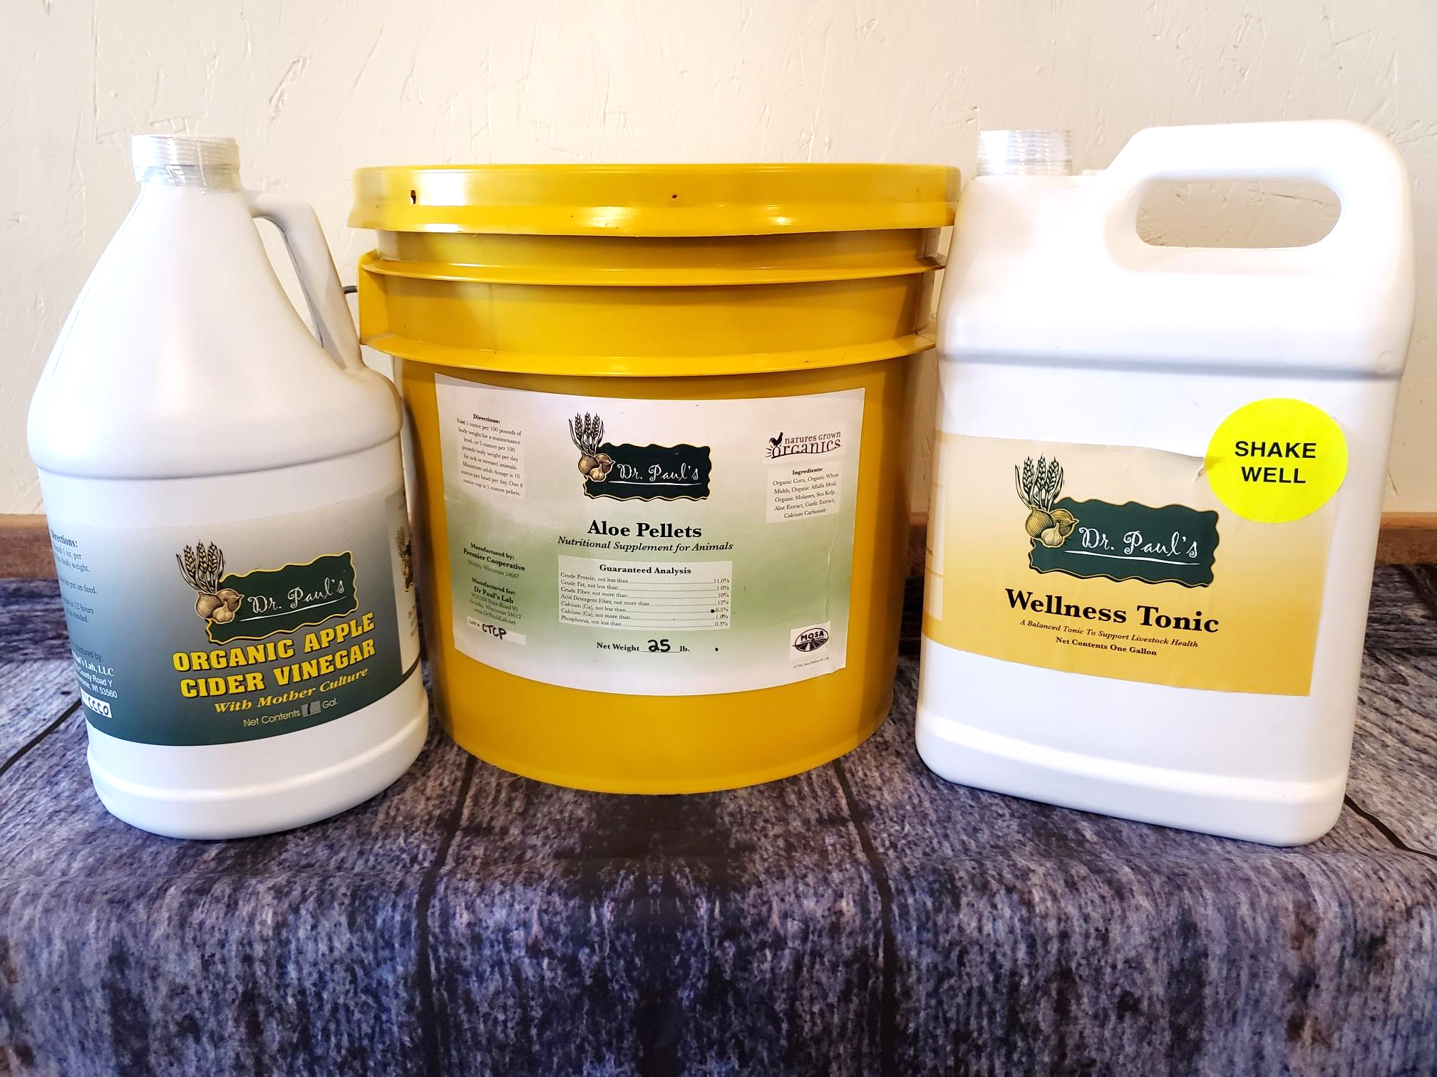  Wellness Tonic:  Wellness Tonic should be used when animals are in great stress, such as high demand for milk with low energy levels (Ketosis), or when recovering from surgery, such as birthing complications.

Warehouse offerings!
CONTACT US!
300 Forest Street
Riceville, IA 50466
641-985-2494 Office
riversidefeeds@gmail.com
www.riversidefeeds.net
Current specials of available supplies. Please refer to enclosed Price List for all products. All items/products are FOB Riceville, IA. Our most recent Organic Certificate is also enclosed with this month’s newsletter for organic producers. |  |  |  |  |  | ORGANIC GRAIN PRICES:  *Upper Midwest References  Corn: $6.50 / Bu  Soybeans: $18.25 / Bu Feed, $20.50 / Bu Food  Wheat: $8.00 / Bu  Barley: $7.00 / Bu  Oats: $5.50 / Bu  Soybean Meal: $850 / Ton
Smidley Livestock Equipment: single, double, and triple hog drinking bars available in used, refurbished condition.  Seasonal Products:  Redmond’s Trophy Rock – mineral supplement for wildlife, will promote antler growth on deer. Available for $15 / 20# rock.  Wildlife Feed – Special grain screening and molasses blended pellet for any wildlife species. $10 / 50# sack.  Non-GMO Chick Starter Crumbles – Now OUT OF STOCK!  Organic Oat Mill Run Pellets – can be offered in sacks or totes, but currently available in bulk. $185 / ton bulk. |  |  | Organic Steamed Rolled Oats – either 50 pound sacks, or 1600 pound totes, $900 / ton.  Non-GMO Oat Mill Run Pellets – 50 pound sacks, totes, or bulk. Check Price List for recently updated prices. Stock up now before winter sets in!  Non-GMO Pig Starter/Grower, and Non-GMO Hog Grower/Finisher in 50 pound sacks in stock.  Retail: Smidley, Crystal Creek, Fertrell, Redmond, Dr. Paul’s, Dr. Sarah’s, Pyganic, Apple Cider Vinegar – For humans and animals!  Full Warehouse selection of vitamins, minerals, and ingredients! Ingredient prices have been going up, so stock up now to save money.
FUTURE EVENTS:
- Upcoming virtual conferences: Minnesota Organic Conference, Practical Farmer’s of Iowa Annual Meeting, and MOSES Organic Farming Conference (which includes the Midwest Organic Swine Conference!) Riverside Feeds will be sponsoring and exhibiting at each of these online conferences!
- *HOLIDAY HOURS*: December 24th – Closing at 12 Noon. December 25th – CLOSED.
December 31 – Closing at 12 Noon. January 1st – CLOSED.
- We REQUIRE face masks and social distancing when visiting our facility. If you wish to pick your order up via curbside without coming in contact with our staff, please call our office when you arrive for load out instructions. We will continue to offer customer service at the window in front of our office to avoid traffic inside of the office.
- If any customers would like to see our new feed mill setup, feel free to give us a call or stop by and ask for a personal tour! We encourage social distancing and face masks when visiting our facility.

