. | The Feeder |  |  |  | December 2021

new bins completed just in time for use
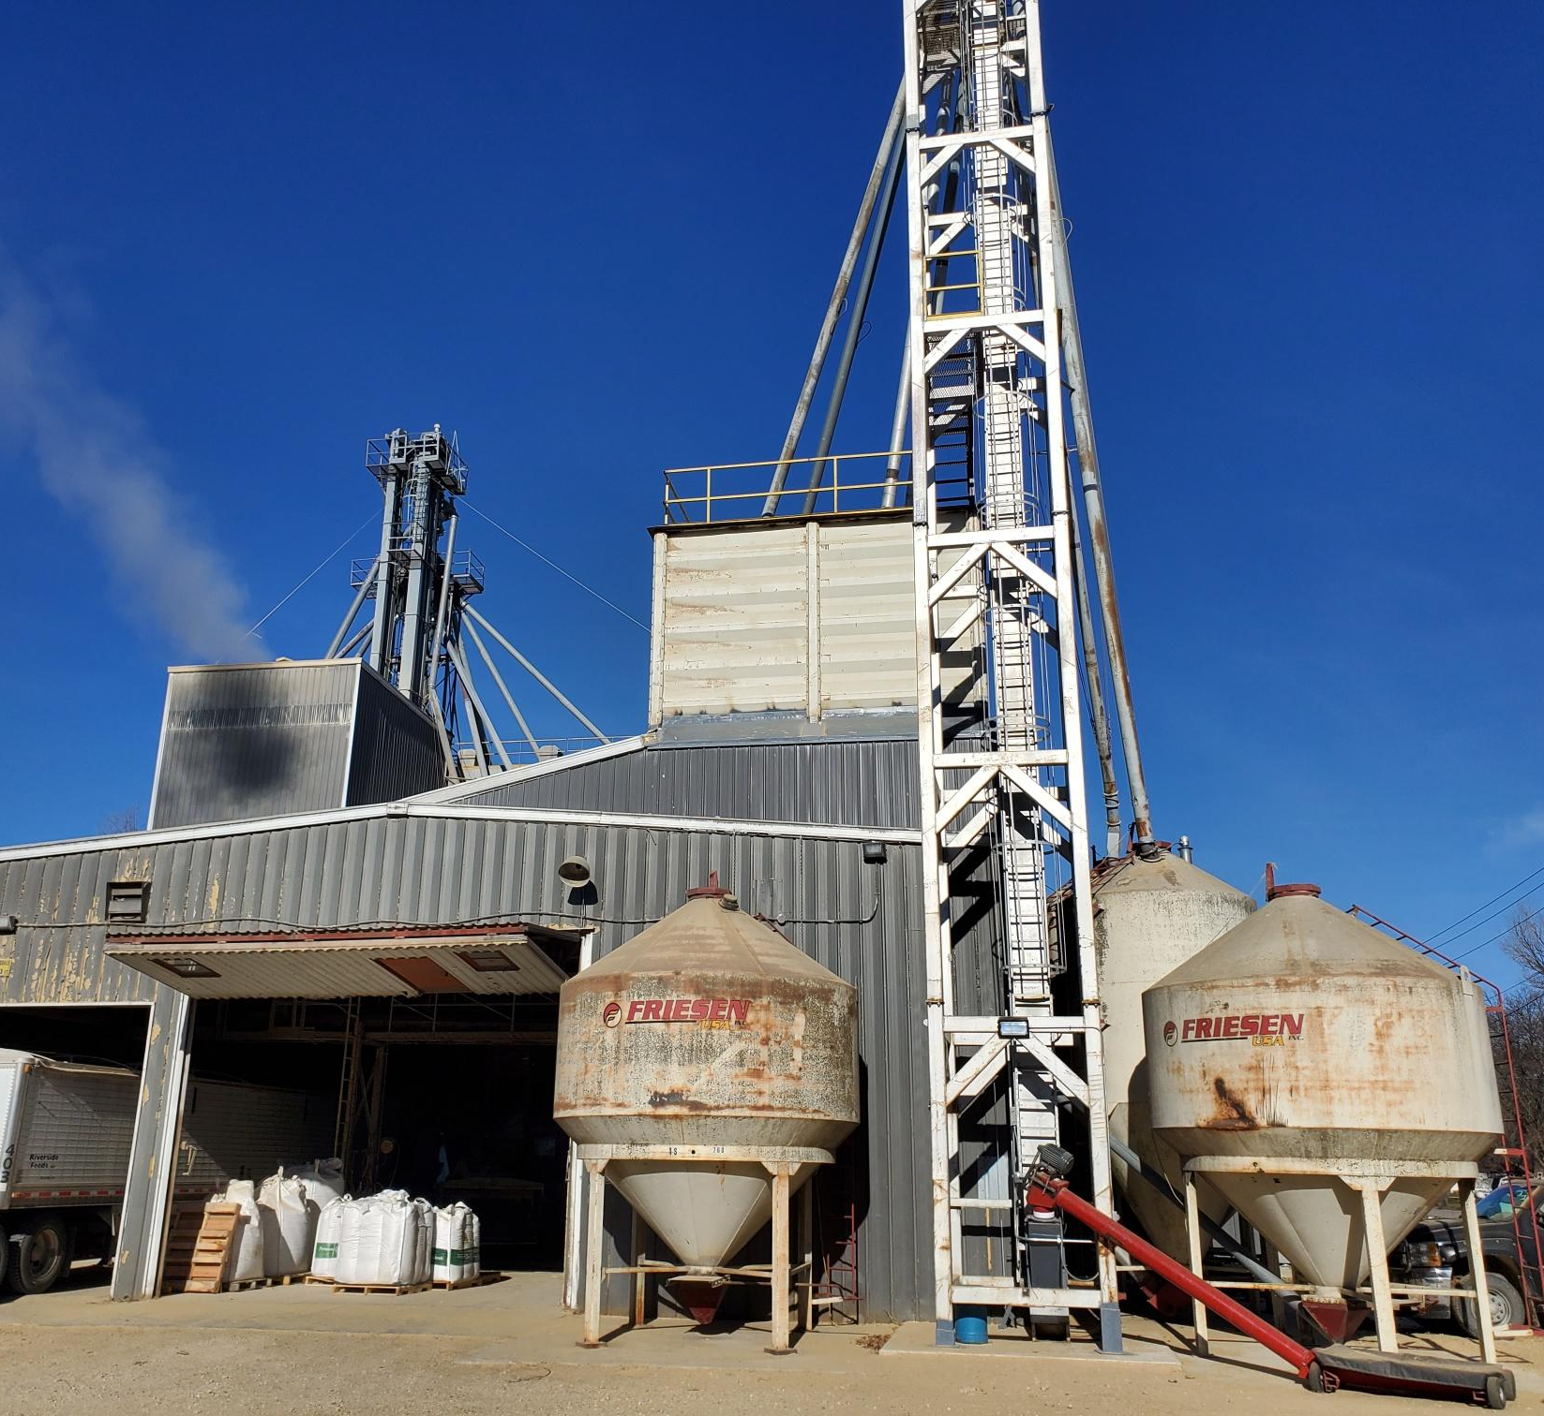  We finally wrapped up construction on our new overhead storage bins around Thanksgiving, which is just in time for our busiest season – Winter! Many customers in the Upper Midwest either run short on feed supply or need additional feed inputs during the harsh winter months, and our sales generally sky rocket around this time of the year. These new bins are currently in great use to help us take on this increase in workload and demand, and help us fulfill orders in a timely manner. However, this year due to high commodity prices of grain (both Non-GMO and Organic), our demand has reached to record levels, and we are struggling to keep up with all orders in a timely manner – even with the new bins! PLEASE help us out by placing your feed orders with us with as much advance notice as possible. Right now, we are pushing two weeks out on new orders on our production schedule. Our common products that we stock heavily on should be available at most times, however, custom orders or new accounts will have to wait their turn. |  | Our new raw material receiving system and bins for the feed mill are working very nicely for us and will greatly improve our handling efficiencies for inbound materials. Our new outbound pellet mill bins are proving their worth as well! With these new bins, we have been able to rearrange our existing bins, which provides more flexibility to us. Now, we have one bin available to store our new product, Non-GMO Soy-Oat Pellets, which you can read about in this month’s product feature column! We also have some Non-GMO Whole Oats available for sale – Please see the Warehouse Offerings on the back side of this page!  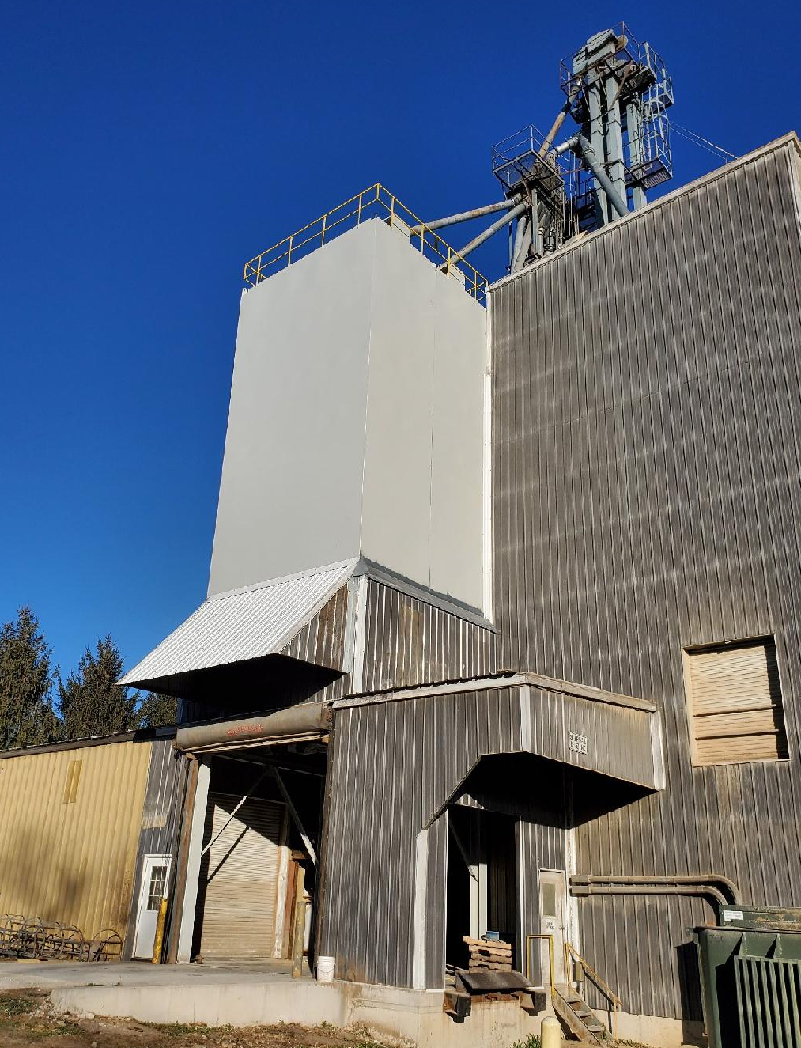  As always, please keep winter road and driveway conditions in mind for our hard working and highly skilled truck drivers. If you have any questions or concerns about getting a feed truck in your yard to deliver feed products, please feel free to call us. Please check our Future Events section on the back page for our Holiday Hours at the end of this month! |  |  | New product:  Non-GMO Soy-Oat Pellets  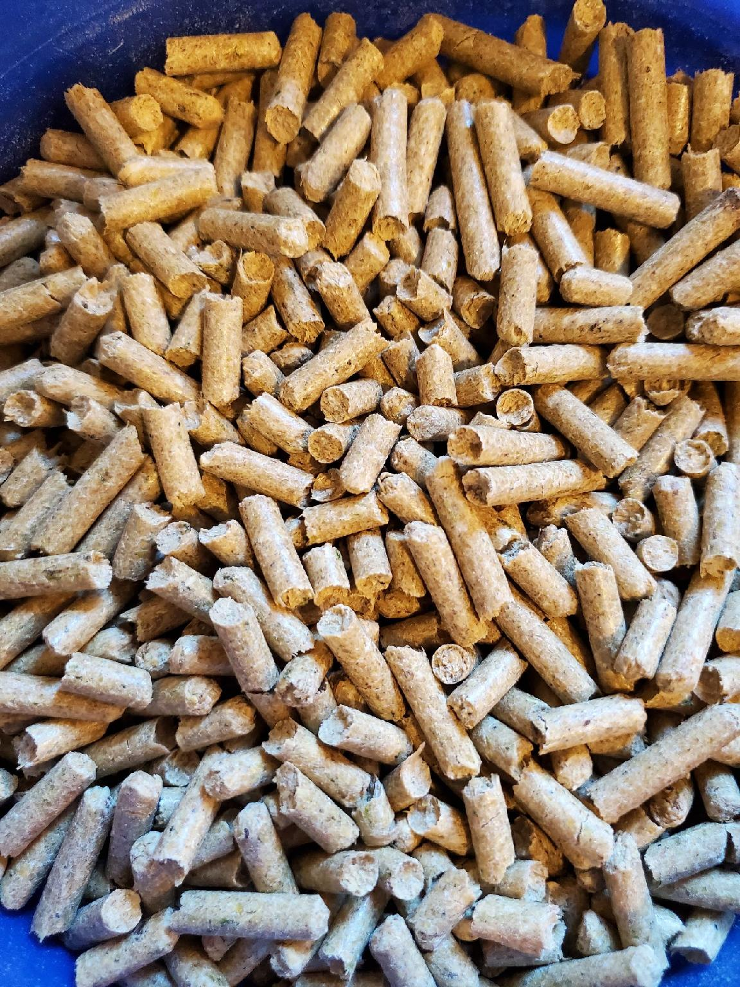  We have decided to create a new product to solve some demands from customers, and to better utilize more industry byproducts. Our new Non-GMO Soy-Oat Pellets consist of a 50/50 mix of Non-GMO Oat Mill Run Byproduct and Non-GMO Soy Hulls. This mixed product is a very uniform blend as it is mixed through our feed mill. Since the soy hulls are high in protein, this product comes in around 15% crude protein. That kind of protein level may be a bit more attractive for our equine customers who may be looking for a higher protein boost, compared to our Non-GMO Oat Mill Run Pellets that are only 10% crude protein. Currently, we are planning on trying to keep up with stocking 2 loads of this product, but with current high demands, we may have a hard time to keep up with all orders! Call today for more information!

Warehouse offerings!
CONTACT US!
300 Forest Street
Riceville, IA 50466
641-985-2494 Office
riversidefeeds@gmail.com
www.riversidefeeds.net
Current specials of available supplies. Please refer to enclosed Price List for all products. All items/products are FOB Riceville, IA. Please call to verify availability on all products. Customer pickup or delivery of products can be arranged anytime. |  |  |  |  |  | ORGANIC GRAIN PRICES:  *Upper Midwest References  Corn: $9.50 / Bu  Soybeans: $32.00 + / Bu Feed, $34.00 + / Bu Food  Wheat: $8.00 / Bu  Barley: $8.00 / Bu  Oats: $7.50 / Bu  Soybean Meal: $1550 / Ton
Smidley Livestock Equipment: single, double, and triple hog drinking bars & hog scales available in used, refurbished condition. |  |  | Non-GMO Whole Oats, 42# test weight. $350 per ton Bulk. Have about 10 ton that needs to move.  Non-GMO Oat Mill Run Pellets – 50 pound sacks, totes, or bulk. Supply is readily available again!  Non-GMO Pig Starter/Grower, and Non-GMO Hog Grower/Finisher in 50 pound sacks in stock.  Retail: Smidley, Crystal Creek, Fertrell, Redmond Agriculture, Redmond human & hunt products, Dr. Paul’s Lab, Dr. Sarah’s Essentials, Pyganic, Apple Cider Vinegar – For humans and animals!  Full Warehouse selection of vitamins, minerals, and ingredients! Ingredient prices have been going up, so stock up now to save money.
FUTURE EVENTS:
- We are finished with heavy construction! Feel free to stop by to check out all our new bins!
- Office & Production Holiday Hours:
- Christmas: Closing at 12 Noon on December 23rd. Closed all day on December 24th. Normal hours starting Monday, December 27th.
- New Year’s: Closed all day on December 31st. Normal hours starting Monday, January 3rd.
- Don’t forget to stock up on your favorite Redmond Real Salt seasonings for the holidays!
- Keeping COVID-19 concerns in mind, please do NOT enter our premises if you are feeling ill or recently tested positive for COVID-19. Our office doors are OPEN to the public.
- PLEASE NOTE - Office Hours: Monday – Thursday: 8 am – 5 pm. Friday: 8 am – 4 pm.
Seasonal Products:

Wildlife Feed Pellets – Fresh made, Now Available! $10 / 50# bag
Redmond Trophy Rock – Wildlife mineral rock. $15 / 20# rock
Redmond Hunt Cherry or Apple Bomb $14 / 20# bag - $22 / 40# bag Cherry or Apple Bomb Spray $14
SunCoast Pine Shavings – Keep your critters warm and dry! $8 / 25# bag 12 cubic foot
Non-GMO Oat Fiber for bedding use only – Available in 50# bags, totes, or bulk – Call for more info. $125 / ton. LIMITED TIME ONLY!

