. | The Feeder |  |  |  | December 2022

thank you for another great year!
As we close in on another successful year, we have been already starting to crunch some numbers to analyze our success. Obviously, none of our success would be possible without our loyal customers, vendors, and haulers who keep the supply streams moving through our mill! THANK YOU!!  Due to our never ending growth, we made a recent investment in a third hauling semi truck this past month. We now have three semi trucks with hopper bottom grain trailers, and all three haul ground oat screenings out of St. Ansgar every day of the week, as that is our primary byproduct that we pelletize. Having three hauling rigs gives us a lot more flexibility to haul several loads every day and to allow sufficient maintenance time for all three rigs. All of these hauling trucks are blue! This year alone, we will haul over 900 loads of ground oat screenings from St. Ansgar to Riceville to get pelleted through our mill! This product makes up our ‘Oat Mill Run Pellets’, which gets distributed all over the central United States. Many of our local customers may receive these pellets via our bulk feed truck, or may pick up directly from our mill either in bulk, tote bag, or 50# sack form. We primarily focus on this product line as it accounts for roughly 75% of our supply. We take great pride in making these Oat Mill Run Pellets, and are eager to serve your feed needs with this ingredient! |  | 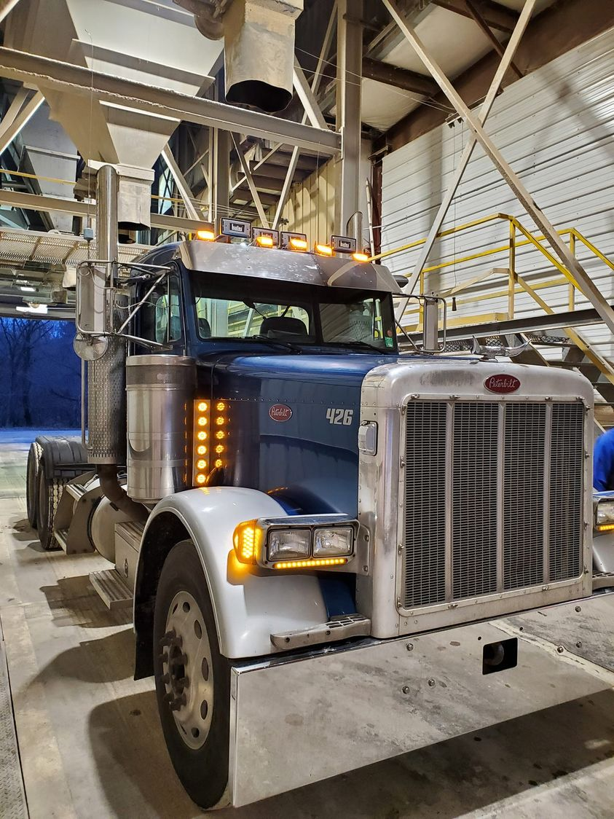  We are also on track to hit new record levels this year. We are projecting to sell over 33,000 tons this year, with a gross revenue value of $6,100,000! These numbers are record shattering, as they show roughly 20% increase over last year’s production and sales numbers. Again, thank you for this impressive growth!  Product supplies have been slowly rebounding. We have started to see some organic soy proteins become available, but the price is still holding strong yet. Certain byproducts like organic soy hulls are very difficult to find, and are very limited. Keep a close eye on our price list to see what products are available or not. Our production schedule is very tight for up to 2 weeks out, so please call us ahead of time to schedule for any feed needs. Also pay attention to our upcoming holiday hours, which you can read on the back side of this page! |  | 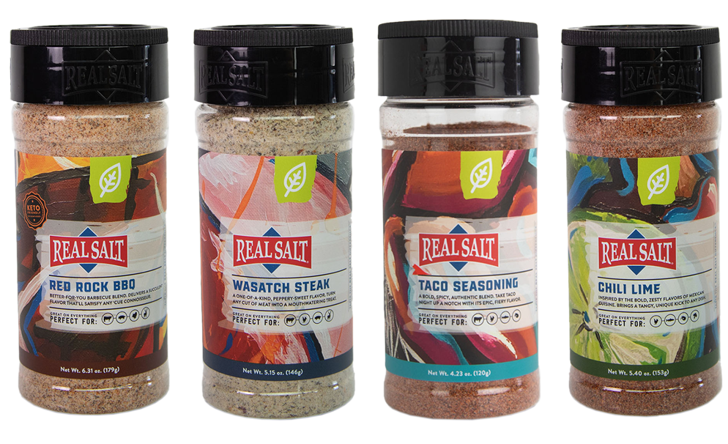  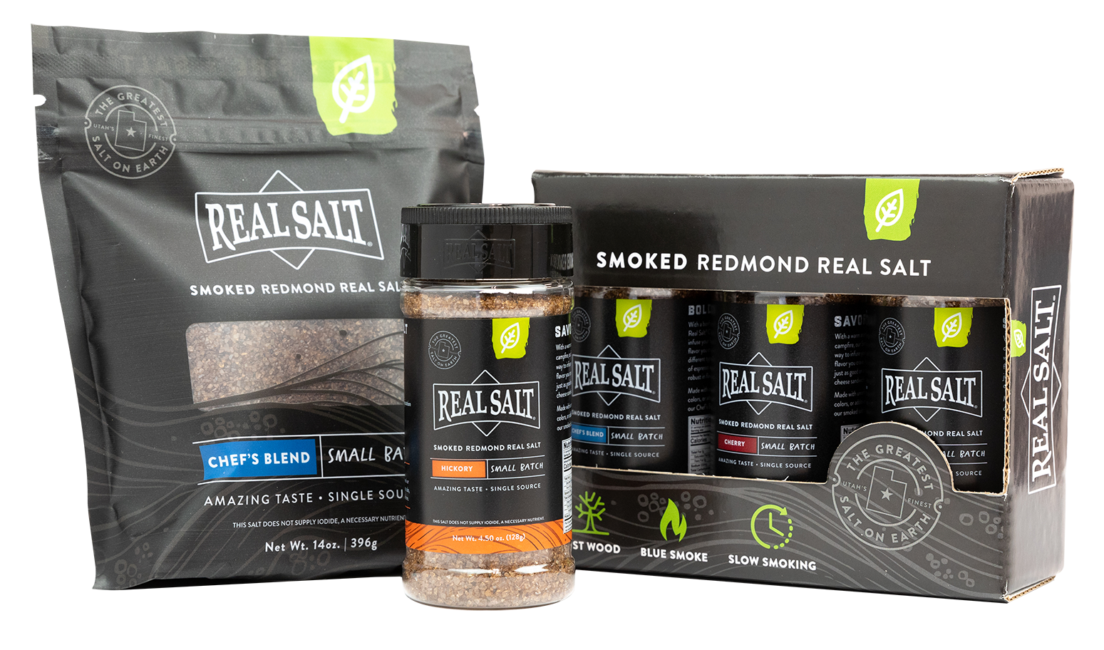 | Real salt seasonings  Did you know that Redmond also produces and sells human grade salt products under the brand Real Salt? We proudly stock all of Real Salt’s different seasoning salts for human consumption, plus we even use these seasoning salts right here in our break room (aka Feed Lot)! Recently, Real Salt introduced to the market their smoked seasoning salts, which is superior for any kind of smoked meats. Now, Real Salt has also introduced some new seasoning salts beyond what they already have had on the shelf. This includes Red Rock BBQ, Wasatch Steak, Taco Seasoning, and Chili Lime! We have these new seasoning salts on order and are eager to get them on our shelf very soon for you to check out! Stop by at our newly renovated office to stock up on the best seasoning salts for the upcoming holidays!

Warehouse offerings!
CONTACT US!
300 Forest Street
Riceville, IA 50466
641-985-2494 Office
riversidefeeds@gmail.com
www.riversidefeeds.net
Current specials of available supplies. Please refer to enclosed Price List for all products. All items/products are FOB Riceville, IA. Please call to verify availability on all products. Customer pickup or delivery of products can be arranged anytime. |  |  |  |  |  | ORGANIC GRAIN PRICES:  *Upper Midwest References – NOT Riverside Feeds Offers  Corn: $10.00 / Bu  Soybeans: $28.00 + / Bu Feed, $30.00 + / Bu Food  Wheat: $9.00 / Bu  Barley: $8.00 / Bu  Oats: $6.00 / Bu  Soybean Meal: $1370 / Ton +
Smidley Livestock Waterer Equipment: single, double, and triple hog drinking bars and scales available in used, refurbished condition.  Smidley used equipment special: Hog, Sheep, Goat portable head chute! A great condition oldie. Asking $950 OBO. Digital head hog scale - $2800. |  |  | Organic Soybean Oil – Available in 1 ton liquid totes for $0.85 / #. Currently have 1 tote available.  Organic Opro 40 Soy Protein – Available either bulk or 2,000# totes. $1150 / ton. Organic Okara Soy Protein – bulk or totes $1,000 / ton.  Non-GMO & Organic Oat Mill Run Pellets – 50 pound sacks, totes, or bulk. Supply is readily available!  Organic Steamed Rolled Oats – Available in 2,000# totes or bulk. $1000 / ton.  EXPANDED Retail Shelf: Smidley, Crystal Creek, Fertrell, Redmond Agriculture, Redmond human & hunt products, Dr. Paul’s Lab, Dr. Sarah’s Essentials, Pyganic, Apple Cider Vinegar – For humans and animals!
FUTURE EVENTS:
- Upcoming holiday hours – Please plan around our closings so we can spend time with our families:
- Closing at 12 noon on Friday, December 23rd for Christmas Eve.
- Closed on Monday, December 26th for Christmas.
- Closing at 12 noon on Friday, December 30th for inventory count/end of year business.
- Closed on Monday, January 2nd for New Year’s Day.
- We are planning on attending several organic farming conferences this winter, including Minnesota Organic Conference in St. Cloud, MN; Practical Farmers of Iowa Conference in Ames, IA; and Marbleseed Organic Farming Conference in La Crosse, WI.
- Keeping COVID-19 concerns in mind, please do NOT enter our premises if you are feeling ill or recently tested positive for COVID-19. Our office doors are OPEN to the public.
- PLEASE NOTE - Office Hours: Monday – Thursday: 8 am – 5 pm. Friday: 8 am – 4 pm.
Seasonal Products:

Non-GMO Swine Feeds – Hog Starter/Grower pellets for $16 / 50# bag, and Hog Grower/Finisher pellets for $13 / 50# bag
Redmond Trophy rock ($15 / 20#) and Bomb Pellets (Cherry or Apple flavor - $14 / 20# bag) for wildlife growth and development. Redmond Apple or Cherry Spray for $14. Riverside’s Wildlife Feed freshly made for $10 / 50# bag.

