. | The Feeder |  |  |  | February 2023

winter conference season in progress
Like any other year, we always attend a few organic farming conferences in the Upper Midwest to advertise our business and products that we have available. This past month, we attended the Minnesota Organic Conference in St. Cloud, MN, and the Practical Farmer’s of Iowa Annual Meeting in Ames, IA. Both of these conferences were well attended and we made great connections with current and potentially new customers! We also greatly enjoyed the delicious, local, organic food that was served (the best part!). We are planning on attending the Marbleseed Organic Farming Conference in La Crosse, WI, later this month.  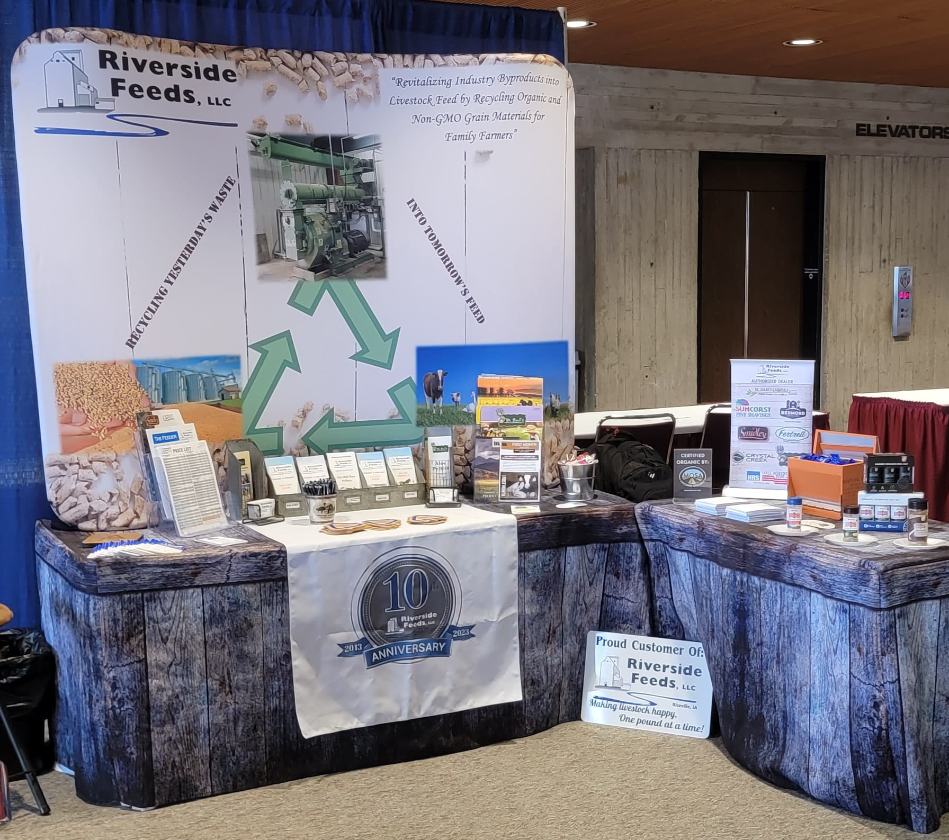  We highly encourage you to attend these conferences at some point. There are many great workshops, exhibitors, and friendly networking to learn from and gain new acquaintances! While we are fairly busy with our pelleting work at this time, we are trying to push more of our retail products at these shows, including Dr. Paul’s Lab, Redmond Agriculture, Fertrell minerals, Smidley equipment, and more. |  | SAVE THE DATE!  Friday, August 4th, 2023  Riverside Feeds 10th Anniversary Open House – Riceville, IA  More details will come throughout the year, but we are already in the planning stages of hosting an open house on Friday, August 4th to the general public and our customers! This open house will include food, beverages, music, and tours of our fully revamped facility that we have been building for the past 10 years! We hope you can join in on the fun! We will also have many giveaways to celebrate our 10 successful years that we will be handing out at the open house as well as the Redmond Agriculture meeting on Tuesday, March 14th.  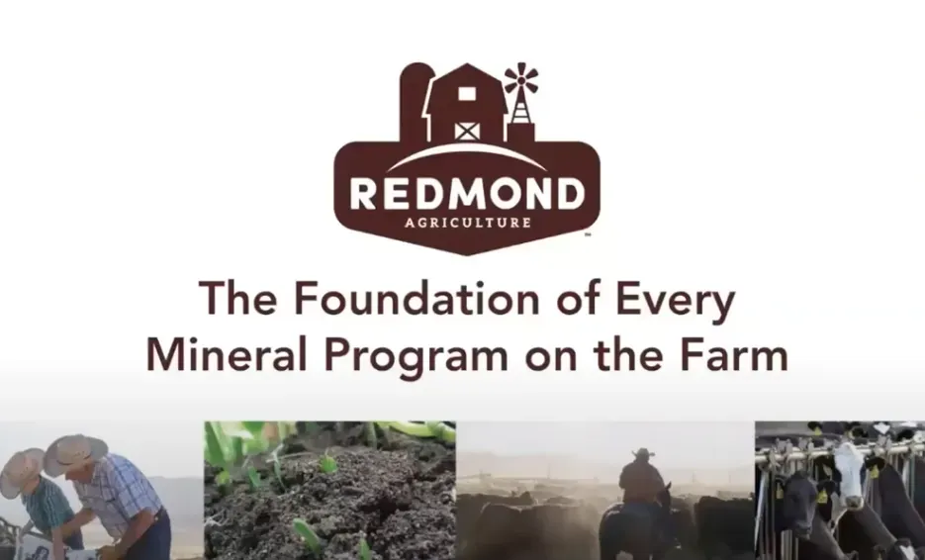  Product supplies have been slowly rebounding. We have started to see some organic soy proteins become available, and the prices have slowly been easing. Certain byproducts like organic soy hulls are very difficult to find, and are very limited. We have been holding a steady but constantly moving supply of Non-GMO Oat Mill Run Pellets. Keep a close eye on our price list to see what products are available or not. Our production schedule is very tight for up to 2 weeks out, so please call us ahead of time to schedule for any feed needs. Also keep in mind that Mother Nature can slow us down, which can greatly effect our trucking and production schedules. |  |  | redmond agriculture meeting coming soon – march 14th  Keep in mind that minerals are critically important for all species of livestock for proper nutrition. Proper mineral balances can lead to best possible gains, milk, and breeding production rates, as well as crop yields and nutritional quality. Grazing livestock can source some minerals from the ground or from diverse plants during the grazing season, but during the cold months, those minerals are not always available to them. It is important to continue to offer minerals and vitamins to your livestock either in their feed or free choice.  We are coordinating another Redmond Agriculture production meeting this spring for our local customers in the Northeast Iowa area. Last year’s meeting was a great success, so we decided to host Tim Williams again this coming March 14th here in Riceville, IA. Come learn what Redmond has to offer to your farm & family!

Warehouse offerings!
CONTACT US!
300 Forest Street
Riceville, IA 50466
641-985-2494 Office
riversidefeeds@gmail.com
www.riversidefeeds.net
Current specials of available supplies. Please refer to enclosed Price List for all products. All items/products are FOB Riceville, IA. Please call to verify availability on all products. Customer pickup or delivery of products can be arranged anytime. |  |  |  |  |  | ORGANIC GRAIN PRICES:  *Upper Midwest References – NOT Riverside Feeds Offers  Corn: $10.00 / Bu  Soybeans: $28.00 + / Bu Feed, $30.00 + / Bu Food  Wheat: $9.00 / Bu  Barley: $8.00 / Bu  Oats: $6.00 / Bu  Soybean Meal: $1300 / Ton +
Smidley Livestock Waterer Equipment: single, double, and triple hog drinking bars and scales available in used, refurbished condition.  Smidley used equipment special: Hog, Sheep, Goat portable head chute! A great condition oldie. Asking $950 OBO. Digital head hog scale - $2800. |  |  | Organic Prewean 22 – This swine feed is made for young pigs to start on dry creep feed prior to weaning. $34 / 50#  Organic Opro 40 Soy Protein – Available either bulk or 2,000# totes. $1000 / ton. Organic Okara Soy Protein – bulk or totes $1,000 / ton.  Non-GMO & Organic Oat Mill Run Pellets – 50 pound sacks, totes, or bulk. Supply is readily available!  Organic Steamed Rolled Oats – Available in 2,000# totes or bulk. $1000 / ton.  EXPANDED Retail Shelf: Smidley, Crystal Creek, Fertrell, Redmond Agriculture, Redmond human & hunt products, Dr. Paul’s Lab, Dr. Sarah’s Essentials, Pyganic, Apple Cider Vinegar – For humans and animals!
FUTURE EVENTS:
- Marbleseed Organic Conference (formerly MOSES) will be Thursday – Saturday, February 23rd – 25th in LaCrosse, WI. We will be on the trade show floor with our exhibit booth – look for us for info!
- Redmond Agriculture meeting – Tuesday, March 14th, 9:30 am – 3 pm, Riceville Community Center, Riceville, IA. Come learn about all the products and benefits that Redmond Agriculture has to offer! Will include a free lunch & giveaways. We will be fully stocked for all your Redmond needs!
- Riverside Feeds 10 Year Open House – Friday, August 4th, 2023, 1 pm – 6 pm, in Riceville, IA. Will include Food Trucks, Mill Tours, LIVE MUSIC, Beverages/Ice Cream, & Giveaways! Save the Date!!!
- Keeping COVID-19 concerns in mind, please do NOT enter our premises if you are feeling ill or recently tested positive for COVID-19 or Influenza. Our office doors are OPEN to the public.
- PLEASE NOTE - Office Hours: Monday – Thursday: 8 am – 5 pm. Friday: 8 am – 4 pm.
Seasonal Products:

Non-GMO Swine Feeds – Hog Starter/Grower pellets for $16 / 50# bag, and Hog Grower/Finisher pellets for $13 / 50# bag
Redmond Trophy rock ($15 / 20#) and Bomb Pellets (Cherry or Apple flavor - $14 / 20# bag) for wildlife growth and development. Redmond Apple or Cherry Spray for $14. Riverside’s Wildlife Feed freshly made for $10 / 50# bag.

