. | The Feeder |  |  |  | February 2024

surviving the cold winter weather
This month has been a great start to another very busy year. We have been meeting or exceeding our sales expectations, which is normal this time of the year. Winter season is generally a very busy time for us as farmers need additional pelleted feed supplies to supplement hay and forages. We have been very busy selling our Non-GMO Oat Mill Run Pellets for cattle and horse feed ingredients, and as you can see below, our bulk feed truck delivery schedule is extremely busy! Yes, we do need a second feed delivery truck in order to keep up, but that is not a cheap addition so that option will take some time for us to attain. We greatly appreciate everyone’s patience and cooperation as we try our best to fulfill everyone’s orders. PLEASE order well in advance of your needs – as listed, we are pushing 12 plus business days out on our feed truck delivery schedule! We also greatly appreciate everyone’s cooperation with moving snow to allow our truck to manueveur around yards with ease, and being flexible with delivery times as we have to work around mother nature at times. Again, thanks for your patience!  18 TON FEED TRUCK SCHEDULE:  Currently 12 + business days out for deliveries – Please order EARLY! |  | We have been very busy with conference season this past month as we appreciate supporting local farming organizations and meeting our customers on the road! We exhibited at the Minnesota Organic Conference in St. Cloud, and the Practical Farmers of Iowa Annual Meeting in Des Moines recently, and made many great connections with exisitng and new customers! We heard many great comments on our exhibit booth, which was fully designed and recently updated by our marketing specialist, Amanda.  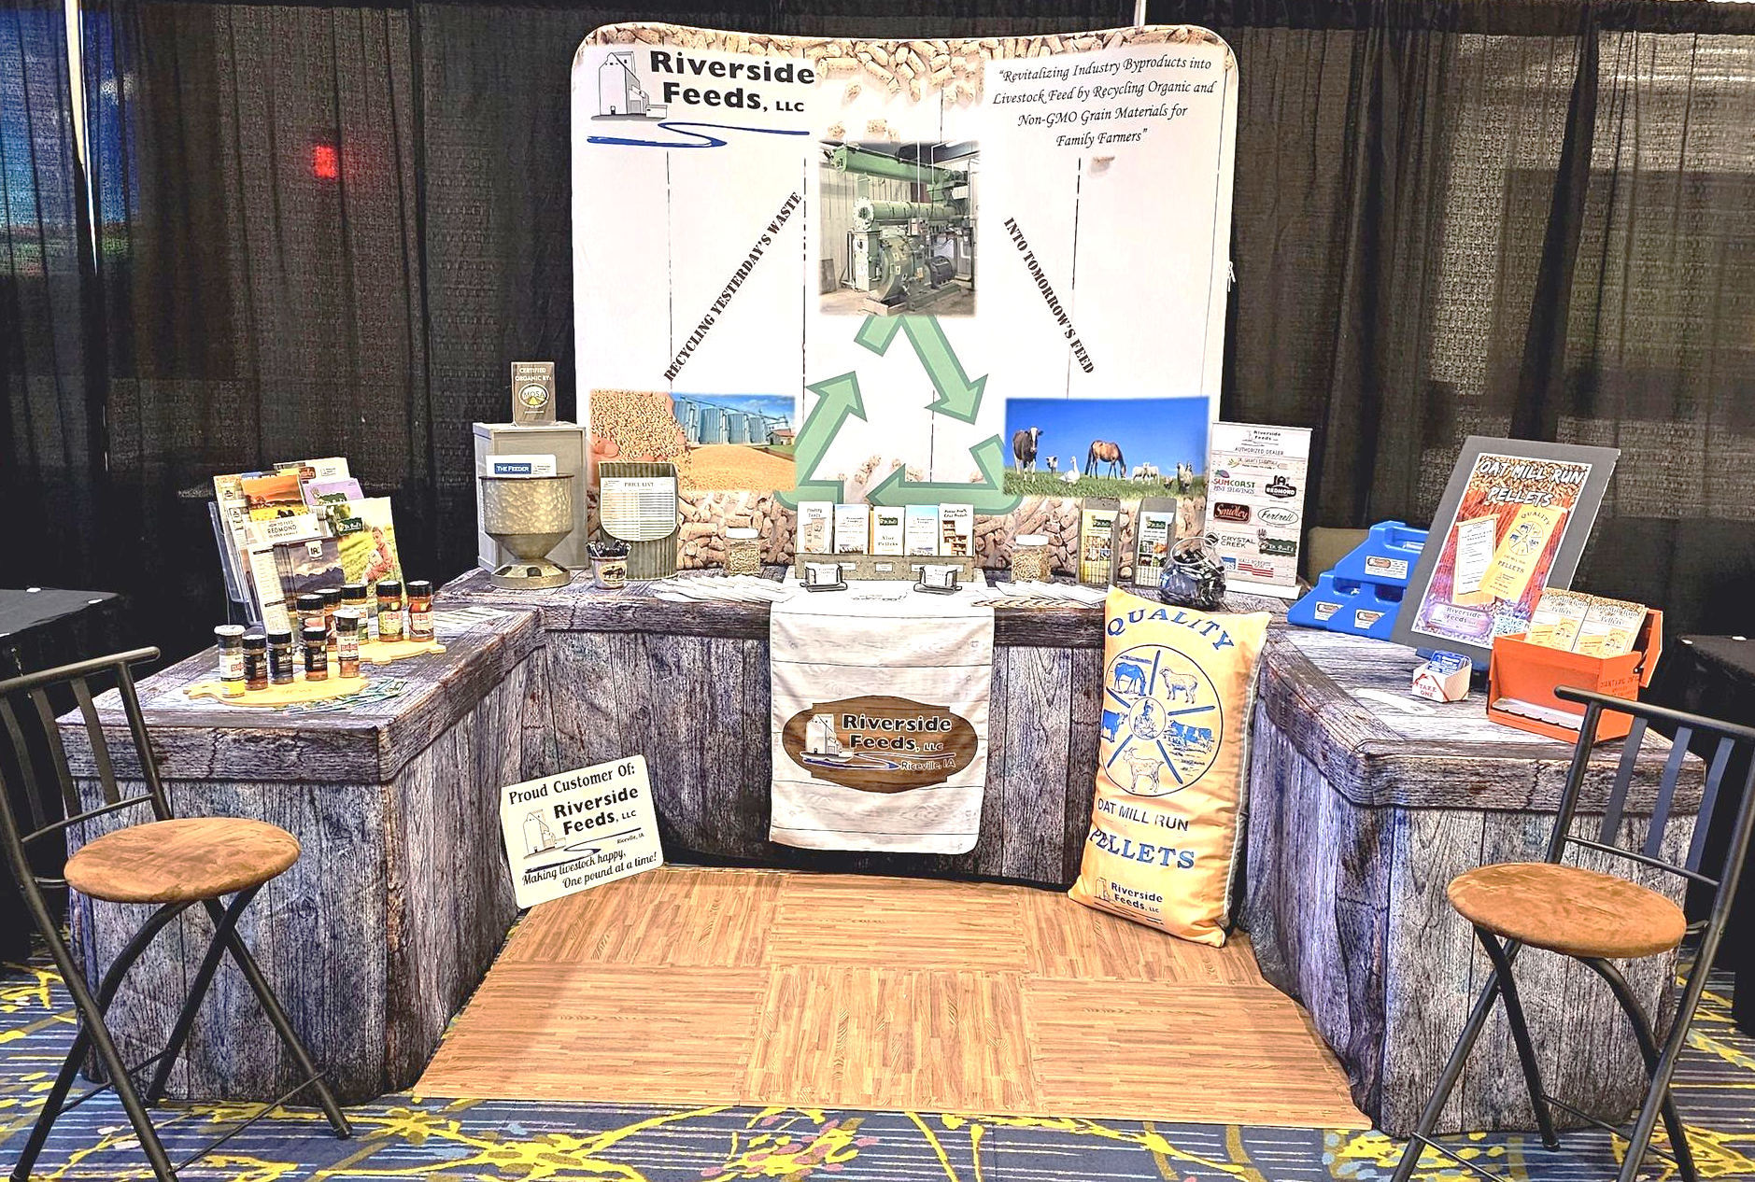  By the time you read this newsletter, Amanda and I will be attending the International Production & Processing Expo (IPPE) in Atlanta, Georgia, which we are very excited to see! This expo includes over 1400 exhibitors and over 30,000 attendees from all over the world, specializing in the food, feed, meat, and poultry industries. We will be learning a lot about the future of the animal feed industry and finding all the new products and tools to better serve you in the future! I will share more from this expo online and next month! |  | 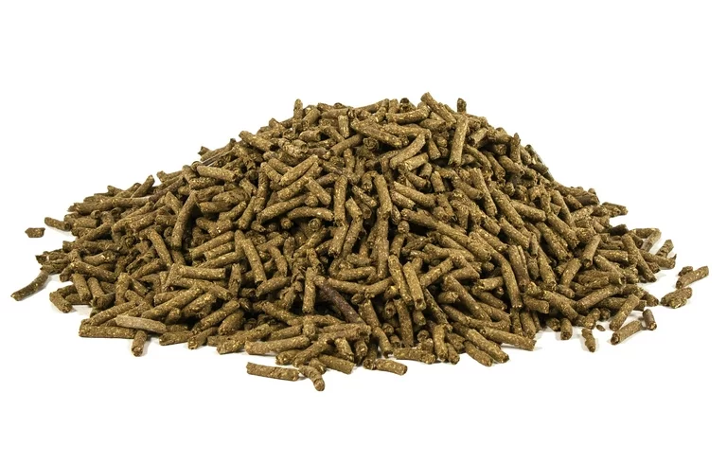 | Dr. Paul’s Lab  Aloe Pellets  I know I have written about these aloe pellets several times in the past; however, I find that these pellets work so well and are critical to use this time of the year that I wanted to share more information about them again! We have had some extreme temperature swings in the Upper Midwest this winter season. It was a very warm and mild December with hardly any snow, then finally winter in January with snow and extreme cold temps with swings from 30 degrees down to -30 degrees. Now, it is supposed to warm back up this coming week to the mid 40’s, which will create excessive amounts of humidity. This moisture in the air is going in and out of every animal on your farm (including yourself) and is very challenging for your immune system. I’m going to share a very famous and easy quote from the late Dr. Paul regarding these conditions: “Aloe Pellets, Aloe Pellets, Aloe Pellets!” It’s that simple! Fresh stock just arrived last week!  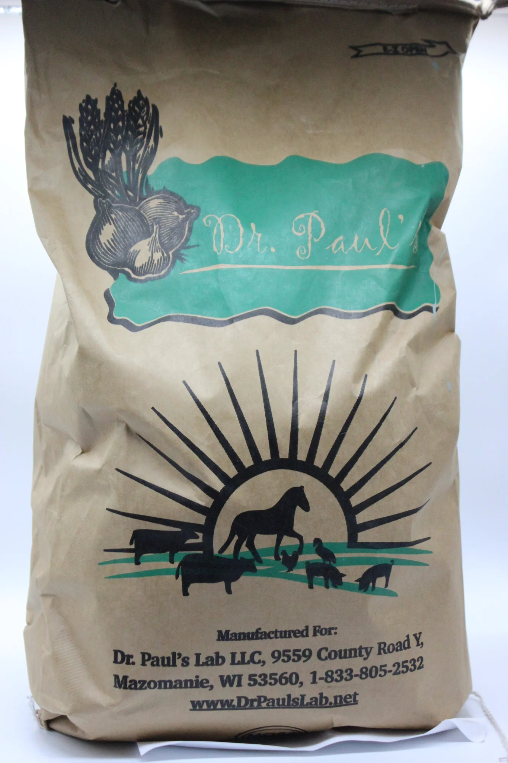  $62 / 40# Bag  1 – 2 ounces /  100# Body  Weight /  Day

Warehouse offerings!
CONTACT US!
300 Forest Street
Riceville, IA 50466
641-985-2494 Office
riversidefeeds@gmail.com
www.riversidefeeds.net
Current specials of available supplies. Please refer to enclosed Price List for all products. All items/products are FOB Riceville, IA. Please call to verify availability on all products. Customer pickup or delivery of products can be arranged anytime. |  |  |  |  |  | ORGANIC GRAIN PRICES:  *Upper Midwest References – NOT Riverside Feeds Offers  Corn: $8.00 / Bu  Soybeans: $20.00 + / Bu Feed, $24.00 + / Bu Food  Wheat: $8.00 / Bu  Barley: $6.00 / Bu  Oats: $4.50 / Bu  Soybean Meal: $925 / Ton +
Smidley Livestock Waterer Equipment: single, double, and triple hog drinking bars and scales available in used, refurbished condition.  Seasonal Products:  Non-GMO Wildlife Feed Pellets (grain and protein mix with molasses and cherry flavoring) - $10 / 50# bag.  Remond Hunt Trophy Rock – mineral rock for wildlife. $15 / 20#.  Non-GMO Hog Starter-Grower and Grower-Finisher: $17 & $14/50# bag  SunCoast Pine Shavings for $9 / 12 cubic foot bag.  Smidley used equipment special: Hog, Sheep, Goat portable head chute! A great condition oldie. Asking $950 OBO. New digital hog scale available. |  |  | Dr. Paul’s Lab Clean Start Pellets – All natural dewormer/intestinal cleanser for ALL species of livestock! $85 / 25#  Non-GMO Soy Pro 40 – 40% soy protein with high levels of fat, but suitable for multi species of livestock. $400 / ton in sacks or totes.  Organic Apple Cider Vinegar – 55 gal drums $525, or 4 gal pail $45. Non-GMO Apple Cider Vinegar avail too.  Organic Steamed Rolled Oats – Available in 2,000# totes or bulk. $1000 / ton.  EXPANDED Retail Shelf: Smidley, Crystal Creek, Fertrell, Redmond Agriculture, Redmond human (Real Salt & Re-Lyte) & hunt products, Dr. Paul’s Lab, Dr. Sarah’s Essentials, Pyganic, Apple Cider Vinegar – For humans and animals!
FUTURE EVENTS:
- Conference season is taking place! We will be traveling to the following conference this month – check out our exhibit booth for up-to-date information and new swag!
- Southern Iowa Grazing Conference, Bloomfield, IA – February 16 & 17, 2024

- We will also be traveling to the International Production and Processing Expo in Atlanta, GA which will take place January 30 – February 1, to learn more about our feed processing industry! Stay tuned to hear about our trip in next month’s newsletter!

- Waukon Organic Farmer’s Meeting, Freedom Bank Community Room in Waukon, IA. Wednesday, February 21st from 7 pm – 9 pm. For more information, call Gary Welsh at 563-535-7318

- Riverside Feeds M/Core Team Retreat – Saturday, March 2nd, 2024. Our staff will be discussing long term goals and planning for the future of this business!

- PLEASE NOTE - Office Hours: Monday – Thursday: 8 am – 5 pm. Friday: 8 am – 4 pm.

