. | The Feeder |  |  |  | March 2023

redmond agriculture meeting march 14
We are very excited to host Tim Williams from Redmond Agriculture again this spring for a farmer educational meeting! This meeting will be taking place at the Riceville Community Center on Tuesday, March 14th from 9 am to 3 pm. Tim will be sharing information about all of Redmond’s products which are beneficial to all species of livestock, your soils for crop fertility, and even human grade products for your food and skin care! Redmond Minerals is located in Redmond, Utah, where they have an above ground open pit mine of volcanic ash clay, and an underground mine of some of the highest quality mineral salt in the world. This ancient sea salt comprises of over 65 trace minerals that has shown to improve livestock health and production, nutritional density in grain and forage crops, and human health and flavor! We are looking forward to sharing this information with you at this meeting, and will be fully stocked at the mill (located just a few blocks away) for you to stock up on products following the meeting. Lunch will be provided to all attendees so come hungry! |  | SAVE THE DATE!  Friday, August 4th, 2023  Riverside Feeds 10th Anniversary Open House – Riceville, IA  We have had a great start to the new year with production and sales! We continue to stay very busy with pelleting Oat Mill Run Pellets and shipping that product all over the central US for multiple species, primarily consisting of cattle and horses. We have also been busy processing byproducts for other companies as well, which goes out to organic dairy farms all across the US. Our byproduct soy proteins have been rebounding and becoming more readily available recently, primarily Organic Opro 40 and Non-GMO Soy Pro 40. If you have used these products in the past and would like to use this protein again, feel free to call us and place an order soon while it’s available!  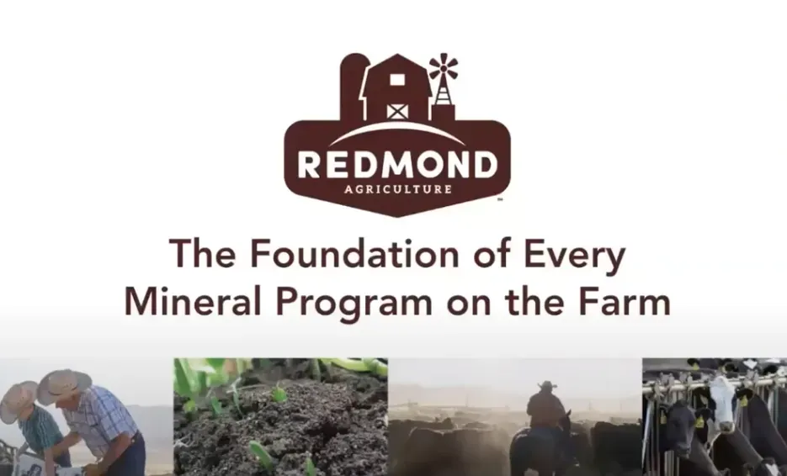  Our production schedule is very tight for up to 2 weeks out, so please call us ahead of time to schedule for any feed needs. Also keep in mind that Mother Nature can slow us down, which can greatly effect our trucking and production schedules. We are now entering mud season for our area, which can make on farm deliveries challenging. Please make every attempt possible to have hard packed rock available in your yards for our feed truck, as we wish to avoid major towing bills if we happen to get stuck! |  |  | Spring products are ready for you  I’m sure you are as eager as I am to see winter moving on and spring arriving soon! We know our seasons well here, and we’ve already been busy preparing for this next season for you. We just made our first batch of our Non-GMO Chick Starter Crumbles up for this spring, and it is in the warehouse and ready for your new chicks! We also have a plentiful supply of our Non-GMO Layer Feed and Broiler Grower Feed ready for your birds. Our SunCoast Pine Shavings make for great dry bedding for your young animals as we will continue to have some wet, damp, and cold days ahead yet.  We also can order any amounts of Redmond SR65 for your agronomy needs as we prepare to till the ground and plant crops over the next couple of months. As you may have learned from last year’s Redmond meeting or will learn in a couple of weeks, Redmond has some great beneficial products for your soil to boost yields and nutritional density of your crops. Since we are a Redmond dealer, we can order in any of their agronomy products for you to use. Agronomy products may take a couple weeks to arrive, so you may want to order soon!

Warehouse offerings!
CONTACT US!
300 Forest Street
Riceville, IA 50466
641-985-2494 Office
riversidefeeds@gmail.com
www.riversidefeeds.net
Current specials of available supplies. Please refer to enclosed Price List for all products. All items/products are FOB Riceville, IA. Please call to verify availability on all products. Customer pickup or delivery of products can be arranged anytime. |  |  |  |  |  | ORGANIC GRAIN PRICES:  *Upper Midwest References – NOT Riverside Feeds Offers  Corn: $10.00 / Bu  Soybeans: $28.00 + / Bu Feed, $30.00 + / Bu Food  Wheat: $9.00 / Bu  Barley: $8.00 / Bu  Oats: $6.00 / Bu  Soybean Meal: $1200 / Ton +
Smidley Livestock Waterer Equipment: single, double, and triple hog drinking bars and scales available in used, refurbished condition.  Smidley used equipment special: Hog, Sheep, Goat portable head chute! A great condition oldie. Asking $950 OBO. Also have 2 hog scales available. |  |  | Organic Prewean 22 – This swine feed is made for young pigs to start on dry creep feed prior to weaning. $34 / 50#  Organic Opro 40 Soy Protein – Available either bulk or 2,000# totes. $1000 / ton. Organic Okara Soy Protein – bulk or totes $1,000 / ton.  Non-GMO & Organic Oat Mill Run Pellets – 50 pound sacks, totes, or bulk. Supply is readily available!  Organic Steamed Rolled Oats – Available in 2,000# totes or bulk. $1000 / ton.  EXPANDED Retail Shelf: Smidley, Crystal Creek, Fertrell, Redmond Agriculture, Redmond human & hunt products, Dr. Paul’s Lab, Dr. Sarah’s Essentials, Pyganic, Apple Cider Vinegar – For humans and animals!
FUTURE EVENTS:
- Redmond Agriculture meeting – Tuesday, March 14th, 9:00 am – 3 pm, Riceville Community Center, Riceville, IA. Come learn about all the products and benefits that Redmond Agriculture has to offer! Will include a free lunch & giveaways. We will be fully stocked for all your Redmond needs!
- Organic Valley Annual Meeting – Tuesday – Thursday, March 28th – 30th in LaCrosse, WI. I will be attending the meeting, so we can catch up if you are an Organic Valley farmer!
- Riverside Feeds 10 Year Open House – Friday, August 4th, 2023, 1 pm – 6 pm, in Riceville, IA. Will include Food Trucks, Mill Tours, LIVE MUSIC, Beverages/Ice Cream, & Giveaways! Save the Date!!!
- Keeping COVID-19 concerns in mind, please do NOT enter our premises if you are feeling ill or recently tested positive for COVID-19 or Influenza. Our office doors are OPEN to the public.
- PLEASE NOTE - Office Hours: Monday – Thursday: 8 am – 5 pm. Friday: 8 am – 4 pm.
Seasonal Products:

Non-GMO Swine Feeds – Hog Starter/Grower pellets for $16 / 50# bag, and Hog Grower/Finisher pellets for $13 / 50# bag
Non-GMO Chick Starter Crumbles now available! $20 / 50# bag. Also have Non-GMO Layer Feed Pellets and Broiler Grower Pellets available at $17 / 50# bag. SunCoast Pine Shavings for $9 / 12 cubic foot bag. Stock up now for your flock!

