. | The Feeder |  |  |  | March 2024

Ippe expo 2024 – atlanta, ga
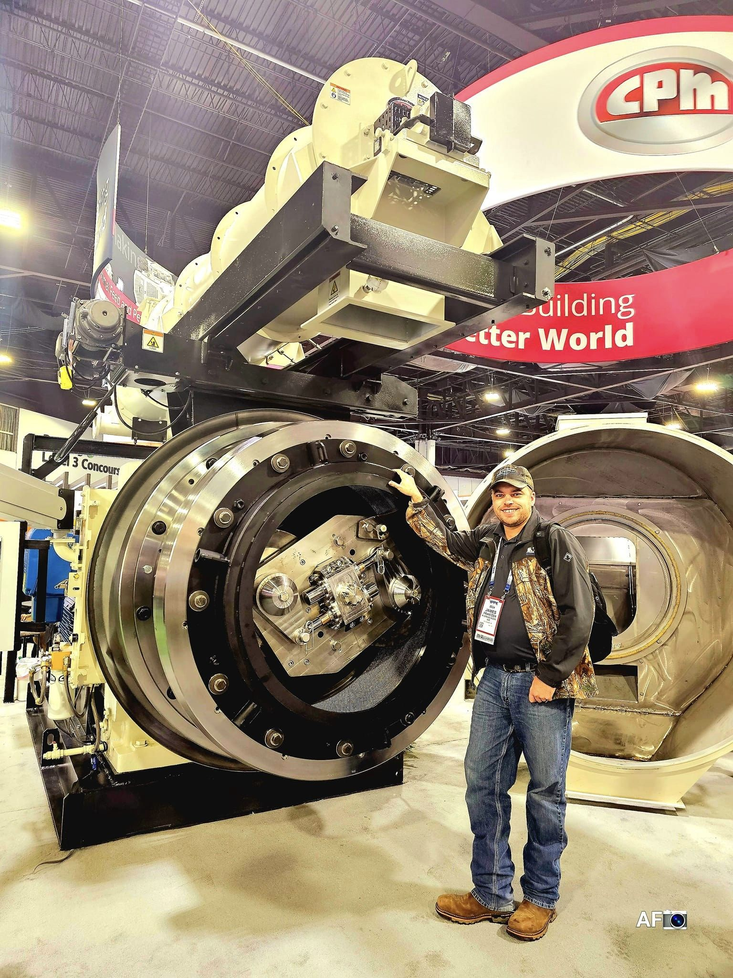  A month ago, Amanda and I traveled to Atlanta, GA, and attended for our first time ever the International Production & Processing Expo. We were blown away when we walked through over 620,000 square feet of exhibit hall space with over 30,000 attendees and over 1,400 exhibitors. We spent most of our time in the animal feed hall, learning and meeting numerous vendors that we currently work with or may possibly work with in the near future to help us with all of our feed processing equipment and products. We viewed multiple brands of feed delivery truck/trailer manufacturers, as we are interested in upgrading our feed delivery truck. We also spent some time with an Iowa based company that manufactures wear parts for our hammer mill and pellet mill. When we visited CPM’s exhibit booth, we were both astonished to see the largest pellet mill in the world, which you can see pictured with me standing in front of the “beast”! This is a lot larger mill than what we have, and is powered by an 800 hp motor which produces 137 tons of feed pellets per hour! This is a bit outside of our budget, however!  18 TON FEED TRUCK SCHEDULE:  Currently 5 + business days out for deliveries – Finally catching up! |  | The other exhibit halls featured poultry, egg, and meat production and processing including facilities, equipment, employee safety, regulation assistance, packaging, and much more. It was fastinating to see that side of the industry as well. I also attended the Feed Mill of the Future Conference, which was a very educational few hours hearing from industry leaders across the world discuss several topics about our immediate feed industry future, which includes insect protein to replace plant proteins. I also heard some interesting remarks about how feed mills can be more efficient and sustainable. It was well worth our trip to Atlanta to see some of the largest and newest products and equipment in our industry! We look forward to attending this expo again at some point in the future to stay in tune with our animal feed industry. |  |  | poultry dirt bath  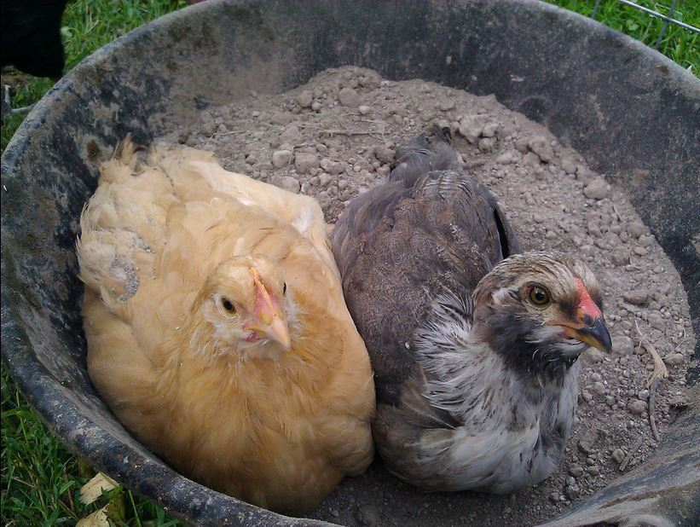  Recently, I ran into some pest issues with our own laying hens (mites). With our abnormally mild winter, insect issues have been very concerning, especially winter lice and mites. A quick, cheap, and natural method came to mind, and it worked very well for us! We blended 50/50 Diatomaceous Earth and Reed Sedge Peat Humates, and placed this mixture in a rubber pan for the birds to bathe in. To top it off, we also added garlic powder to this mixture (insects are NOT attracted to garlic powder!). Instantly, our problem went away, and within 48 hours our birds looked far healthier! We also have Dr. Sarah’s Essentials Delice and Mange Spray on hand, but I didn’t even get a chance to spray that on the birds yet as this poultry dirt bath worked so well so quickly. It is also important to keep the bedding supply changed and fresh as much as possible in these warmer temperatures, which is critical for all livestock at this time. Both products to make this dirt bath are always in stock – stop by today!

Warehouse offerings!
CONTACT US!
300 Forest Street
Riceville, IA 50466
641-985-2494 Office
riversidefeeds@gmail.com
www.riversidefeeds.net
Current specials of available supplies. Please refer to enclosed Price List for all products. All items/products are FOB Riceville, IA. Please call to verify availability on all products. Customer pickup or delivery of products can be arranged anytime. |  |  |  |  |  | ORGANIC GRAIN PRICES:  *Upper Midwest References – NOT Riverside Feeds Offers  Corn: $8.00 / Bu  Soybeans: $20.00 + / Bu Feed, $24.00 + / Bu Food  Wheat: $8.00 / Bu  Barley: $6.00 / Bu  Oats: $4.50 / Bu  Soybean Meal: $925 / Ton +
Smidley Livestock Waterer Equipment: single, double, and triple hog drinking bars and scales available in used, refurbished condition.  Seasonal Products:  Non-GMO Wildlife Feed Pellets (grain and protein mix with molasses and cherry flavoring) - $10 / 50# bag.  Non-GMO Chick Starter – COMING SOON! $22 / 50#.  Non-GMO Hog Starter-Grower and Grower-Finisher: $17 & $14/50# bag  SunCoast Pine Shavings for $9 / 12 cubic foot bag.  Smidley used equipment special: Hog, Sheep, Goat portable head chute! A great condition oldie. Asking $950 OBO. New digital hog scale available. |  |  | Dr. Paul’s Lab Clean Start Pellets – All natural dewormer/intestinal cleanser for ALL species of livestock! $85 / 25#  Non-GMO Soy Pro 40 – 40% soy protein with high levels of fat, but suitable for multi species of livestock. $400 / ton in sacks or totes.  Organic Apple Cider Vinegar – 55 gal drums $525, or 4 gal pail $45. Non-GMO Apple Cider Vinegar avail too.  Organic Steamed Rolled Oats – Available in 2,000# totes or bulk. $1000 / ton.  EXPANDED Retail Shelf: Smidley, Crystal Creek, Fertrell, Redmond Agriculture, Redmond human (Real Salt & Re-Lyte) & hunt products, Dr. Paul’s Lab, Dr. Sarah’s Essentials, Pyganic, Apple Cider Vinegar – For humans and animals!
FUTURE EVENTS:

- Riverside Feeds M/Core Team Retreat – Saturday, March 2nd, 2024. Our staff will be discussing long term goals and planning for the future of this business!

- Solar Town Farm & Home – Seed Days – March 2nd – 9th in Soldier’s Grove, WI. We will be present on Friday, March 8th, to help advertise and answer all your Riverside Feeds product questions! Hope to see you there if you are in that area!

- We will be CLOSED on Good Friday for the Easter Holiday, which is Friday, March 29th. We will be open on Easter Monday, April 1, for regular hours and business. Please plan your feed orders accordingly.

- PLEASE NOTE - Office Hours: Monday – Thursday: 8 am – 5 pm. Friday: 8 am – 4 pm.

