. | The Feeder |  |  |  | April 2023

retreat strategizes future of business
Every year, our Management Team and Core Team meet on a Saturday to avoid any business interruptions and strategize our business direction and future. On March 18th, we spent 6 hours discussing our business focus and where to drive our future as a growing company.  We learned several business lessons in which we applied to Riverside Feeds in order to figure out what our long term focuses should be. One of those focuses is to know and understand what objections are the best for Riverside Feeds, and any future decisions would need to be challenged around key areas including what we can be the best at, what our economic drivers are, and what we are passionate about. These lessons come from the book Good to Great by Jim Collins.  We also spent time looking back at past pictures and discussed how we have built this business up from nothing over the past ten years. It was great to look back at what little infrastructure we had at one time, and where we are today. Who knows what the next ten years has in store for us, but we realize that now is a critical time for us to slow down on construction and focus heavily on team and personal development. We’ve spent so much time these past few years building, and we now need to focus on training our staff to be the best leaders as possible as we grow and develop. |  | SAVE THE DATE!  Friday, August 4th, 2023  Riverside Feeds 10th Anniversary Open House – Riceville, IA  Due to supply constraints, we have been starting to get a bit tight on Non-GMO Oat Mill Run Pellet supply again. We are currently scheduled 2 solid weeks out on our feed truck and pellet orders due to the tight inbound raw supply, so please call us ahead of time if you are getting low. We have an increasing available supply of our high end soy proteins – both Organic Opro 40 and Non-GMO Soy Pro 40. These are full fat processed soy proteins with minimum of 40% crude protein. If you are interested in using this for poultry, swine, or ruminant protein source, please reach out to us for more information.  Our production schedule is very tight for up to 2 weeks out, so please call us ahead of time to schedule for any feed needs. Also keep in mind that Mother Nature can slow us down, which can greatly effect our trucking and production schedules. We do our best when scheduling logistics, but plans can change at times. We are now in mud season for our area, which can make on farm deliveries challenging. Please make every attempt possible to have hard packed rock available in your yards for our feed truck, as we wish to avoid major towing bills if we happen to get stuck! |  | 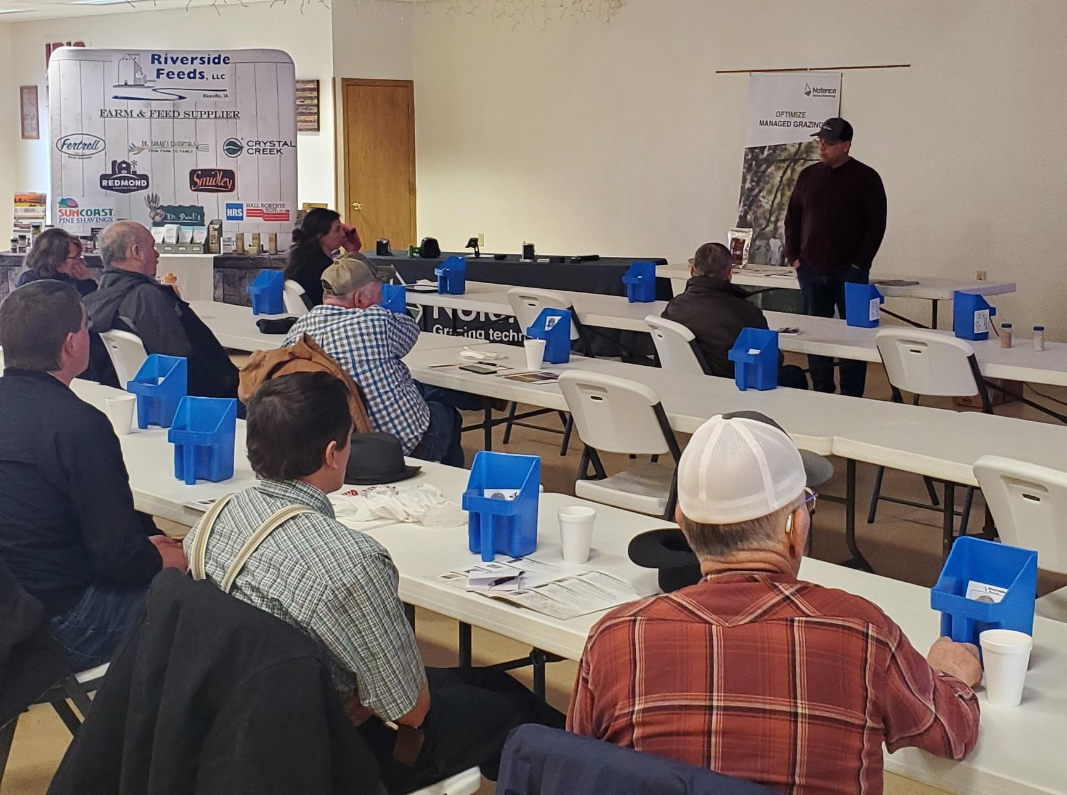 | Redmond meeting  We had a great crowd of local farmers who showed up at our March 14th meeting discussing Redmond Agriculture and No Fence! We learned about multiple benefits of using Redmond’s mineral salt and conditioner for livestock, soil, and human health. If anyone is interested in trying SR50 or SR65 products for agronomy use on your soils, now is the time to place your order as those products are available from our distributor. I’ll be receiving these orders in early April, and we would greatly appreciate to move those totes out the door in a timely manner since we are very tight on warehouse space.  As we are preparing for the spring, keep in mind that we do have Non-GMO Chick Starter on hand and ready for your new baby chicks! We also are well stocked with Non-GMO Layer and Broiler Grower feeds, as well as Non-GMO Swine feeds. To keep your young stock warm and dry, stock up on pine shavings while you are picking up your feedstuffs as well.

Warehouse offerings!
CONTACT US!
300 Forest Street
Riceville, IA 50466
641-985-2494 Office
riversidefeeds@gmail.com
www.riversidefeeds.net
Current specials of available supplies. Please refer to enclosed Price List for all products. All items/products are FOB Riceville, IA. Please call to verify availability on all products. Customer pickup or delivery of products can be arranged anytime. |  |  |  |  |  | ORGANIC GRAIN PRICES:  *Upper Midwest References – NOT Riverside Feeds Offers  Corn: $10.00 / Bu  Soybeans: $26.00 + / Bu Feed, $29.00 + / Bu Food  Wheat: $9.00 / Bu  Barley: $8.00 / Bu  Oats: $6.00 / Bu  Soybean Meal: $1200 / Ton +
Smidley Livestock Waterer Equipment: single, double, and triple hog drinking bars and scales available in used, refurbished condition.  Smidley used equipment special: Hog, Sheep, Goat portable head chute! A great condition oldie. Asking $950 OBO. Also have 2 hog scales available. |  |  | Organic Prewean 22 – This swine feed is made for young pigs to start on dry creep feed prior to weaning. $34 / 50#  Organic Opro 40 Soy Protein – Available either bulk or 2,000# totes. $950 / ton. Organic Okara Soy Protein – bulk or totes $1,000 / ton.  Non-GMO Soy Pro 40 Soy Protein – Available either bulk, 2000# totes, or 50# sacks. $400 / ton.  Organic Steamed Rolled Oats – Available in 2,000# totes or bulk. $1000 / ton.  EXPANDED Retail Shelf: Smidley, Crystal Creek, Fertrell, Redmond Agriculture, Redmond human & hunt products, Dr. Paul’s Lab, Dr. Sarah’s Essentials, Pyganic, Apple Cider Vinegar – For humans and animals!
FUTURE EVENTS:
- We will be CLOSED on Good Friday, April 7th, for the Easter holiday weekend. We will be open on Monday, April 10th. Please plan accordingly.

- Riverside Feeds 10 Year Open House – Friday, August 4th, 2023, 1 pm – 6 pm, in Riceville, IA. Will include Food Trucks, Mill Tours, LIVE MUSIC, Beverages/Ice Cream, & Giveaways! Save the Date!!!

- Keeping COVID-19 concerns in mind, please do NOT enter our premises if you are feeling ill or recently tested positive for COVID-19 or Influenza. Our office doors are OPEN to the public.
- PLEASE NOTE - Office Hours: Monday – Thursday: 8 am – 5 pm. Friday: 8 am – 4 pm.
Seasonal Products:

Non-GMO Swine Feeds – Hog Starter/Grower pellets for $16 / 50# bag, and Hog Grower/Finisher pellets for $13 / 50# bag
Non-GMO Chick Starter Crumbles now available! $20 / 50# bag. Also have Non-GMO Layer Feed Pellets and Broiler Grower Pellets available at $17 / 50# bag. SunCoast Pine Shavings for $9 / 12 cubic foot bag. Stock up now for your flock!

