. | The Feeder |  |  |  | May 2024

new feed truck will be in service in june!
Last month, an incredible opportunity became available to us on a very short notice. Our bulk feed truck is 20 years old with over 1.5 million miles in total. We are currently putting on about 65,000 miles per year right now. This is our only feed delivery truck in our fleet, so it is in very high demand to serve all of our regional customers (located in Iowa, Minnesota, and Wisconsin). The discussion of replacing and upgrading our feed truck in the recent months has become our highest priority in the business in order to keep up with our very busy delivery schedule. We have spent far more on truck maintenance than what we would like to see each year, so a reduction in repair costs will help justify a newer truck. We found through a local truck dealership a 2016 Freightliner with a 21 ton bulk feed tank with 8 compartments in excellent condition and very low miles right here in Northeast Iowa! While this is the largest and highest dollar truck I have ever purchased, we are certain that this will prove its worth long term. We are hoping that this truck will get licensed and signed and be ready by June 1!  18 TON BULK FEED TRUCK SCHEDULE:  Currently 4 + business days out for deliveries – Ready for more orders! |  | Once this new truck is ready to hit the road with deliveries, we will have the capacity to deliver more tons on your route, but all for the same trucking charge! Yes, you heard that correct – just because we purchased a high dollar and much newer feed truck, we are NOT changing our delivery costs per mile for this truck, even though this truck can haul 3 more tons than our current old truck. For any customers who do take FULL truck load quantities or help build local routes, this new truck can haul 21 tons of product. Out of the 8 separate compartments, 6 of them can hold three tons each, and 2 compartments can hold 1.5 tons each of pelleted feed. I know that this will be an adjustment to some from our current truck, but we believe that this will provide very similar, if not, better delivery options on our established routes. This new truck also has a slightly longer delivery auger as well – 32 feet long compared to our old truck auger is only 28 feet. We are very excited to get this truck on the highway soon, and be able to deliver more high quality feed pellets and ingredients to you!  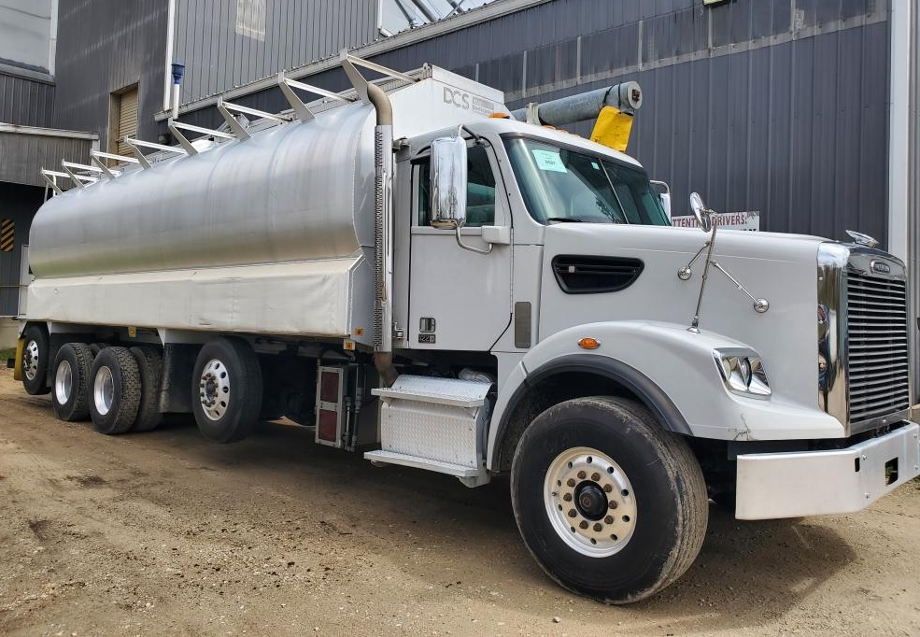 |  |  | summer fly control options  Summer is right around the corner, and you know what that means! Those nasty pesty flies will soon be driving us crazy but can also have some negative effects on your livestock. We have several fly control options – all approved for organic use – on stock today. Give us a call or stop by to ask for more information, but here is a list of these options available for multiple species of livestock or animals:  Crystal Creek – Oil or Water based fly repellent  Dr. Sarah’s Essentials – Shoo-Fly Spray  Fertrell – Fly Aside Liquid or Fly Aside Mineral  Redmond Agriculture – NTM 10 Fine Salt with Organic Garlic  *These products are made from natural remedies including essential oils or organically produced garlic. Garlic has been proven to reduce fly populations due to its scent, plus garlic is naturally a very beneficial product for immune systems and overall health.

Warehouse offerings!
CONTACT US!
300 Forest Street
Riceville, IA 50466
641-985-2494 Office
riversidefeeds@gmail.com
www.riversidefeeds.net
Current specials of available supplies. Please refer to enclosed Price List for all products. All items/products are FOB Riceville, IA. Please call to verify availability on all products. Customer pickup or delivery of products can be arranged anytime. |  |  |  |  |  | ORGANIC GRAIN PRICES:  *Upper Midwest References – NOT Riverside Feeds Offers  Corn: $7.75 / Bu  Soybeans: $20.00 + / Bu Feed, $24.00 + / Bu Food  Wheat: $8.00 / Bu  Barley: $6.00 / Bu  Oats: $4.50 / Bu  Soybean Meal: $900 / Ton
Smidley Livestock Waterer Equipment: single, double, and triple hog drinking bars and scales available in used, refurbished condition.  Seasonal Products:  Redmond SR35, SR50, & SR65 blends for your soil amendment needs! Can order in tote quantities - $425 / 2000# Tote.  Non-GMO Chick Starter – NOW AVAILABLE! $22 / 50#.  Non-GMO Hog Starter-Grower and Grower-Finisher: $17 & $14/50# bag  SunCoast Pine Shavings for $9 / 12 cubic foot bag.  Smidley used equipment special: Hog, Sheep, Goat portable head chute! A great condition oldie. Asking $950 OBO. |  |  | Dr. Paul’s Lab Clean Start Pellets – All natural dewormer/intestinal cleanser for ALL species of livestock! $85 / 25#  Non-GMO Soy Hull Pellets (Rumapro) – 18% minimum protein. Great alternative cattle feed! $250 / ton bulk. Ask about Soy-Oat Pellets!  Organic Apple Cider Vinegar – 55 gal drums $525, or 4 gal pail $45. Non-GMO Apple Cider Vinegar avail too.  Non-GMO Whole Oats (Heavy Weight/Race Horse Oats) - $450 / ton in either 40# or 50# sacks.  EXPANDED Retail Shelf: Smidley, Crystal Creek, Fertrell, Redmond Agriculture, Redmond human (Real Salt & Re-Lyte) & hunt products, Dr. Paul’s Lab, Dr. Sarah’s Essentials, Pyganic, Apple Cider Vinegar – For humans and animals!
FUTURE EVENTS:

- We will be CLOSED on Monday, May 27th, in observance of Memorial Day. Please plan your feed orders accordingly.

- Local town festival parade season is coming upon us! Our first parade this year will be in my hometown of Alta Vista, IA – AV Days will kick off with a parade on Saturday, June 1st at 11:30 AM. We will hopefully be featuring our new feed truck in this parade! See you there!

- Also planning on several other local town parades this summer including Colwell, St. Ansgar, Osage, Elma, LeRoy, Stacyville, and Riceville!

- PLEASE NOTE - Office Hours: Monday – Thursday: 8 am – 5 pm. Friday: 8 am – 4 pm.

