 | The Feeder |  |  |  | June 2020

New feed mill will improve efficiencies
*This is an extremely important message for ALL customers to read carefully. We are asking for ALL customers to take their time and responsibility to accept this message and reach out to us with any questions or concerns!*  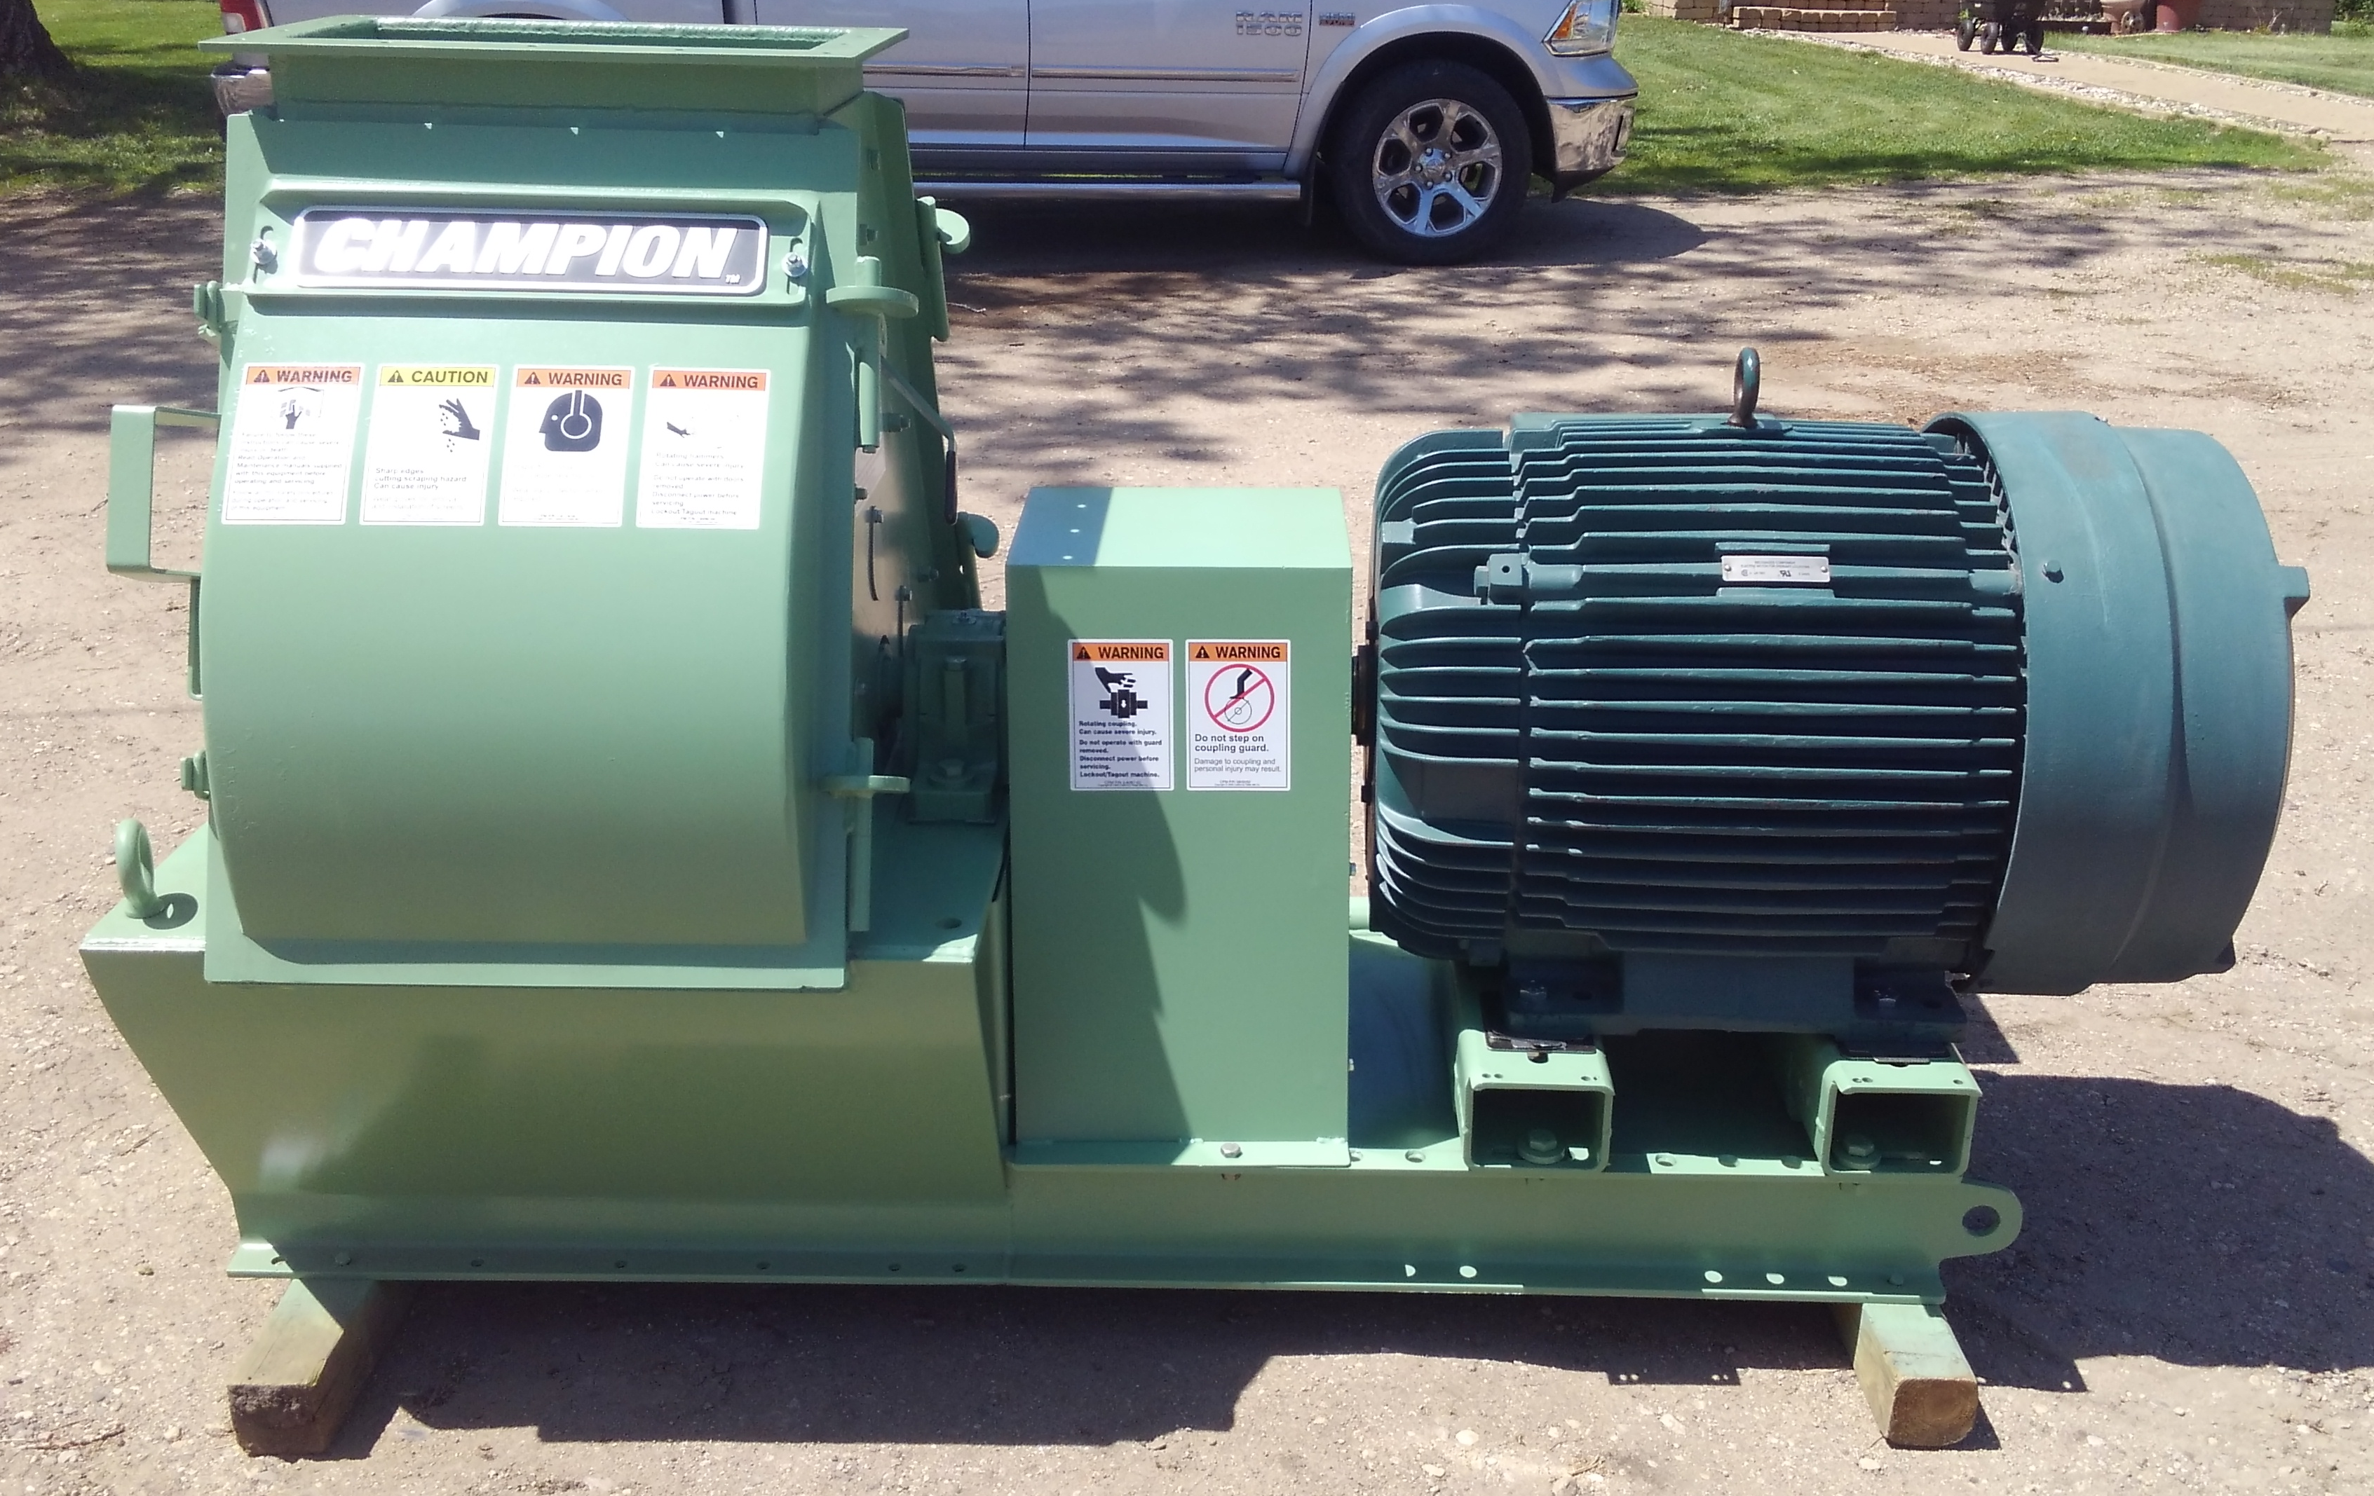  As you may have read in recent newsletters, we have made the investment in a much larger and more efficient hammermill, and will be changing our feed mill layout, design, and flow of materials. The time has finally come where we now have all parts and equipment on hand to make our much needed upgrade. We will be changing out our 50 hp Jacobson hammermill with a 125 hp CPM Champion hammermill, and changing the flow of materials through various augers, conveyors, and many electrical functions. This project will be completed with our own highly skilled production team staff as well as our long time electrical contractor. This new mill will grind about twice as fast as our current mill. The new mill is pictured below, and those are 4” x 4” boards that it is sitting on! |  | *FEED MILL WILL NOT BE AVAILABLE FOR GRINDING AND MIXING FROM JUNE 15th – JULY 4th. PLEASE PLAN AND ORDER AHEAD OF TIME DURING THIS SHUT DOWN!!!*  This shut down on the feed mill will NOT effect the pellet mill, so any oat pellet orders will remain available (bulk, tote, and sacks). We will also stock up heavily on the following items: Non-GMO Chick Starter, Non-GMO Layer Feed, Non-GMO Broiler Grower, Non-GMO Hog Starter-Grower, Non-GMO Hog Grower-Finisher, and Horse Pellets. All premix or ingredient items (such as Fertrell, Riverside’s premixes, Redmond, Acadian, etc.), will also be available since those products are ordered in.  We are planning on shutting the mill down and begin removing equipment on June 17th, and may possibly not be running until as late as July 4th. We will likely be finishing the last few orders up on June 15th and 16th, so I ask for everyone to place their orders by Friday, June 12th at the very latest so we can remain on schedule. If you need double production in early June to have enough feed until July, PLEASE order accordingly. Please discuss feed needs and options with Douglas or myself within the next two weeks. I can assure you that this upgrade will be well worth everyone’s cooperation! |  |  | Product feature!  Crystal Creek Lice and Mange Wash:  New on our shelf: Lice and Mange Wash. To be added to 3 parts of water, and sprayed externally on animals with lice and mange problems. Works well on swine, and is approved for organic use.  Dr. Paul’s Poultry Plus:  Poultry Plus can be mixed with water for poultry of all sizes to avoid scours. We sell this product in half gallon containers, which is enough to treat 1,200 – 4 pound laying hens. This can also be used on chicks to avoid or treat scours.  Dr. Paul’s Pig Ade:  Pig Ade should be used to prevent and treat scours in young pigs while still on the sow. This in an oral product, so smaller pigs are easier to handle.  Dr. Paul’s Calf Start:  Calf Start is designed to be mixed in with milk or milk replacer for either bottle or bucket calves to prevent and treat scours. I have personally used this product with tremendous results!

Warehouse offerings!
CONTACT US!
300 Forest Street
Riceville, IA 50466
641-985-2494 Office
riversidefeeds@gmail.com
www.riversidefeeds.net
This new section will be dedicated towards product that we have a healthy supply of, or equipment available for sale. This is a limited list, as we will always continue to carry everything listed on the Price List. All items/products are FOB Riceville, IA. |  |  |  |  |  | ORGANIC GRAIN PRICES:  *Upper Midwest References  Corn: $7.50 / Bu  Soybeans: $18.25 / Bu Feed, $20.50 / Bu Food  Wheat: $8.00 / Bu  Barley: $8.00 / Bu  Oats: $5.50 / Bu  Soybean Meal: $850 / Ton
Smidley Livestock Equipment: single, double, and triple hog drinking bars available in used, refurbished condition.  50 hp Jacobson Hammermill with screens and dust cyclone. Call!  Schlagel 8” double swing distributor with 24 outlet holes, great shape.  40’ x 10” drag chain conveyor, U-Trough. Needs new chain and paddles, and sprockets. Make offer. |  |  | Organic Steamed Rolled Oats – either 50 pound sacks, or 1600 pound totes, $900 / ton.  Non-GMO Soy Pro 40 meal – 2,000 pound totes or bulk, $375 / ton.  Non-GMO Oat Mill Run Pellets – 50 pound sacks, totes, or bulk. Check Price List. Now readily available, and will continue to be available during feed mill shut down!  Non-GMO Pig Starter/Grower, and Non-GMO Hog Grower/Finisher in 50 pound sacks in stock.  Retail: Smidley, Crystal Creek, Fertrell, Redmond, Dr. Paul’s, Dr. Sarah’s, Pyganic, Apple Cider Vinegar – For humans and animals!  Full Warehouse selection of vitamins, minerals, and ingredients!
FUTURE EVENTS:
- Unfortunately, due to COVID-19, we will not be present in any local community parades this summer. Even though Iowa has started to reopen its economy, we feel it is the safest to continue to limit public and truck drivers in our office and provide window service and curbside pickup on orders.
- As mentioned on the front page, we will be shutting the FEED MILL (hammermill and mixer) down from June 15th – July 4th. ALL feed orders that require the mill and mixer MUST be ordered no later than 12th. If you usually get feed products from us on a frequent basis, we may ask for you to take double amount in early June to last until July. We will stock heavily on retail products that we manufacture, including all Non-GMO chicken and swine feeds, which will be available for sale during this shut down. If you have any custom rations, we will NOT be able to process during this shut down. THIS IS YOUR RESPONSIBILITY TO PLACE FEED ORDERS PRIOR TO SHUT DOWN, AND ORDER ENOUGH TO LAST UNTIL WEEK OF JULY 6th!!!
Seasonal Products:
Time for Chicks!

Non-GMO Chick Starter Crumbles in stock now! $18 / 50# sack.
SunCoast Pine Shavings $8 / Bale

