 | The Feeder |  |  |  | June 2021

Scales and bedding products available!
Short on bedding this summer? We may have a solution for you! For a limited time only, we have up to 11 ton of Oat Fiber available in either 50# sacks, tote bags, or bulk. This product is a fine flour, so it is not the easiest to handle, however, it soaks up moisture VERY well. I would recommend layering this product under straw or cornstalks to help absorb moisture. This is NOT certified organic, so organic livestock producers would not be able to use this product. I am offering this product for $150 per ton. Any questions, please call to discuss.  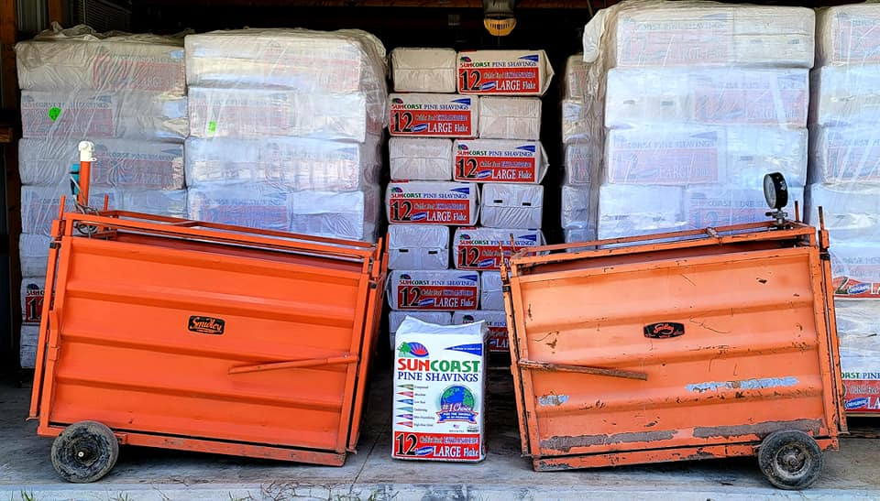  It’s that time of the year for show pig season, and that means we are well stocked up on SunCoast Pine Shavings as well as 3 used Smidley hog scales available for sale! We have 2 dial head scales and 1 digital head. They are all in excellent condition, and work perfectly. We have many local customers in Iowa and Minnesota with county and state fair pigs, who love using our SunCoast Pine Shavings, and this year we have a few scales to offer! Whether you need to weigh your show pigs or your production hogs or goats, call us today for pricing on a used scale to save money on a new one! |  | 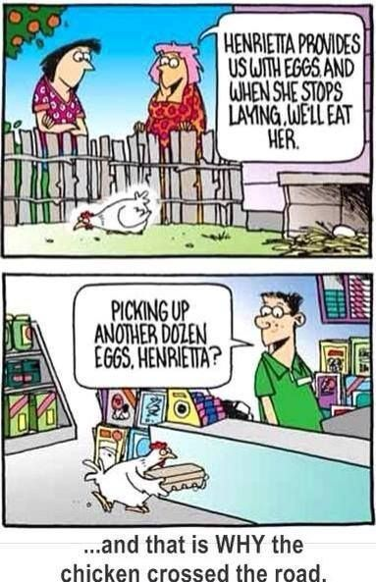  Secrets to Dark Yokes  Did you know that dark colored eggs yokes can be the result from fresh green grass or alfalfa forage?  In order to produce a higher quality and tastier egg yoke, a diversified poultry ration is key. Here at Riverside Feeds, we cut back on the corn and soy proteins slightly and add in diversified ingredients that the competitor may or may not have, including, oat pellets, steamed rolled oats, barley, and alfalfa meal! In order to enhance this diet even more, let your hens out to forage on your lawn or pasture. Personally, we feed meal worms as a protein treat everyday. When the temps are over 90 degrees F, we feed frozen corn to our hens as a treat to help them cool off! |  |  | Shipping & trucking services:  Our Chief Logistics Officer, Douglas, can assist you any day with connecting our products to your farm, anywhere in the lower 48 states! We have a unique fleet of delivery vehicles for both local and long distance including the following:  - ½ ton pickup truck  - ¾ ton pickup truck  - 1 ton pickup truck with flatbed trailer  - 18 ton bulk feed truck  - 25 ton semi trucks with hopper bottom and cargo van trailers  While we only keep our fleet in Iowa for local deliveries, we can also hire out long distance and LTL (Less Than Load). We can hire the following services:  - Small package freight (UPS, Fedex, Speedee)  - Single or Few pallet LTL freight (Panama Transfer, Speedee, Central Transport)  - Bulk product freight (hopper, belt, walking floor, or van for bags/totes)  - We can even load railcar in St. Ansgar, Iowa!

Warehouse offerings!
CONTACT US!
300 Forest Street
Riceville, IA 50466
641-985-2494 Office
riversidefeeds@gmail.com
www.riversidefeeds.net
Current specials of available supplies. Please refer to enclosed Price List for all products. All items/products are FOB Riceville, IA. Please call to verify availability on all products. Customer pickup or delivery of products can be arranged anytime. |  |  |  |  |  | ORGANIC GRAIN PRICES:  *Upper Midwest References  Corn: $8.50 / Bu  Soybeans: $26.50 / Bu Feed, $28.50 / Bu Food  Wheat: $8.00 / Bu  Barley: $8.00 / Bu  Oats: $5.50 / Bu  Soybean Meal: $1200 / Ton
Smidley Livestock Equipment: single, double, and triple hog drinking bars & hog scales available in used, refurbished condition.  Seasonal Products:  SunCoast Pine Shavings – Keep your critters well bedded and warm! $8 / 25# bag  Non-GMO Chick Starter Crumbles – NOW IN STOCK! $18 / 50# bag!  Non-GMO Oat Fiber for bedding use only – Available in 50# bags, totes, or bulk. Blend with coarse bedding to absorb moisture. $150 / ton. LIMITED TIME ONLY!  Organic Oat Mill Run Pellets – can be offered in sacks or totes, but currently available in bulk. $185 / ton bulk. |  |  | Organic Steamed Rolled Oats – either 50 pound sacks, or 1600 pound totes, $900 / ton.  Non-GMO Oat Mill Run Pellets – 50 pound sacks, totes, or bulk. Stock up now before you run short on feed or hay products!  Non-GMO Pig Starter/Grower, and Non-GMO Hog Grower/Finisher in 50 pound sacks in stock.  Retail: Smidley, Crystal Creek, Fertrell, Redmond Agriculture, Dr. Paul’s Lab, Dr. Sarah’s Essentials, Pyganic, Apple Cider Vinegar – For humans and animals!  Full Warehouse selection of vitamins, minerals, and ingredients! Ingredient prices have been going up, so stock up now to save money.
FUTURE EVENTS:
- We will be supporting a few local town festivities this summer including the following June events:
- Alta Vista Day, Saturday, June 5th, 11:30 AM parade in Alta Vista, IA.
- Colwell Day, Saturday, June 19th, 12:00 Noon parade in Colwell, IA.
- Independence Day Parade, Saturday, July 3rd, 10:00 AM parade in Osage, IA.
- We will also partake in a few more parades in July and August in our local area – look for our feed truck that will be well decorated to promote our business!
- Keeping COVID-19 concerns in mind, please do NOT enter our premises if you are feeling ill or recently tested positive for COVID-19. Our office doors ARE OPEN to the public now.

