. | The Feeder |  |  |  | June 2022

Grain bin project underway with office
Construction work has been progressing well here at Riverside Feeds. Last week, we assembled and mounted two 18’ grain bins on hopper bottom cones for raw grain screening storage for our feed mill! This project has been in dire need for a long time to supply ample storage for our inbound products. These grain bins do NOT mean that we will be buying organic grains from farmers, and does NOT necessarily mean that we will be increasing our throughput. These bins are an addition to our current facility to help us become more efficient with handling and storing our current inbound products, primarily organic grain screenings.  We have also been very busy with demolition work on our front office as we prepare the area for a major renovation this summer. Over the past few weeks, we have stripped all interior walls, old electrical wiring, and insulation, and recently we removed all exterior walls. We are currently prepping the new office and rest room areas for a new concrete floor, which will get poured this coming week. After the new concrete floor is poured, we will be busy helping our contractor frame the new exterior walls so we can get the office wrapped back up with new tin. When those walls are done, we will have a lot of interior work to do throughout the entire month of July. |  | 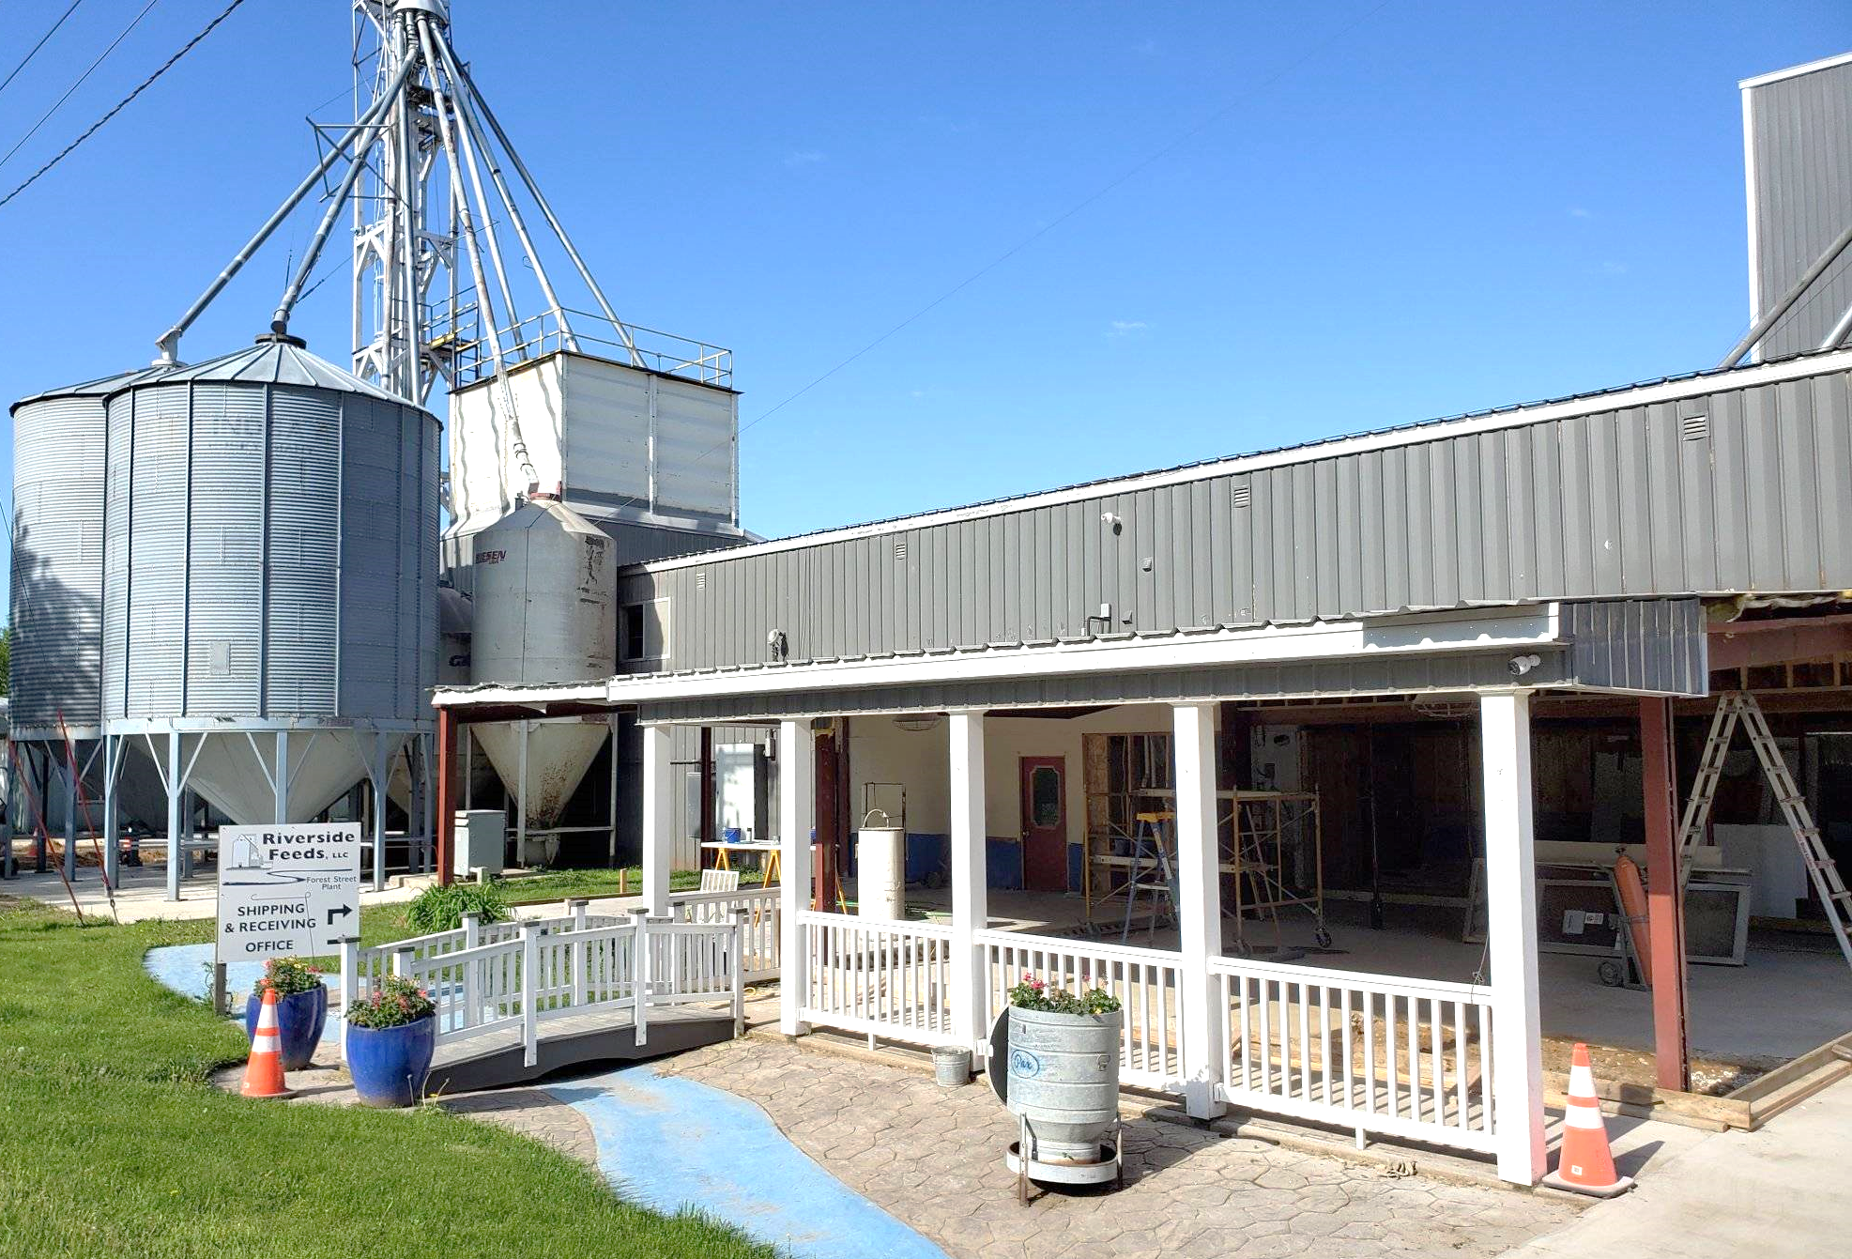  As you can see in the above picture, our front office is completely gutted for renovation work which will take place over the next couple of months. In the background of the picture, you can see our two new grain bins for raw grain screening storage for the feed mill. Lots of changes!  Please keep in mind during all of this construction to be cautious and curteous of our job site areas. Due to our major office renovation project, our primary office is CLOSED TO PUBLIC, as we will be operating out of the temporary office unit in the East driveway. We have signs stating this. Please do NOT randomly walk around our office renovation project site, as it could be dangerous or delicate. We are on track for an August completion date on the office project, at which time we will be moving back in with the new layout!  You may see on the price list that a lot of products are marked as “Limited” or “OUT”. We are very short on supply with certain vendors due to lack of available byproduct supplies, but working hard to get more in soon. |  |  | busy schedule and tight warehouse space  Business growing pains! While we are in the middle of a major office renovation project, we lost some space temporarily for retail and bagged products. Due to this, our warehouse has become EXTREMELY full and very hard to navigate and pull different products. Please keep this in mind when you place feed orders as we ask for your patience and cooperation as we juggle our way through a very packed warehouse. It may take some time to dig certain products/ingredients out for customer load out.  Please also keep in mind that while we are serving over 500 loyal customers, we ask for you to pick up your orders in a timely manner to help move product through the warehouse. It can be very inconvenient at this time if we have a customer order stacked and ready to load out, and it ends up plugging our limited warehouse space for a few extra days. We do need more warehouse space, which will hopefully happen in our future. When the office project finds its completion in August, we will have more space for retail shelving for our retail products and will get into a new norm with product storage.

Warehouse offerings!
CONTACT US!
300 Forest Street
Riceville, IA 50466
641-985-2494 Office
riversidefeeds@gmail.com
www.riversidefeeds.net
Current specials of available supplies. Please refer to enclosed Price List for all products. All items/products are FOB Riceville, IA. Please call to verify availability on all products. Customer pickup or delivery of products can be arranged anytime. |  |  |  |  |  | ORGANIC GRAIN PRICES:  *Upper Midwest References – NOT Riverside Feeds Offers  Corn: $13.00 / Bu  Soybeans: $38.00 + / Bu Feed, $40.00 + / Bu Food  Wheat: $12.00 / Bu  Barley: $12.00 / Bu  Oats: $10.00 / Bu  Soybean Meal: $1900 / Ton +
Smidley Livestock Waterer Equipment: single, double, and triple hog drinking bars available in used, refurbished condition.  Smidley used equipment special: Hog, Sheep, Goat portable head chute! A great condition oldie. Asking $950 OBO. Currently out of hog scales. |  |  | Organic Soybean Oil – Available in 1 ton liquid totes for $0.85 / #. Currently have 4 totes available.  Non-GMO Oat Mill Run Pellets – 50 pound sacks, totes, or bulk. Supply is readily available!  Organic Steamed Rolled Oats – Available in 2,000# totes or bulk. $1000 / ton.  Retail: Smidley, Crystal Creek, Fertrell, Redmond Agriculture, Redmond human & hunt products, Dr. Paul’s Lab, Dr. Sarah’s Essentials, Pyganic, Apple Cider Vinegar – For humans and animals!  Full Warehouse selection of vitamins, minerals, and ingredients! Ingredient prices have been going up, so stock up now to save money.
FUTURE EVENTS:
- Independence Day: We will be CLOSED on Monday, July 4th, for Independence Day. Please plan accordingly for all feed orders.
- Local town parades will be a major hit again this summer! Look for our feed truck in the coming months, including Colwell Day on Saturday, June 18th in Colwell, IA! We will also be in the Fourth of July Parade in Osage, IA, on Monday, July 4th.
- Keeping COVID-19 concerns in mind, please do NOT enter our premises if you are feeling ill or recently tested positive for COVID-19. Our office doors are OPEN to the public.
- We will have several construction projects take place again this year, so as always, please be cautious when picking up your feed orders over the next several months. We are currently in middle of very heavy office renovation work, and our temporary office is in a jobsite trailer in the East driveway.
- PLEASE NOTE - Office Hours: Monday – Thursday: 8 am – 5 pm. Friday: 8 am – 4 pm.
Seasonal Products:

Wildlife Feed Pellets – Few bags left yet! $10 / 50# bag
Redmond Trophy Rock – Wildlife mineral rock. $15 / 20# rock
Non-GMO Chick Starter Crumbles – NOW AVAILABLE!!! $20 / 50# bag
SunCoast Pine Shavings – Keep your chicks warm and dry! $9 / 25# bag 12 cubic foot

