. | The Feeder |  |  |  | June 2023

Riverside feeds avail in soldiers grove, wi
Effective June 1st, Solar Town Farm and Home, LLC, in Soldiers Grove, WI, will be taking over Burkum Milling, Inc. Solar Town Farm and Home is a small scale feed mill with a large feed warehouse and feed and hardware store. A close friend of ours is in a partnership behind this new venture, and has asked for our feed products to be available for sale out of this store location! Currently, our Non-GMO Hog Starter/Grower, Non-GMO Hog Grower/Finisher, Non-GMO Chick Starter, Non-GMO Broiler Grower, Non-GMO Layer Feed, and of course our Non-GMO Oat Mill Run Pellets are in stock and available to purchase from this location in 50# sacks. Soon, tote bags of our Non-GMO Oat Mill Run Pellets will also become available to purchase from this location as well! We have been busy assisting with this store, warehouse, and feed mill revamp and set up, and are proud to be able to offer this location as one of our third party retail sites! We are excited to see this store take over with new owners and hope for a successful future!  We also have our feed products available for retail sale at Riceville True Value in Riceville, IA, and Five Star Coop in New Hampton, IA! We also have several accounts that buy large quantities of tote bags of Non-GMO Oat Mill Run Pellets and resell them to nearby customers. If you are looking for a closer source, give us a call today! |  | SAVE THE DATE!  Friday, August 4th, 2023  Riverside Feeds 10th Anniversary Open House – Riceville, IA  Due to supply constraints, we have been starting to get a bit tight on Non-GMO Oat Mill Run Pellet supply again. We are currently scheduled 2 solid weeks out on our feed truck and pellet orders due to the tight inbound raw supply and high demand, so please call us ahead of time if you are getting low. Our feed truck will also be out of service for maintenance work the week of June 12th. Due to this schedule, the entire month of June will be very tight for feed truck deliveries, so it is CRITICAL that you call in your feed delivery orders in advance (we recommend to try to call 2 weeks prior to when you expect delivery). We do have a healthy supply to offer on several protein products including: Organic Opro 40 Soy Protein, Organic Okara Meal, Organic Flaxmeal, and Non-GMO Soy Hull Pellets.  Our warehouse is well stocked with all your summer feed needs including Non-GMO Hog feeds, Non-GMO Poultry feeds (including chick starter), ruminant and monogastric animal minerals (loose and blocks), Suncoast Pine Shavings, Organic Alfalfa Pellets, Organic Cracked Corn, and certainly our Non-GMO Oat Mill Run Pellets – all in 50# sacks. |  |  | new products:  horse minerals  Since our Non-GMO Oat Mill Run Pellets make a great horse feed product and is fed to thousands of equine, we decided to start offering Stockade Horse Mineral – both loose 25# bag and 33# Block. We now carry these bags and blocks on hand, and can deliver these products to you on our feed truck routes with your Non-GMO Oat Mill Run Pellets, or you can pick these mineral options up when you pick up your pellet orders here in Riceville. We are selling either the bag or the block for $25 each.  Fertrell minerals also has a Horse Power mineral available, which sells for $65 / 50# bag.  For the cattle producers, we also now carry Stockade Bloat Blocks to help prevent digestive bloat in ruminant animals. These 33# bloat blocks retail for $35. Any bags or blocks can be picked up or delivered to you.  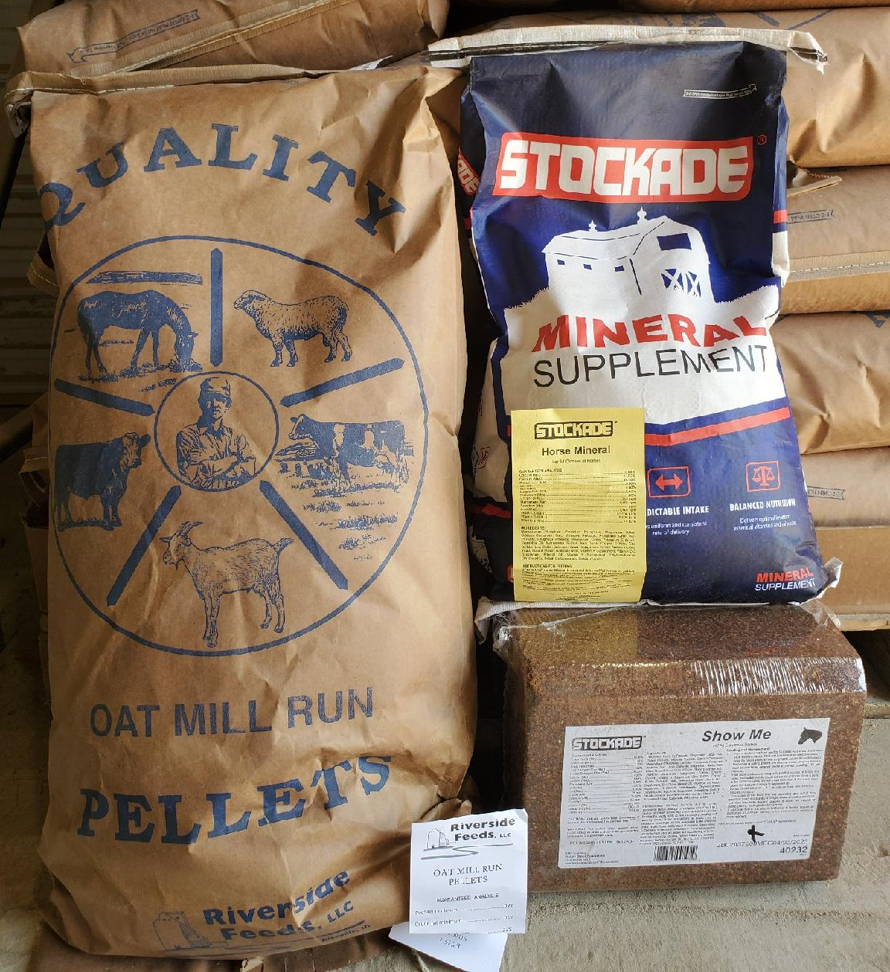

Warehouse offerings!
CONTACT US!
300 Forest Street
Riceville, IA 50466
641-985-2494 Office
riversidefeeds@gmail.com
www.riversidefeeds.net
Current specials of available supplies. Please refer to enclosed Price List for all products. All items/products are FOB Riceville, IA. Please call to verify availability on all products. Customer pickup or delivery of products can be arranged anytime. |  |  |  |  |  | ORGANIC GRAIN PRICES:  *Upper Midwest References – NOT Riverside Feeds Offers  Corn: $10.50 / Bu  Soybeans: $22.00 + / Bu Feed, $28.00 + / Bu Food  Wheat: $9.00 / Bu  Barley: $7.00 / Bu  Oats: $5.00 / Bu  Soybean Meal: $1100 / Ton +
Smidley Livestock Waterer Equipment: single, double, and triple hog drinking bars and scales available in used, refurbished condition.  Seasonal Products:  Non-GMO Swine Feeds – Hog Starter/Grower pellets for $16 / 50# bag, and Hog Grower/Finisher pellets for $13 / 50# bag  Non-GMO Chick Starter Crumbles now available! $20 / 50# bag. Also have Non-GMO Layer Feed Pellets and Broiler Grower Pellets available at $17 / 50# bag. SunCoast Pine Shavings for $9 / 12 cubic foot bag. Stock up now for your flock!  Smidley used equipment special: Hog, Sheep, Goat portable head chute! A great condition oldie. Asking $950 OBO. Also have 2 hog scales available. |  |  | Organic Prewean 22 – This swine feed is made for young pigs to start on dry creep feed prior to weaning. $34 / 50#  Organic Opro 40 Soy Protein – Available either bulk or 2,000# totes. $950 / ton. Organic Okara Soy Protein – bulk or totes $1,000 / ton.  Non-GMO Rumapro Soy Hull Pellets - $250 / ton, available bulk or tote. Sacks can also be made available.  Organic Steamed Rolled Oats – Available in 2,000# totes or bulk. $1000 / ton.  EXPANDED Retail Shelf: Smidley, Crystal Creek, Fertrell, Redmond Agriculture, Redmond human (Real Salt & Re-Lyte) & hunt products, Dr. Paul’s Lab, Dr. Sarah’s Essentials, Pyganic, Apple Cider Vinegar – For humans and animals!
FUTURE EVENTS:
- Local summer town parades will be coming soon – Look for our 10 Year Anniversary parade float in nearby town parades, including the following:
- Alta Vista Days in Alta Vista, IA, on Saturday, June 3rd, at 11:30 AM.
- Colwell Day in Colwell, IA, on Saturday, June 10th, at 12:30 PM.
- St. Ansgar Town & Country Days in St. Ansgar, IA, on Saturday evening, June 17th.
- Fourth of July Parade in Osage, IA, on Tuesday, July 4th, at 10:00 AM.
- We will be CLOSED on Tuesday, July 4th, for Independence Day. Please plan accordingly.
- Riverside Feeds 10 Year Open House – Friday, August 4th, 2023, 1 pm – 6 pm, in Riceville, IA. Will include Food Trucks, Mill Tours, LIVE MUSIC, Beverages/Ice Cream, & Giveaways! Save the Date!!!
- PLEASE NOTE - Office Hours: Monday – Thursday: 8 am – 5 pm. Friday: 8 am – 4 pm.

