 | The Feeder |  |  |  | July 2020

feed mill upgrade complete on time!
Happy July! As I write this newsletter, we are on our last full work day of constructing our new feed mill layout and system! As you may have read last month, we took two weeks off to switch our hammer mill from a 50 hp mill to 125 hp mill, and completely changed the design of conveying equipment and product flow to increase our efficiencies when grinding and mixing. This upgrade will more than double our grinding capacity per hour, which has been needed to keep up with demand. We completed this entire project with our own staff, whom I am immensely proud of. Our production workers are incredibly talented welders and builders, and this saved us tens of thousands of dollars from hiring professional contractors. Gerber Electric out of Adams, MN, finished all the electrical connections for us. We should be ready to start grinding tomorrow, July 2nd, and after some testing and tuning, we will hopefully be back to normal operations starting Monday, July 6th – Precisely on schedule! We will be ready to take your grinding and mixing orders anytime after July 6th. We will continue to finish all remaining details and the “third phase” later this month as we build the micro ingredient room above the mixer. As you can see in the pictures, the before and after looks of the mill show just how busy we have been with our crew! |  | 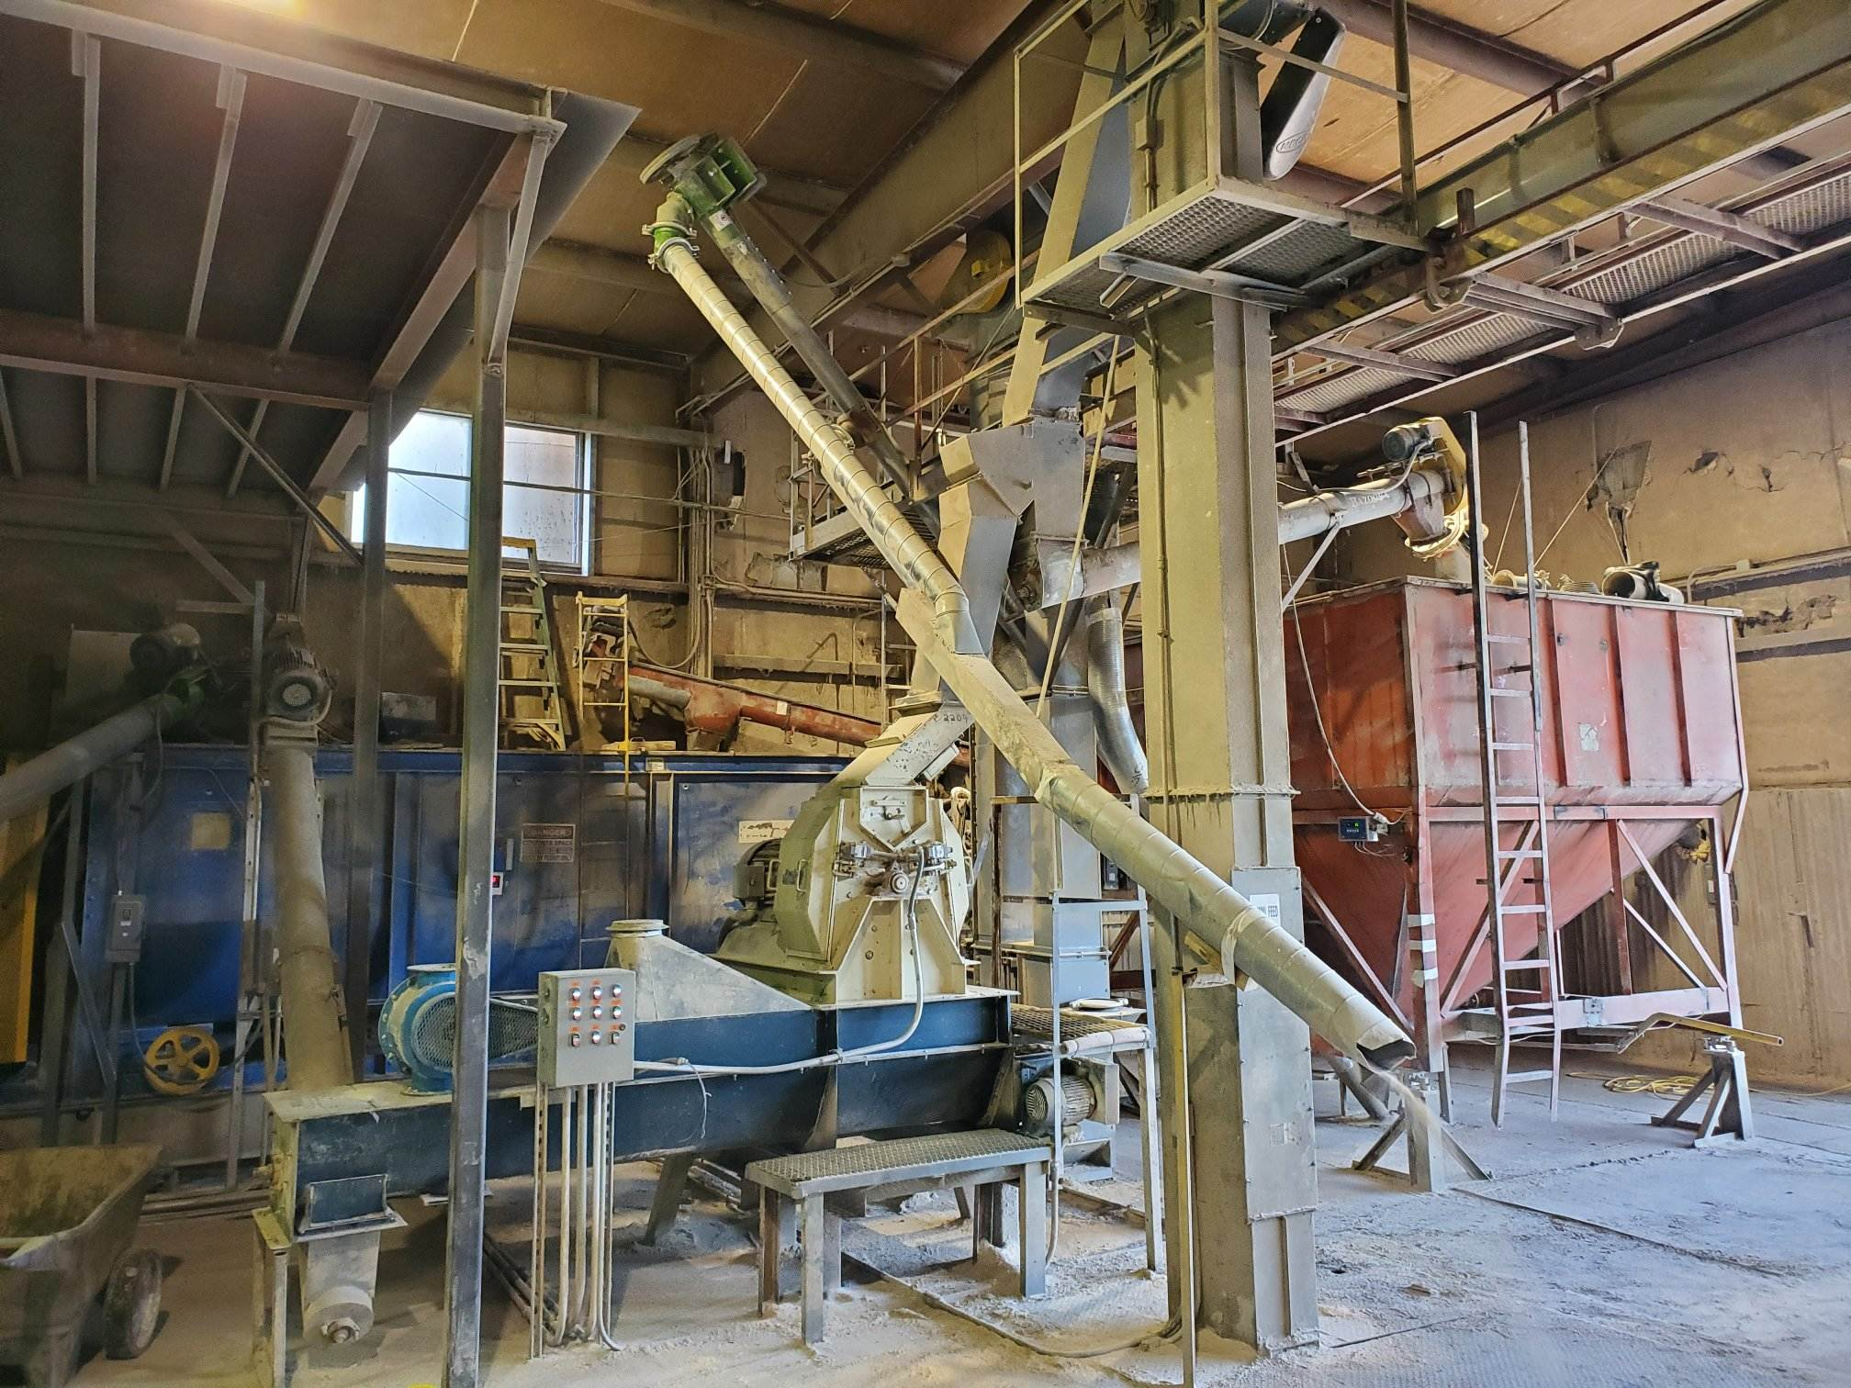  Before – June 17, 2020 – Old setup.  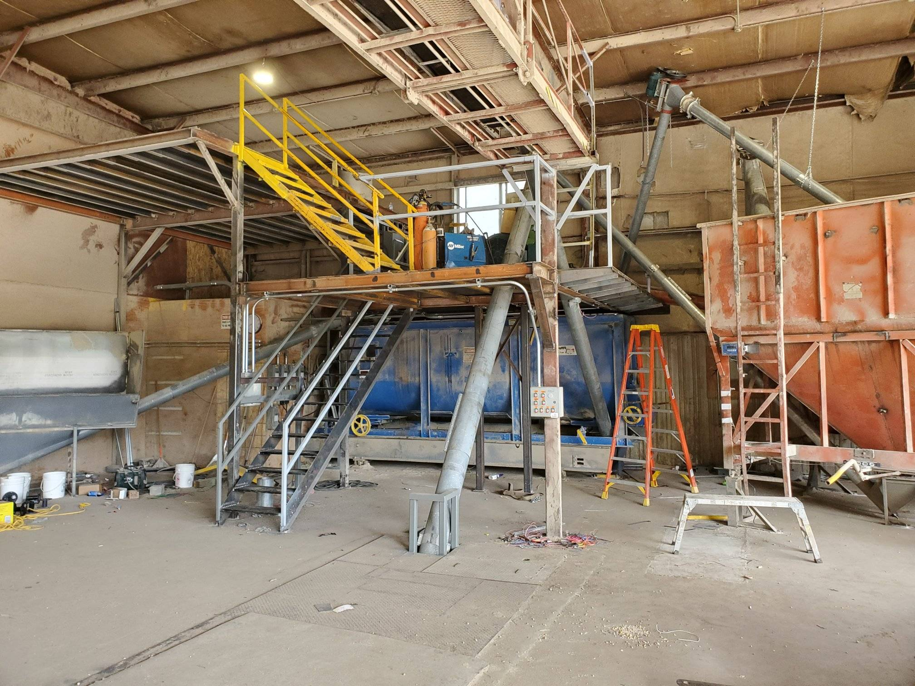  After as of July 1, 2020. This shows the two floors for feed mill production. The top floor will be an enclosed room for micro ingredients, soy oil, and liquid molasses storage, which will be built in late July / early August.  After as of July 1, 2020. This shows the hammer mill floor, with 125 hp electric motor. |  |  | Product feature!  Fly control:  Dr. Sarah’s Shoo-Fly Spray and Concentrate:  Dr. Sarah’s Essentials provides an excellent fly repellent for all species of livestock, consisting of multiple essential oils. We offer multiple sizes of both spray and concentrate on our retail shelf.  Redmond’s Pest Guard Garlic Salt:  Redmond Agriculture now has a garlic salt option available either in bags or blocks to reduce fly counts on ruminant animals. This product is OMRI Approved and has been selling very well for us.  Crystal Creek’s Fly Repellent:  Crystal Creek offers either oil or water based fly repellent made from many essential oils, and can be used as either a spray, wipe, or in an oiler. We do not have this product on the shelf, but can order this in or offer direct ship.  *Call today to discuss your organic and natural options for fly control!

Warehouse offerings!
CONTACT US!
300 Forest Street
Riceville, IA 50466
641-985-2494 Office
riversidefeeds@gmail.com
www.riversidefeeds.net
This new section will be dedicated towards product that we have a healthy supply of, or equipment available for sale. This is a limited list, as we will always continue to carry everything listed on the Price List. All items/products are FOB Riceville, IA. |  |  |  |  |  | ORGANIC GRAIN PRICES:  *Upper Midwest References  Corn: $7.50 / Bu  Soybeans: $18.25 / Bu Feed, $20.50 / Bu Food  Wheat: $8.00 / Bu  Barley: $8.00 / Bu  Oats: $5.50 / Bu  Soybean Meal: $850 / Ton
Smidley Livestock Equipment: single, double, and triple hog drinking bars available in used, refurbished condition.  50 hp Jacobson Hammermill with screens and dust cyclone. Call!  Schlagel 8” double swing distributor with 24 outlet holes, great shape.  40’ x 10” drag chain conveyor, U-Trough. Needs new chain and paddles, and sprockets. Make offer. |  |  | Organic Steamed Rolled Oats – either 50 pound sacks, or 1600 pound totes, $900 / ton.  Non-GMO Soy Pro 40 meal – 2,000 pound totes or bulk, $375 / ton.  Non-GMO Oat Mill Run Pellets – 50 pound sacks, totes, or bulk. Check Price List. Now readily available, and will continue to be available during feed mill shut down!  Non-GMO Pig Starter/Grower, and Non-GMO Hog Grower/Finisher in 50 pound sacks in stock.  Retail: Smidley, Crystal Creek, Fertrell, Redmond, Dr. Paul’s, Dr. Sarah’s, Pyganic, Apple Cider Vinegar – For humans and animals!  Full Warehouse selection of vitamins, minerals, and ingredients!
FUTURE EVENTS:
- Unfortunately, due to COVID-19, we will not be present in any local community parades this summer. Even though Iowa has started to reopen its economy, we feel it is the safest to continue to limit public and truck drivers in our office and provide window service and curbside pickup on orders.
- No current future events are planned due to COVID-19. Please keep in mind everyone’s safety and health, and we always encourage you to maintain social distancing. We greatly appreciate everyone’s cooperation during these difficult times and continue to encourage feed orders placed via phone call or email.
- If any customers would like to see our new feed mill setup, feel free to give us a call or stop by and ask for a personal tour!
Seasonal Products:
Time for Chicks!

Non-GMO Chick Starter Crumbles in stock now! $18 / 50# sack.
SunCoast Pine Shavings $8 / Bale

