. | The Feeder |  |  |  | July 2023

10 Year anniversary open house august 4
We are only one month away from our 10 Year Anniversary Celebration Open House! We have been busy making preparations for this major event, and are very excited to see you here on Friday, August 4th from 1 – 6 PM. For our 10 year open house, we are planning on having food trucks, live music, mill tours, meet the staff, beverages, ice cream, and family friendly yard games, so bring your entire family for this fun event! This afternoon open house leads the festival weekend for Riceville’s annual Wapsi Days which begins that same evening and runs through Saturday, August 5th so if you plan on coming from a distance, there will be plenty to fill up your weekend schedule! This open house is open to not only our current customers, vendors, and haulers, but also to all public of all ages. We highly encourage the public to attend the open house to see what we all do in our mill and see all of our products and services. We also ask for the public to come, relax, and enjoy a beautiful Iowa August afternoon (rain or shine), and help our hard working team celebrate 10 great years of success and feed mill construction to get to where we are now! No RSVP’s are needed as this is an open event. Please see attached flyer for more information about this open house, and we hope to see you right here at Riverside Feeds in Riceville, Iowa, on Friday, August 4th! Thank you for your support! |  | 10 Year Anniversary  Open House  Friday, August 4th, 2023  1:00 PM – 6:00 PM  300 Forest Street  Riceville, IA 50466  Planning on grilling some delicious food this summer? Check out our expanded Redmond Real Salt seasoning selection featuring four new flavored seasonings, and the smoked seasoning salts! Our retail shelf offers the following Real Salt products: fine salt, garlic salt, seasoning salt, onion salt, wasatch steak, taco seasoning, chili lime, red rock BBQ, cherry smoked salt, hickory smoked salt, chef’s blend smoked salt, garlic pepper, and lemon pepper! We also have multiple flavors of Redmond’s Re-Lyte products to keep you well hydrated during this summer heat. Check out our retail selections during the open house on Friday, August 4th!  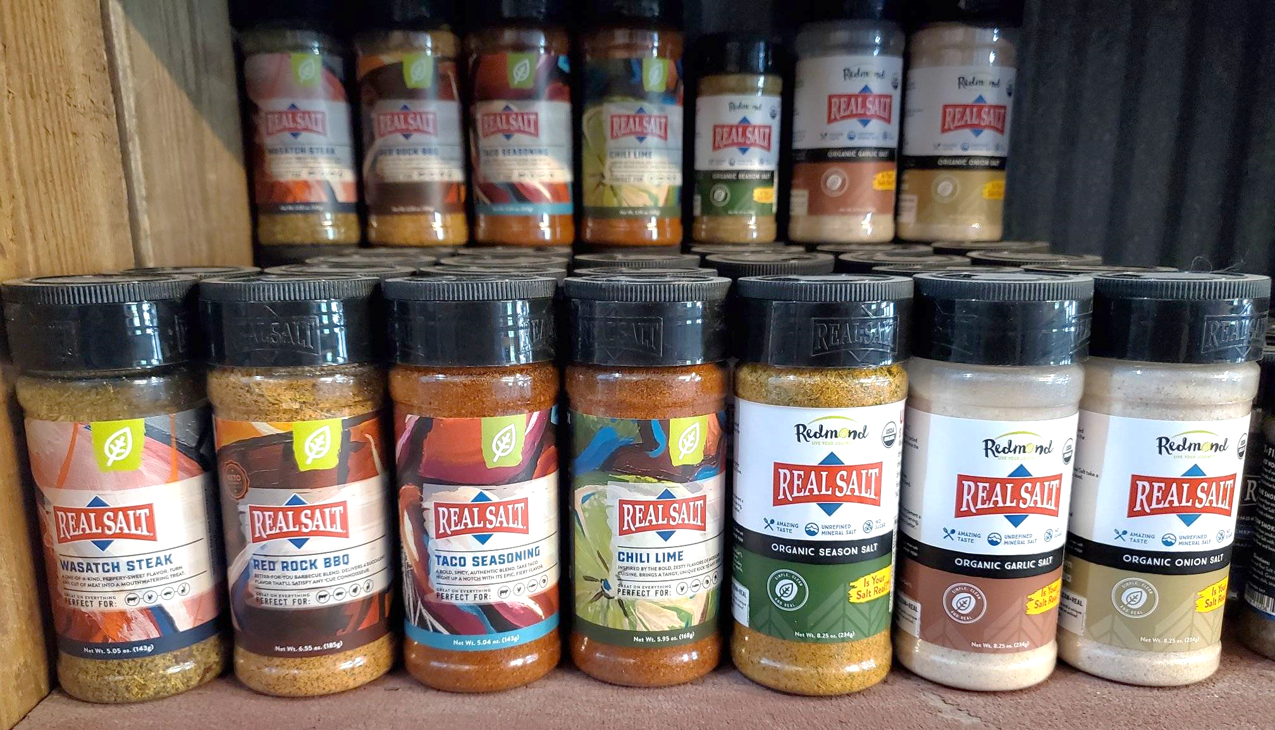  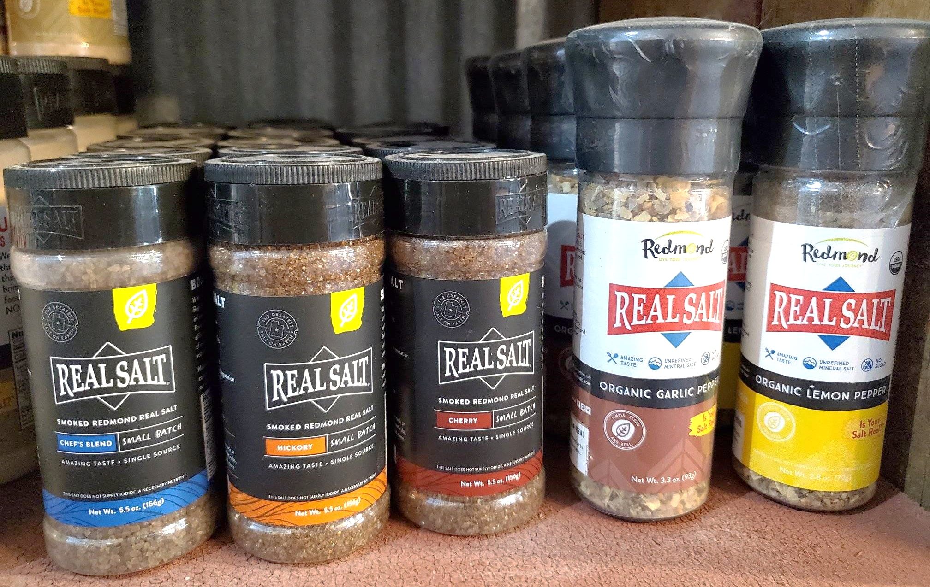 |  | 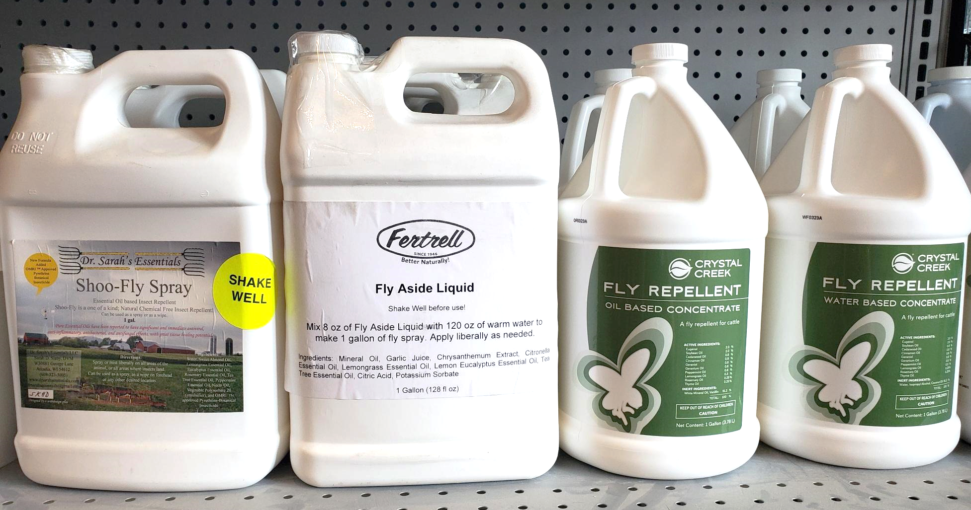 | fly control options  We have seen a sharp increase in demand for natural fly control options recently. Even though we are experiencing a drought in the Upper Midwest, flies still seem to be a common pest. Due to the increased demand from our local customers, we have greatly expanded our offerings on our retail shelf. Call or stop by today to learn more about these options, and keep in mind that offering garlic salt can help reduce fly populations as flies are not attracted to the garlic odors.  - Dr. Sarah’s Essentials Shoo-Fly Spray or Concentrate made from essential oils  - Crystal Creek Fly Repellent (formally “No Fly”) made from essential oils  - Fertrell Fly Aside Liquid made from essential oils and garlic oil  - Redmond Garlic Salt (loose bags or blocks)  - Lice & Mange products also available

Warehouse offerings!
CONTACT US!
300 Forest Street
Riceville, IA 50466
641-985-2494 Office
riversidefeeds@gmail.com
www.riversidefeeds.net
Current specials of available supplies. Please refer to enclosed Price List for all products. All items/products are FOB Riceville, IA. Please call to verify availability on all products. Customer pickup or delivery of products can be arranged anytime. |  |  |  |  |  | ORGANIC GRAIN PRICES:  *Upper Midwest References – NOT Riverside Feeds Offers  Corn: $10.50 / Bu  Soybeans: $22.00 + / Bu Feed, $28.00 + / Bu Food  Wheat: $9.00 / Bu  Barley: $7.00 / Bu  Oats: $5.00 / Bu  Soybean Meal: $1150 / Ton +
Smidley Livestock Waterer Equipment: single, double, and triple hog drinking bars and scales available in used, refurbished condition.  Seasonal Products:  Non-GMO Swine Feeds – Hog Starter/Grower pellets for $16 / 50# bag, and Hog Grower/Finisher pellets for $13 / 50# bag  Non-GMO Chick Starter Crumbles now available! $20 / 50# bag. Also have Non-GMO Layer Feed Pellets and Broiler Grower Pellets available at $17 / 50# bag. SunCoast Pine Shavings for $9 / 12 cubic foot bag. Stock up now for your flock!  Smidley used equipment special: Hog, Sheep, Goat portable head chute! A great condition oldie. Asking $950 OBO. Also have 2 hog scales available. |  |  | Organic Prewean 22 – This swine feed is made for young pigs to start on dry creep feed prior to weaning. $34 / 50#  Organic Opro 40 Soy Protein – Available either bulk or 2,000# totes. $950 / ton. Organic Okara Soy Protein – bulk or totes $1,000 / ton.  Non-GMO Rumapro Soy Hull Pellets - $250 / ton, available bulk or tote. Sacks can also be made available.  Organic Steamed Rolled Oats – Available in 2,000# totes or bulk. $1000 / ton.  EXPANDED Retail Shelf: Smidley, Crystal Creek, Fertrell, Redmond Agriculture, Redmond human (Real Salt & Re-Lyte) & hunt products, Dr. Paul’s Lab, Dr. Sarah’s Essentials, Pyganic, Apple Cider Vinegar – For humans and animals!
FUTURE EVENTS:
- Local summer town parades will be coming soon – Look for our 10 Year Anniversary parade float in nearby town parades, including the following:
- Fourth of July Parade in Osage, IA, on Tuesday, July 4th, at 10:00 AM.
- Old Roundhouse Trail Days Parade in Elma, IA, on Saturday, July 8th at 11:00 AM.
- LeRoy Summerfest Parade in LeRoy, MN, on Sunday, July 16th at 2:00 PM.
- Brat Days Parade in Stacyville, IA, on Saturday, July 29th at 7:00 PM.
- Wapsi Days Parade in Riceville, IA, on Saturday, August 5th at 6:00 PM.
- We will be CLOSING EARLY on Monday, July 3rd and CLOSED on Tuesday, July 4th, for Independence Day. Please plan accordingly. We will be closing at 1 PM on Monday to give our employees a little extra time off from their hard work.
- Riverside Feeds 10 Year Open House – Friday, August 4th, 2023, 1 pm – 6 pm, in Riceville, IA. Will include Food Trucks, Mill Tours, LIVE MUSIC, Beverages/Ice Cream, & Giveaways! Open to all public!
- PLEASE NOTE - Office Hours: Monday – Thursday: 8 am – 5 pm. Friday: 8 am – 4 pm.

