 | The Feeder |  |  |  | August 2020

feed mill catching up on orders!
Following our late June feed mill upgrade, our team was able to catch up on all orders within the first week with the new system! Swapping out our 50 hp hammermill with a 125 hp hammermill turned out to be an incredibly wise decision, as that is saving us a massive amount of overtime. When processing a straight grind of corn, it used to take about 5 hours to grind 25 tons. Now, with the larger mill, it only takes 1.5 hours! We now can fit in more feed grinding and mixing orders into our busy schedule. Following our two-week construction period, we have been tweaking a few motors and augers to maximum efficiencies and putting on finishing touches. Starting next week, we will begin “Phase 3” of our lengthy feed mill project, which will be a new micro feed ingredient room. This room will be above the mixer, so all micro ingredients will simply be poured down a tube and fall straight into the mixer. This room will be insulated and heated since it will also house our soy oils and organic liquid molasses. This construction phase will take place while the feed mill is running, so we will not need to shut down like we did in June. In the top picture to the right, you can see the new feed mill grinding byproducts. The top floor above our concentrate hopper (where the yellow stairs lead to) will be where the new micro room will go. |  | 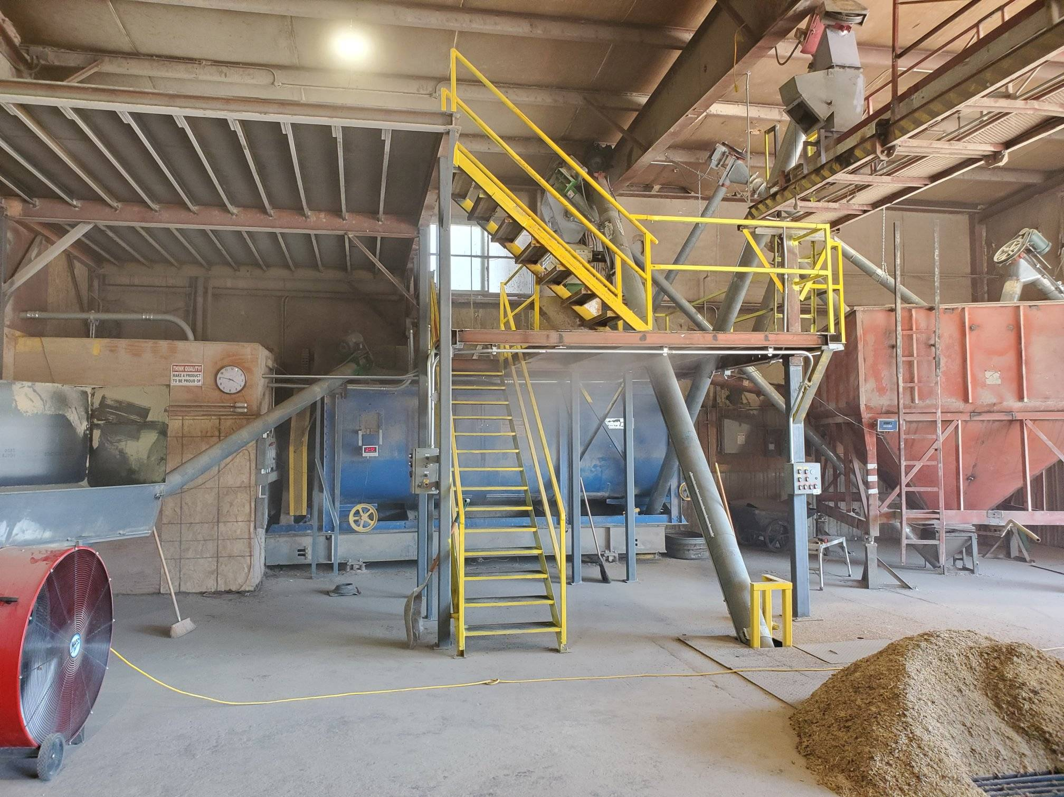  Feed mill complete and running!  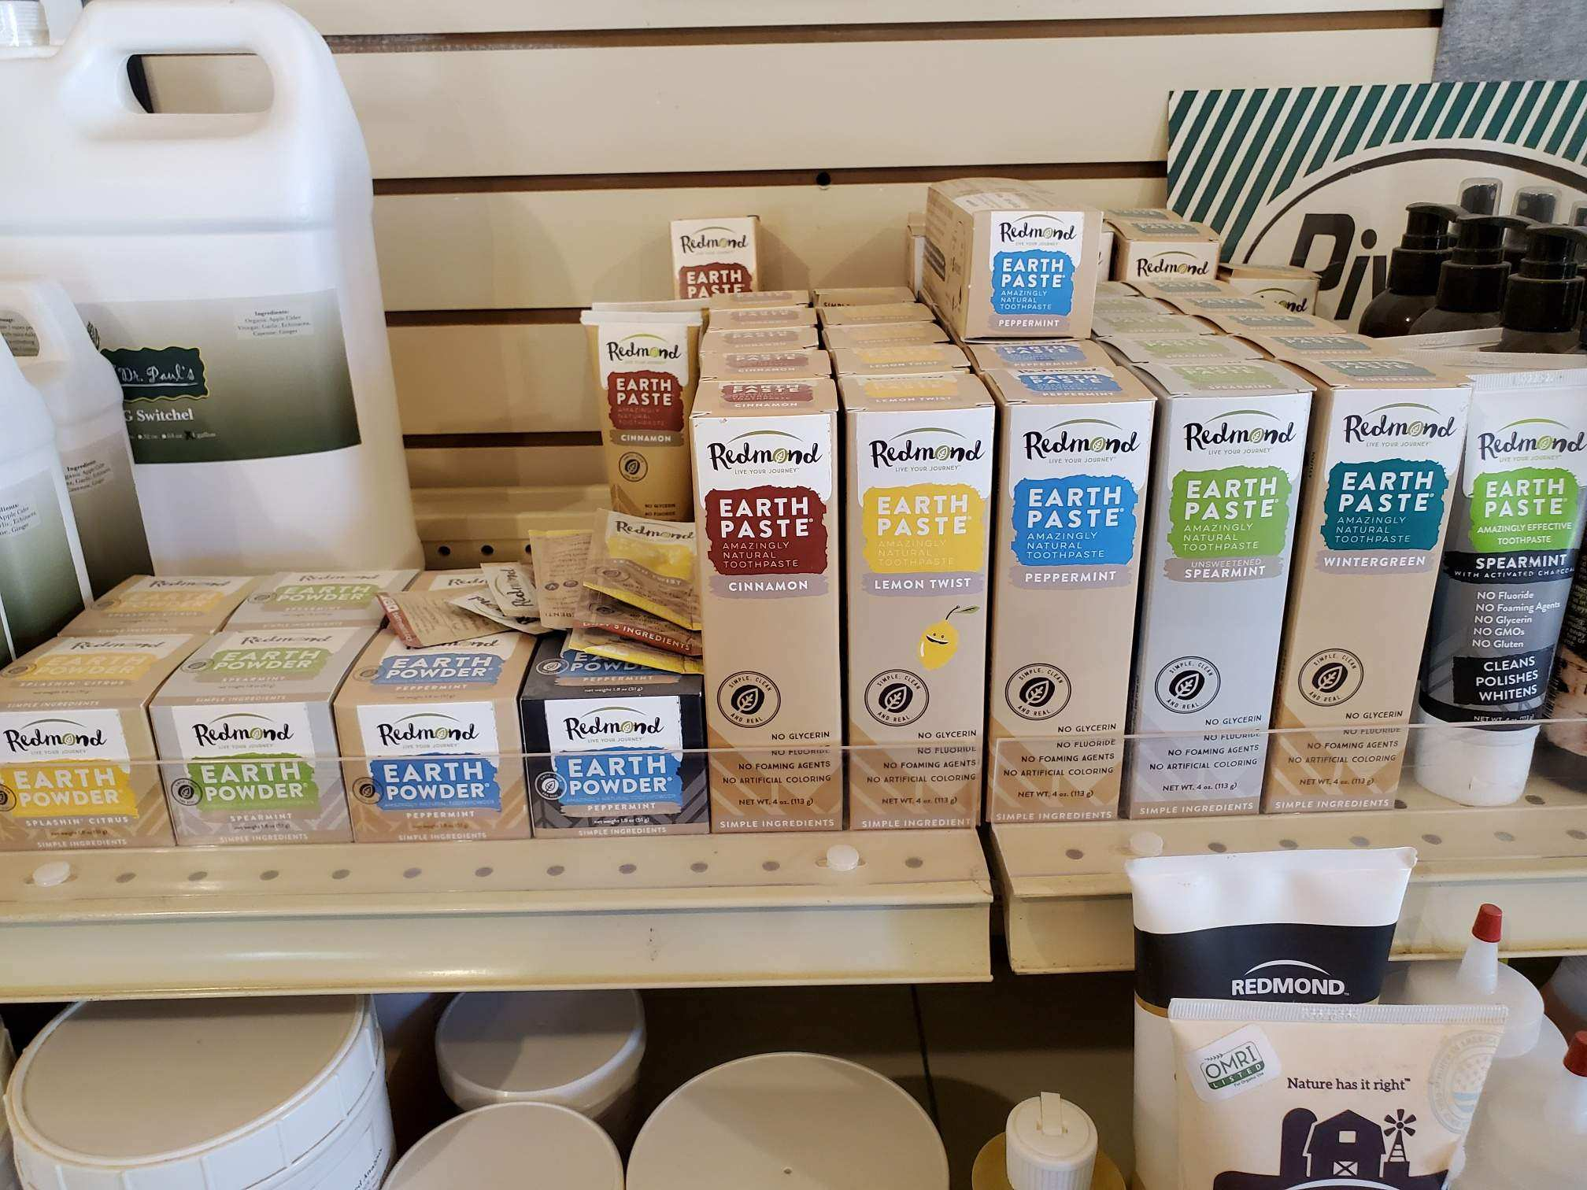  Redmond Earth Powder and Earth Paste on our retail shelf. Come in today to try some!  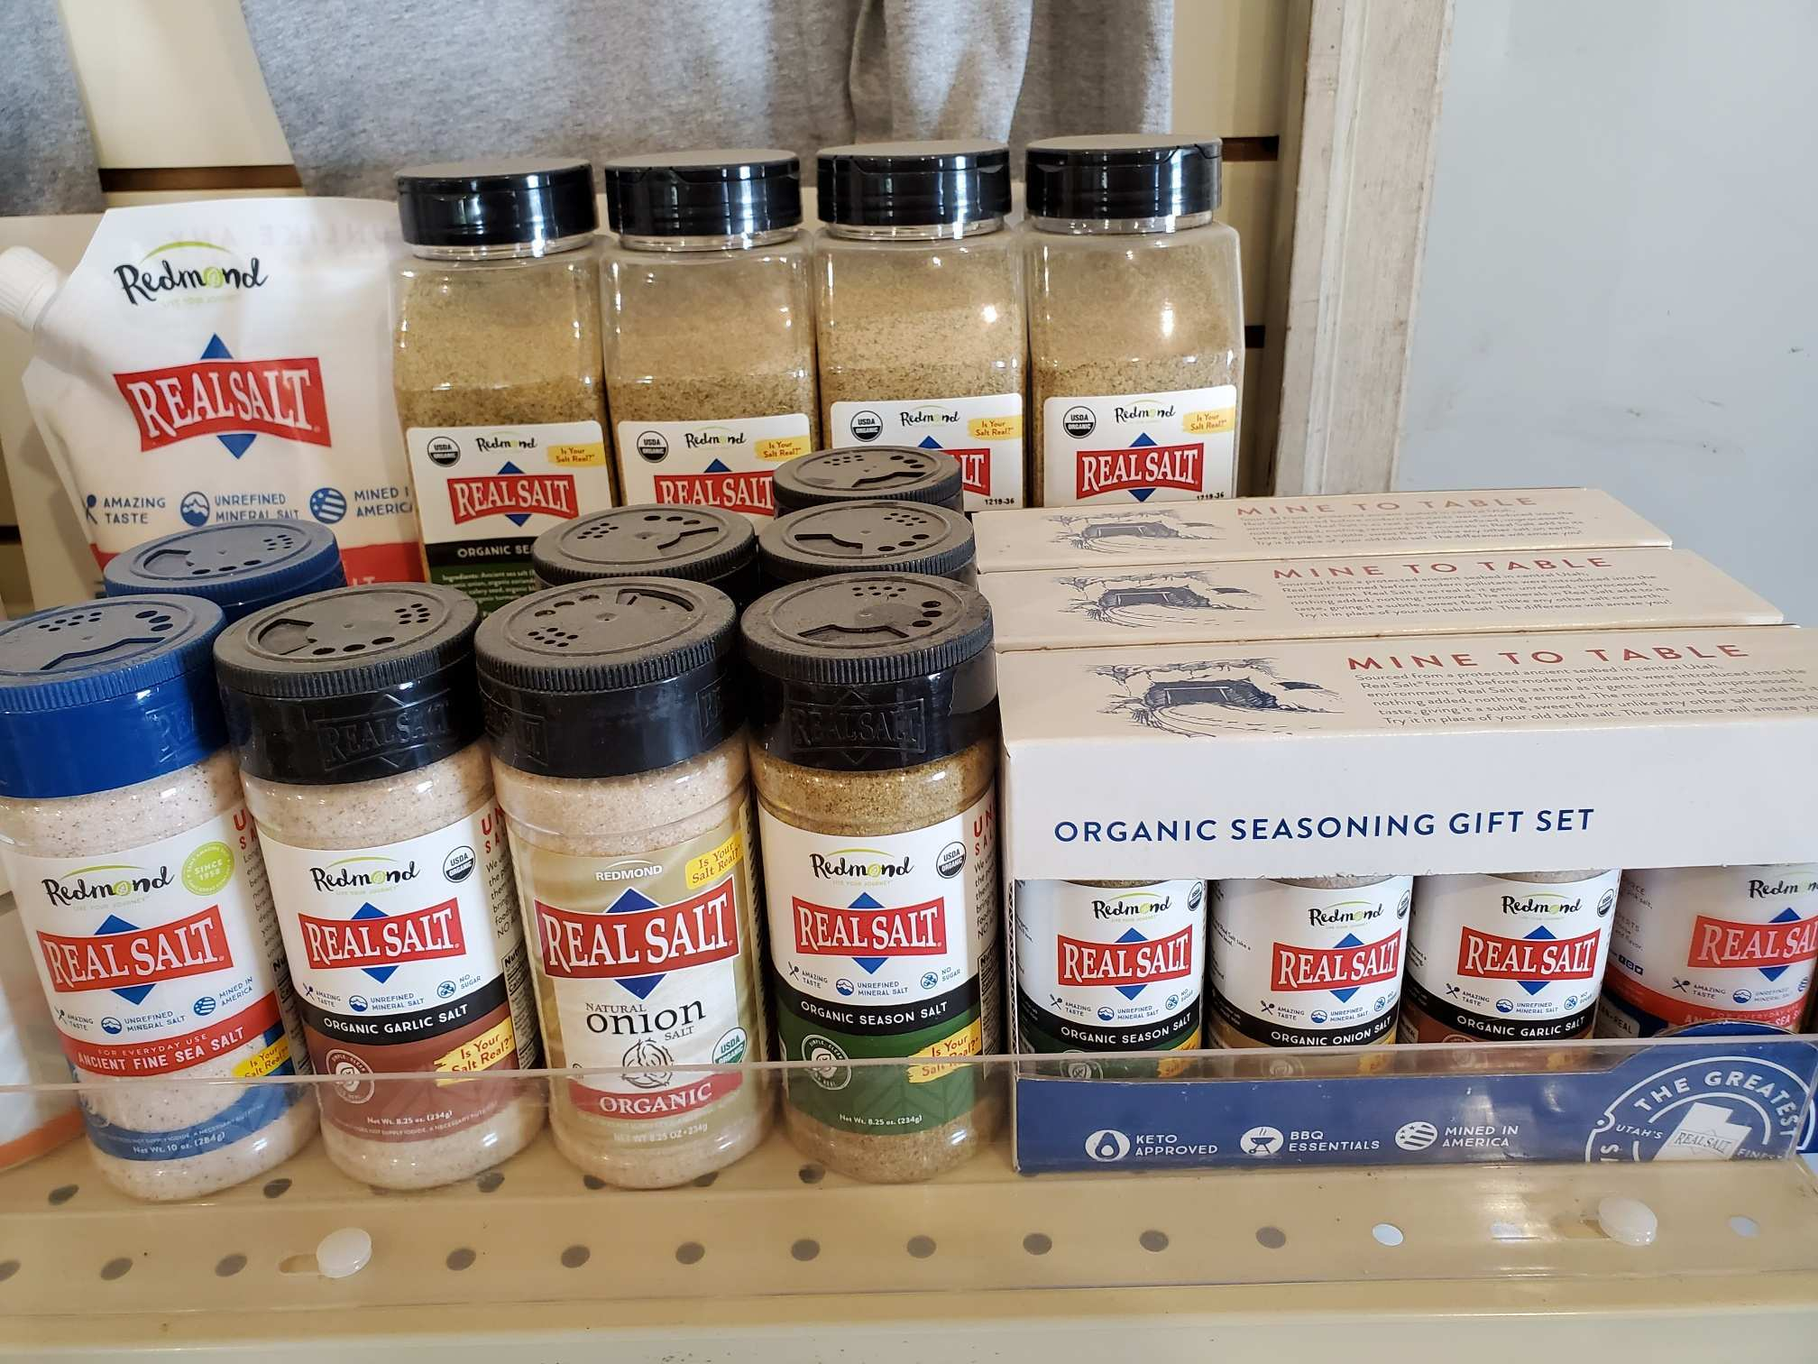  Redmond’s Real Salt products can come in multiple size containers. If you are not sure on what flavor you like best, the “gift set” has a small container of all 4 types of salt. We also carry 32-ounce containers of the season salt! |  |  | Product feature!  Human products:  Redmond Earth Paste and Earth Powder:  Try Redmond’s all natural and healthy toothpaste, which is made without preservative chemicals and foam. Instead, Redmond uses special clay materials that scrubs your teeth clean in a healthy manner. Flavors on our shelf include: Cinnamon, Lemon Twist, Peppermint, Spearmint, Wintergreen, and Spearmint with Charcoal. We also carry Earth Powder, which is a dry powder to use instead of the paste. Flavors on our shelf for Earth Powder include: Lemon Twist, Spearmint, Peppermint, and Peppermint with Charcoal.  Redmond’s Real Salt:  For healthy flavoring options in your food, try Redmond’s Real Salt. Real Salt is made entirely with one ingredient: REAL SALT, from ancient sea salt. No preservatives or chemicals included! For flavoring preferences, we carry the following: Real Salt, Organic Garlic Salt, Organic Onion Salt, and Organic Season Salt. I prefer the Real Salt on my popcorn, and ONLY allow the organic season salt on my steaks!

Warehouse offerings!
CONTACT US!
300 Forest Street
Riceville, IA 50466
641-985-2494 Office
riversidefeeds@gmail.com
www.riversidefeeds.net
This new section will be dedicated towards product that we have a healthy supply of, or equipment available for sale. This is a limited list, as we will always continue to carry everything listed on the Price List. All items/products are FOB Riceville, IA. |  |  |  |  |  | ORGANIC GRAIN PRICES:  *Upper Midwest References  Corn: $7.50 / Bu  Soybeans: $18.25 / Bu Feed, $20.50 / Bu Food  Wheat: $8.00 / Bu  Barley: $7.00 / Bu  Oats: $5.50 / Bu  Soybean Meal: $850 / Ton
Smidley Livestock Equipment: single, double, and triple hog drinking bars available in used, refurbished condition.  50 hp Jacobson Hammermill with screens and dust cyclone. Call!  Schlagel 8” double swing distributor with 24 outlet holes, great shape.  40’ x 10” drag chain conveyor, U-Trough. Needs new chain and paddles, and sprockets. Make offer. |  |  | Organic Steamed Rolled Oats – either 50 pound sacks, or 1600 pound totes, $900 / ton.  Non-GMO Soy Pro 40 meal – 2,000 pound totes or bulk, $375 / ton.  Non-GMO Oat Mill Run Pellets – 50 pound sacks, totes, or bulk. Check Price List. Now readily available, and will continue to be available during feed mill shut down!  Non-GMO Pig Starter/Grower, and Non-GMO Hog Grower/Finisher in 50 pound sacks in stock.  Retail: Smidley, Crystal Creek, Fertrell, Redmond, Dr. Paul’s, Dr. Sarah’s, Pyganic, Apple Cider Vinegar – For humans and animals!  Full Warehouse selection of vitamins, minerals, and ingredients!
FUTURE EVENTS:
- Unfortunately, due to COVID-19, we will not be present in any local community parades this summer. Even though Iowa has started to reopen its economy, we feel it is the safest to continue to limit public and truck drivers in our office and provide window service and curbside pickup on orders.
- No current future events are planned due to COVID-19. Please keep in mind everyone’s safety and health, and we always encourage you to maintain social distancing. We greatly appreciate everyone’s cooperation during these difficult times and continue to encourage feed orders placed via phone call or email.
- If any customers would like to see our new feed mill setup, feel free to give us a call or stop by and ask for a personal tour! We encourage social distancing and face masks when visiting our facility.
Seasonal Products:
Time for Chicks!

Non-GMO Chick Starter Crumbles in stock now! $18 / 50# sack. Season will be ending soon, so stock up now!
SunCoast Pine Shavings $8 / Bale

