. | The Feeder |  |  |  | August 2022

closed on wednesday, august 3rd!
We will be CLOSED on Wednesday, August 3rd, for an all staff professional development and retreat day. Like last summer, we are asking for one business day to shut the trucks, office, and mills down and take our staff on the road for a fun filled outing as a way to show appreciation for all of their hard work, and to development team relationships. We ask for everyone to please plan accordingly, as we will NOT have anyone around to answer phones or to load customers or trucks at all. We greatly appreciate your patience and cooperation towards this event. Our employees work very hard towards building this business up and producing quality byproducts for your needs, and we want to show them the appreciation that they so well deserve while we have time to!  We are finally in our last full month of office renovation, and are currently scheduled to wrap up all of the finish work in middle of August. This means that we will be cleaning the newly renovated office, restroom, and break room and moving into those areas during the last two weeks of August. Please continue with your patience as we make this large transition and set up our new work space. We will do our best to continue to answer phones and load customers out during this process with very limited interruptions. We are excited to show the new office to you soon! |  | Our new main office is in a completely changed layout to better serve all customers and truck drivers, and provide our office staff more desk space. The new storage room for our office is twice the size of the old storage room, and will securely house all of our long term documents, files, and marketing materials. This room will also house our new computer, phone, internet, and security camera server system. Our new unisex rest room is far larger than our old rest room, and includes lockers for production employees, individual stalls for men and women, washer & dryer, and even a shower for our employees or long haul truck drivers to utilize! The new break room will include a full kitchen with all new appliances to have the ability to prepare healthy meals for our hard working production and office staff which will be operated by our highly skilled chef and marketing manager, Amanda Frantzen!  You may see on the price list that a lot of products are marked as “Limited” or “OUT”. Please keep in touch with our staff on your upcoming needs. |  | 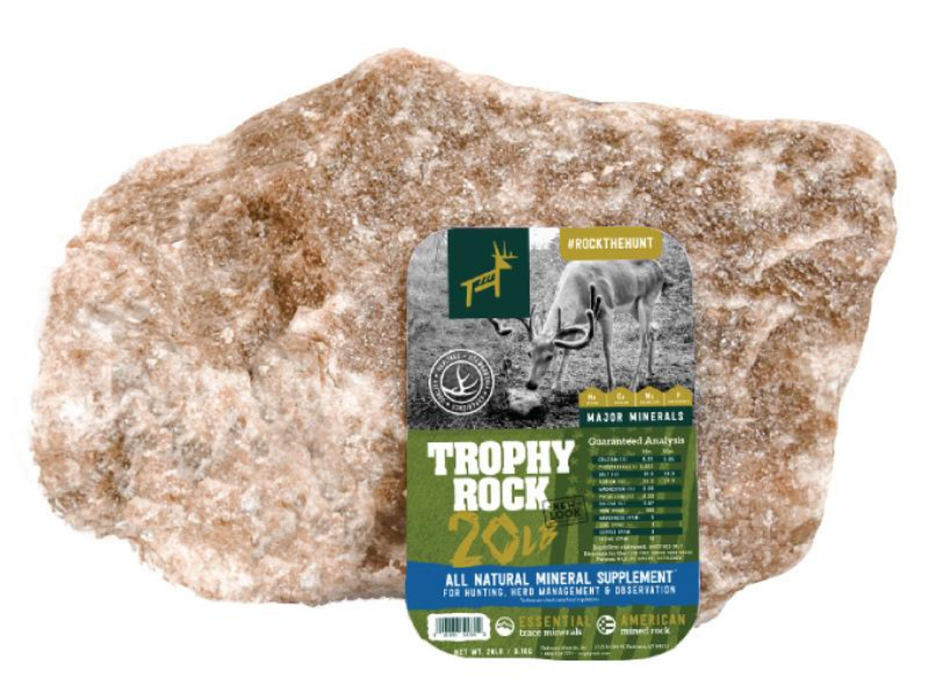 | Fall seasonal products  It’s that time of the year again to prepare for the fall season! We are fully stocked with Redmond Hunt’s products for all of your wildlife needs including Trophy Rock, Cherry or Apple Bomb pellets, and Cherry or Apple spray! Redmond’s Trophy Rocks are a very good selling item and has shown great antler development and growth. We also make our own wildlife feed pellets from a combination of mixed grains and proteins with corn and molasses, available in 50# bags. We will be making a fresh batch of this up in early August.  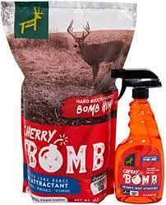  Enclosed is a great article from a recent Fertrell newsletter sharing how effective kelp, aloe pellets, and apple cider vinegar can be for horses and other animals. We stock all these products and refer to these natural remedies for animal health and immunity. Any questions about these products can be answered anytime!

Warehouse offerings!
CONTACT US!
300 Forest Street
Riceville, IA 50466
641-985-2494 Office
riversidefeeds@gmail.com
www.riversidefeeds.net
Current specials of available supplies. Please refer to enclosed Price List for all products. All items/products are FOB Riceville, IA. Please call to verify availability on all products. Customer pickup or delivery of products can be arranged anytime. |  |  |  |  |  | ORGANIC GRAIN PRICES:  *Upper Midwest References – NOT Riverside Feeds Offers  Corn: $12.00 / Bu  Soybeans: $37.00 + / Bu Feed, $39.00 + / Bu Food  Wheat: $12.00 / Bu  Barley: $12.00 / Bu  Oats: $10.00 / Bu  Soybean Meal: $1800 / Ton +
Smidley Livestock Waterer Equipment: single, double, and triple hog drinking bars and scales available in used, refurbished condition.  Smidley used equipment special: Hog, Sheep, Goat portable head chute! A great condition oldie. Asking $950 OBO. Digital head hog scale - $2800. |  |  | Organic Soybean Oil – Available in 1 ton liquid totes for $0.85 / #. Currently have 3 totes available.  Non-GMO & Organic Oat Mill Run Pellets – 50 pound sacks, totes, or bulk. Supply is readily available!  Organic Steamed Rolled Oats – Available in 2,000# totes or bulk. $1000 / ton.  Retail: Smidley, Crystal Creek, Fertrell, Redmond Agriculture, Redmond human & hunt products, Dr. Paul’s Lab, Dr. Sarah’s Essentials, Pyganic, Apple Cider Vinegar – For humans and animals!  Full Warehouse selection of vitamins, minerals, and ingredients! Ingredient prices have been going up, so stock up now to save money.
FUTURE EVENTS:
- Riverside Feeds Summerfest: We will be CLOSED on Wednesday, August 3rd, for employee team building and appreciation day. We will NOT have any function of our business operating that day, including all trucks, mills, and office. Please plan accordingly for all feed orders.
- Our last local town parade that we will partake in will be Riceville Wapsi Days on Saturday, August 6th at 11 AM! Come to town, enjoy the parade, and watch for our parade float!
- Keeping COVID-19 concerns in mind, please do NOT enter our premises if you are feeling ill or recently tested positive for COVID-19. Our office doors are OPEN to the public.
- We are down to our last month of operating our temporary office in the job site trailer in our East driveway! We are currently scheduled to move back into our newly renovated office in late August, but until then, please continue to check in at the temporary office trailer in the driveway.
- PLEASE NOTE - Office Hours: Monday – Thursday: 8 am – 5 pm. Friday: 8 am – 4 pm.
Seasonal Products:

Non-GMO Swine Feeds – Hog Starter/Grower pellets for $16 / 50# bag, and Hog Grower/Finisher pellets for $13 / 50# bag
Redmond Trophy rock ($15 / 20#) and Bomb Pellets (Cherry or Apple flavor - $14 / 20# bag) for wildlife growth and development. Redmond Apple or Cherry Spray for $14. Riverside’s Wildlife Feed freshly made for $10 / 50# bag.

