. | The Feeder |  |  |  | September 2023

10 year anniversary a huge success!
We had a very successful 10 Year Anniversary Open House on Friday, August 4th! We believe over 300 people came to visit and celebrate our past 10 years of business with us that afternoon. Everyone greatly enjoyed the amazing live music that was performed by Jordy Arndt & The Howlers, Goldie and The Willie Stomper, and Will Barnett and Company. Beyond socializing with our entire staff, many people learned a lot more about our business from the facility tours. Attendees also overwhelmingly enjoyed the following food trucks: Egg-Cetera (egg rolls), Tu Wayy Catering (loaded nachos and loaded potatoes), and Sky Kone (ice cream), and enjoyed a few different kinds of locally brewed beer from Limestone Brewers! We are sad if you happened to have missed this amazing celebration, but certainly invite you to stop by anytime to check our facility out!  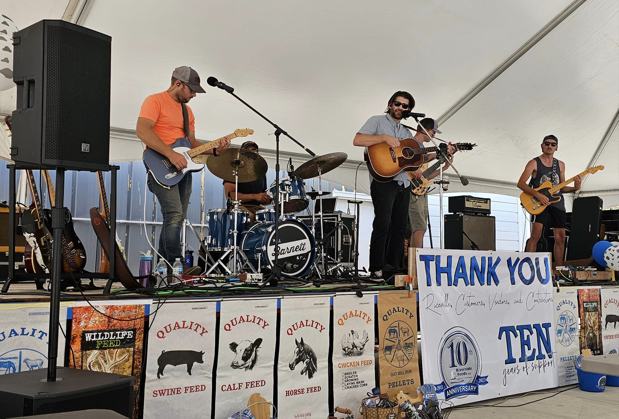  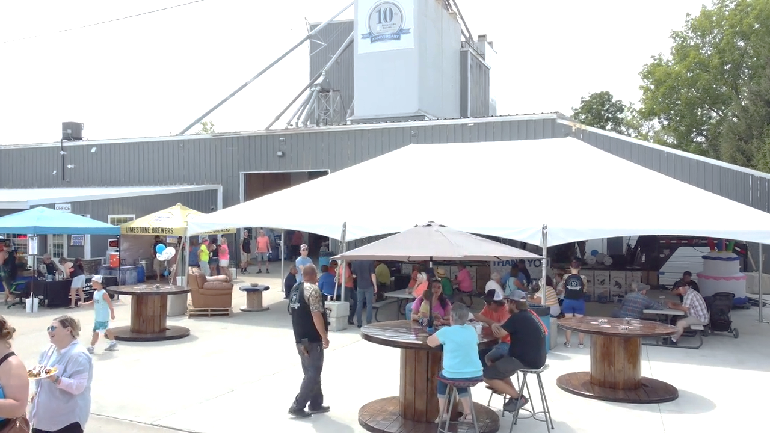 |  | As a payback towards our hard working staff to clean up the facility and help host a fun filled afternoon for our Open House, we enjoyed the following Friday, August 11th, off for our ‘Summerfest’ employee outing! This year, we decided to take a bus down to the Iowa State Fair for a relaxing day. We met up with one of our employee’s family, who was showing swine that same day. For some employees, it was their first time visiting the Iowa State Fair. Everyone enjoyed the day off to spend time seeing the different exhibits and socialize together.  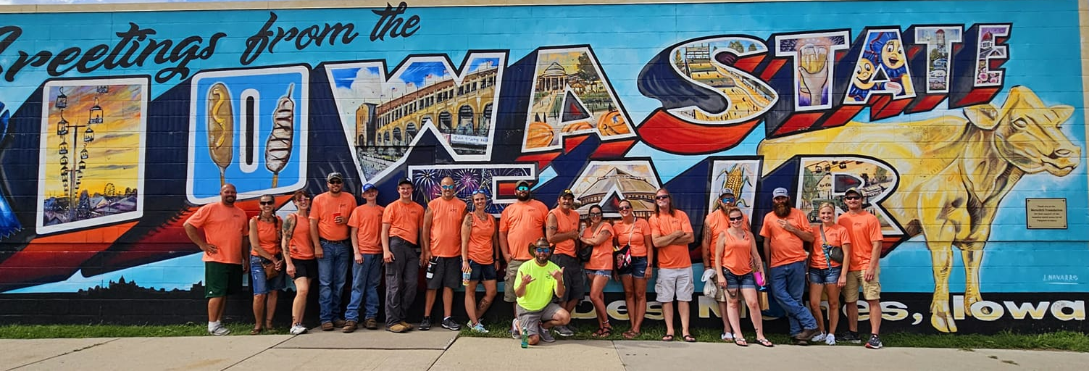  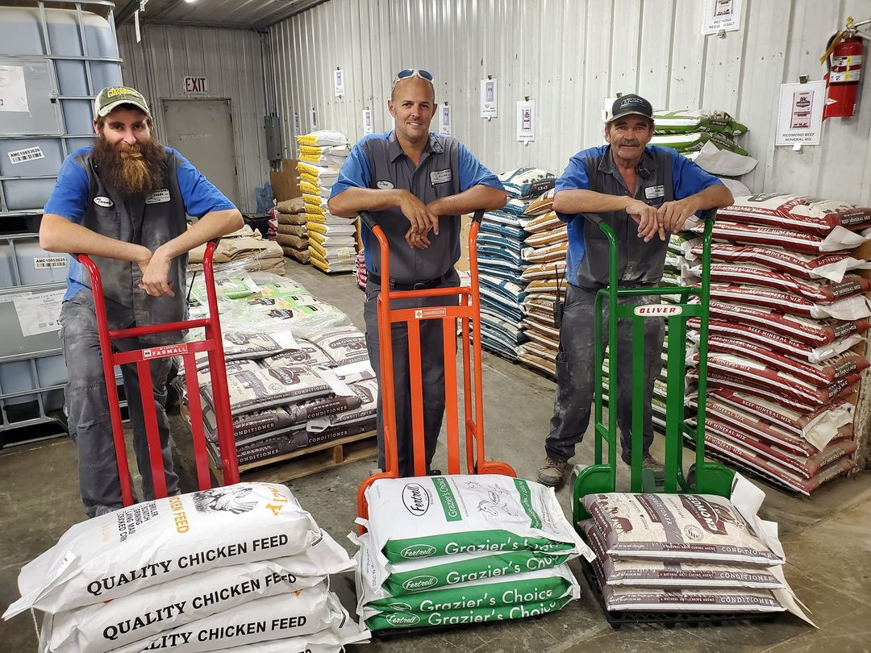  Recently, our warehouse guys decided to refurbish our 2-wheel feed carts with fresh paint and vintage tractor decals! Now, Tanner, Dan, and Milt are ready to serve your needs with our new line of ‘Feed Tractors’, using a McCormick-Farmall, Allis-Chalmers, and Oliver! We didn’t allow John Deere in the line up, because we don’t “putt-putt” around here! (No pun intended!) |  |  | 10 Reasons to use apple cider vinegar  1) Natural Energy: ACV is primarily acetic acid, a natural volatile fatty acid found throughout the body and utilized by the animal as a direct form of pure energy and for butterfat and body fat production. It is absorbed directly, through the wall of the rumen.  2) Buffers (alkalizes) rumen and overall blood pH , Used to prevent or reverse acidosis, ketosis.  3) Digestive tonic: Use to prevent scours, bloat, gas, reflux, indigestion, poor digestion.  4) Anthelmintic: Prevents or removes virtually all forms of internal and external parasites.  5) Contains probiotics (beneficial microbes), minerals, vitamins, & nutriceuticals.  6) Boosts Immunity: Improves disease resistance (bacteria, viral, yeast, fungal, or toxin).  7) Cleanser and Detoxifier: Contains high levels malic acid which helps cleanse and heal the liver for better digestion, and detoxification of toxins and waste.  8) Meat Enhancer: May improve texture and flavor of meat- No off-flavors to milk, meat or eggs.  9) Safe Handling: Completely safe (after 2-3 days of age), easy to administer, and very tasty to animals.  10) Cost-Effective: Less Disease + More Efficient Digestion + Direct Nutritive Value

Warehouse offerings!
CONTACT US!
300 Forest Street
Riceville, IA 50466
641-985-2494 Office
riversidefeeds@gmail.com
www.riversidefeeds.net
Current specials of available supplies. Please refer to enclosed Price List for all products. All items/products are FOB Riceville, IA. Please call to verify availability on all products. Customer pickup or delivery of products can be arranged anytime. |  |  |  |  |  | ORGANIC GRAIN PRICES:  *Upper Midwest References – NOT Riverside Feeds Offers  Corn: $10.50 / Bu  Soybeans: $22.00 + / Bu Feed, $28.00 + / Bu Food  Wheat: $9.00 / Bu  Barley: $7.00 / Bu  Oats: $4.50 / Bu  Soybean Meal: $1000 / Ton +
Smidley Livestock Waterer Equipment: single, double, and triple hog drinking bars and scales available in used, refurbished condition.  Seasonal Products:  Non-GMO Swine Feeds – Hog Starter/Grower pellets for $17 / 50# bag, and Hog Grower/Finisher pellets for $14 / 50# bag  Non-GMO Chick Starter Crumbles still available! $22 / 50# bag. Also have Non-GMO Layer Feed Pellets and Broiler Grower Pellets available at $18 / 50# bag. SunCoast Pine Shavings for $9 / 12 cubic foot bag. Stock up now for your flock!  Smidley used equipment special: Hog, Sheep, Goat portable head chute! A great condition oldie. Asking $950 OBO. Also have 2 hog scales available. |  |  | Organic Prewean 22 – This swine feed is made for young pigs to start on dry creep feed prior to weaning. $34 / 50#  Organic Opro 40 Soy Protein – Available either bulk or 2,000# totes. $950 / ton. Organic Soybean Meal - $950 / ton. Can blend these products.  Organic Apple Cider Vinegar – 55 gal drums $525, or 4 gal pail $45. Non-GMO Apple Cider Vinegar avail too.  Organic Steamed Rolled Oats – Available in 2,000# totes or bulk. $1000 / ton.  EXPANDED Retail Shelf: Smidley, Crystal Creek, Fertrell, Redmond Agriculture, Redmond human (Real Salt & Re-Lyte) & hunt products, Dr. Paul’s Lab, Dr. Sarah’s Essentials, Pyganic, Apple Cider Vinegar – For humans and animals!
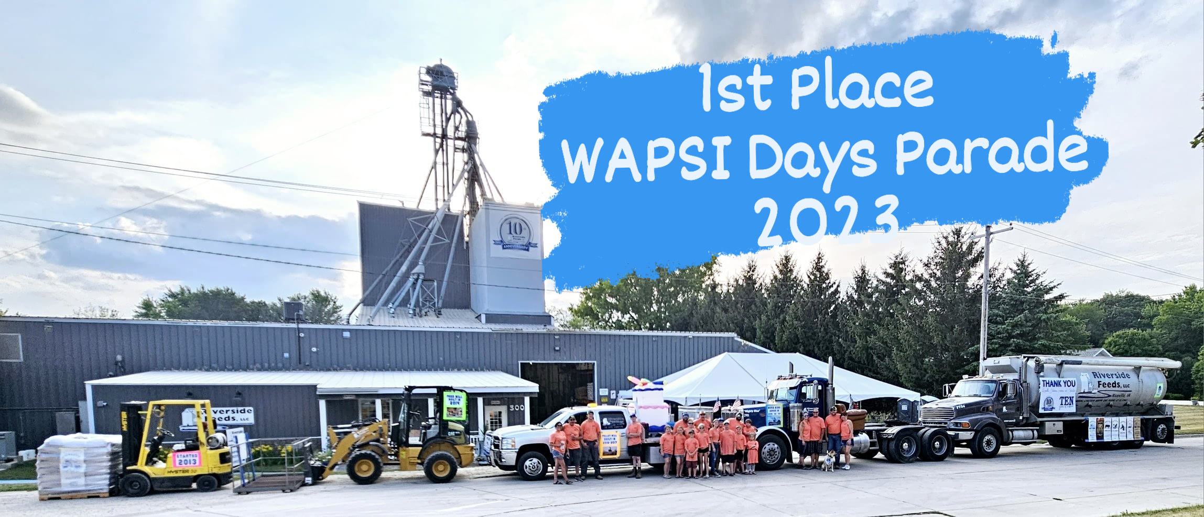
FUTURE EVENTS:

- THANK YOU for attending any of our local
town parades that we participated in this
summer! We won 1st place in the Riceville
Wapsi Days Parade this year as we celebrated
10 years in business! For the Wapsi Days
parade, we had a fleet of vehicles which
included a forklift, compact wheel loader,
flatbed truck, semi truck, and our feed truck!
- We will be CLOSED on Monday, September 4th, in observance of Labor Day. Please plan accordingly. We will be open normal business hours starting Tuesday, September 5th.
- PLEASE NOTE - Office Hours: Monday – Thursday: 8 am – 5 pm. Friday: 8 am – 4 pm.

